Jira

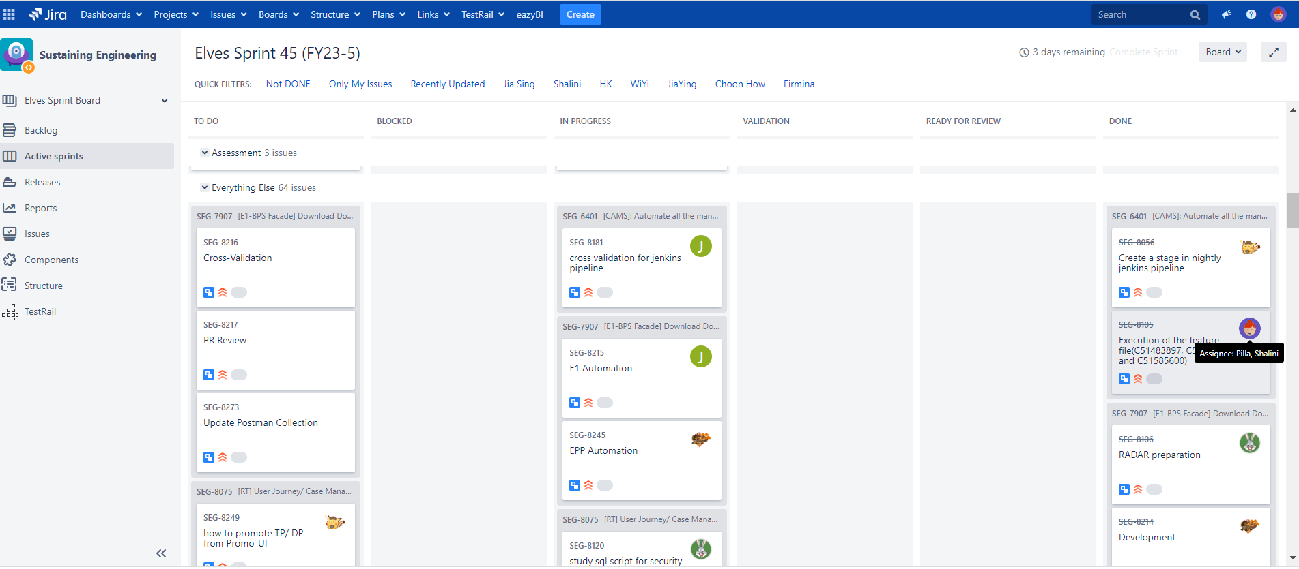

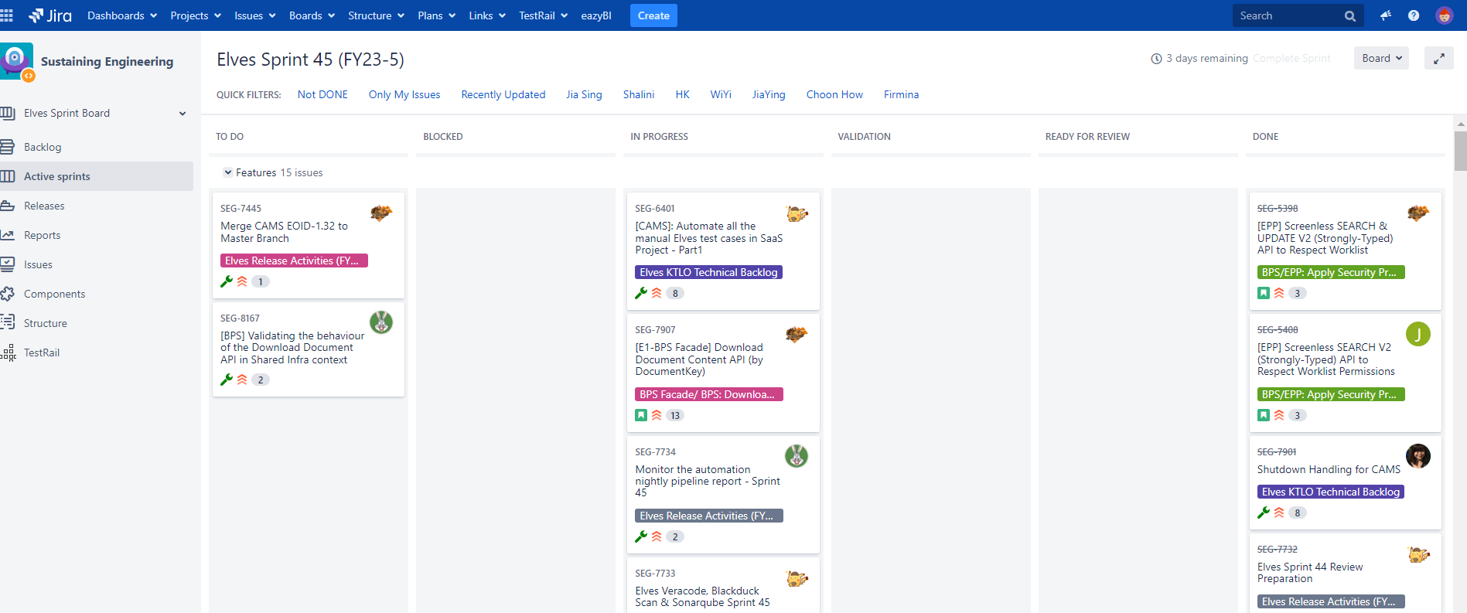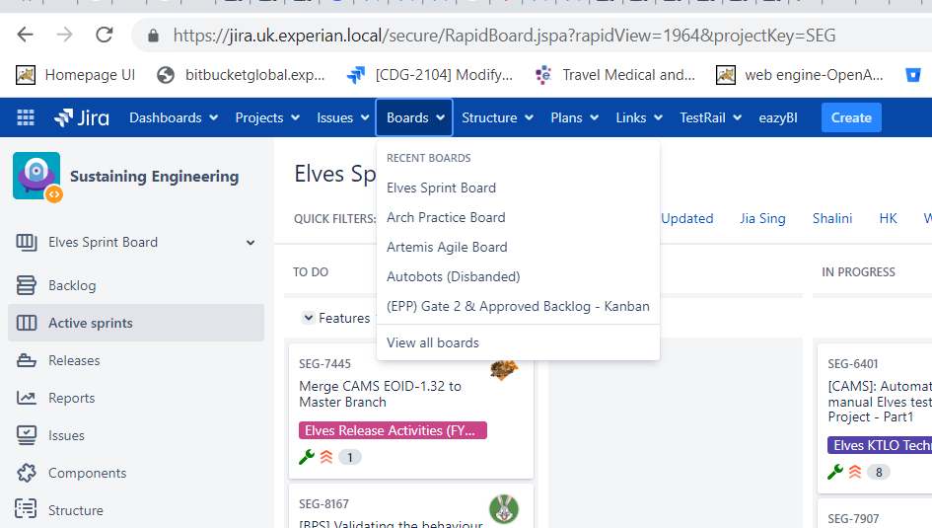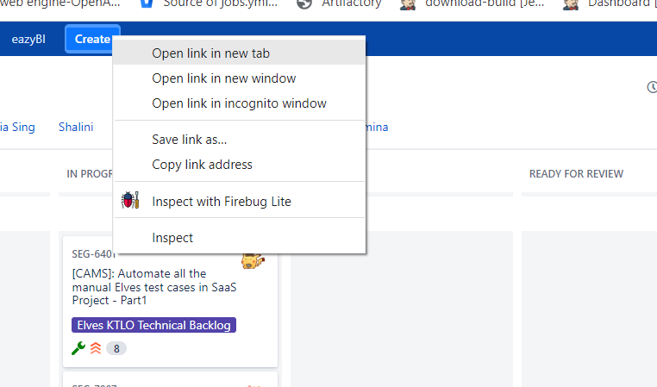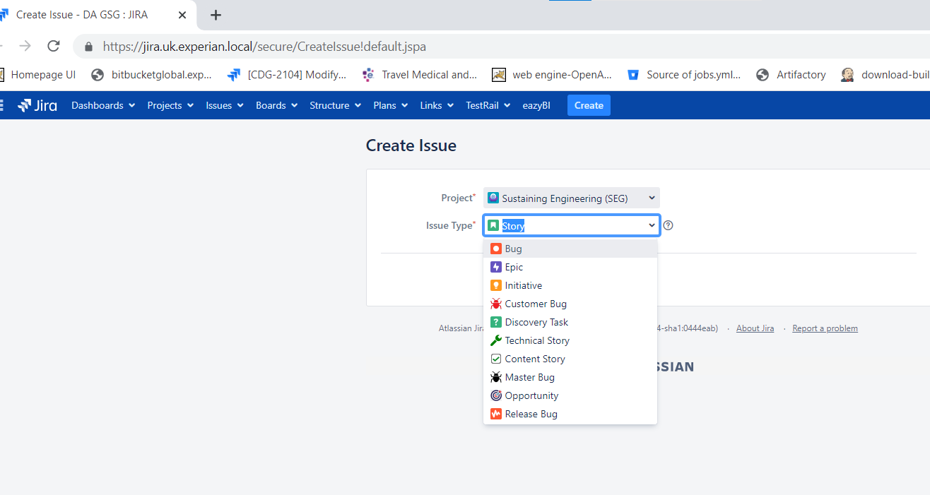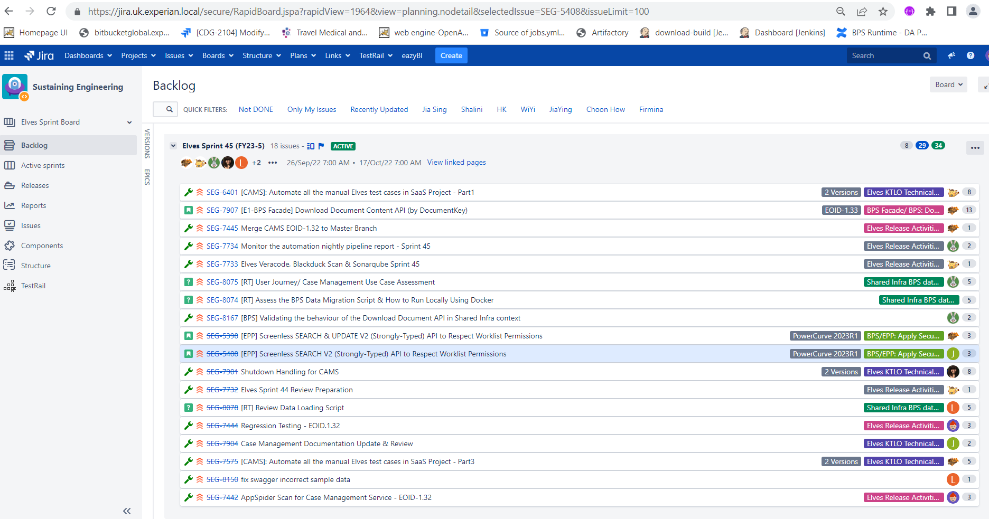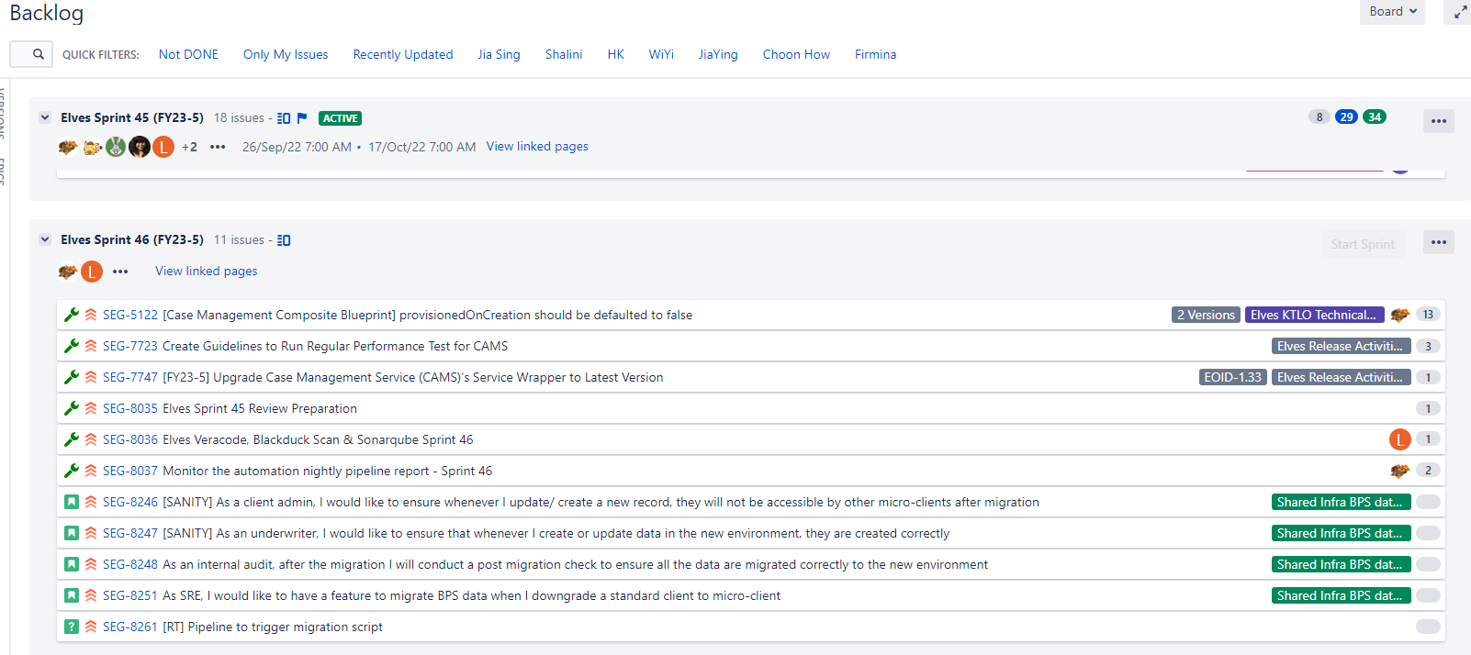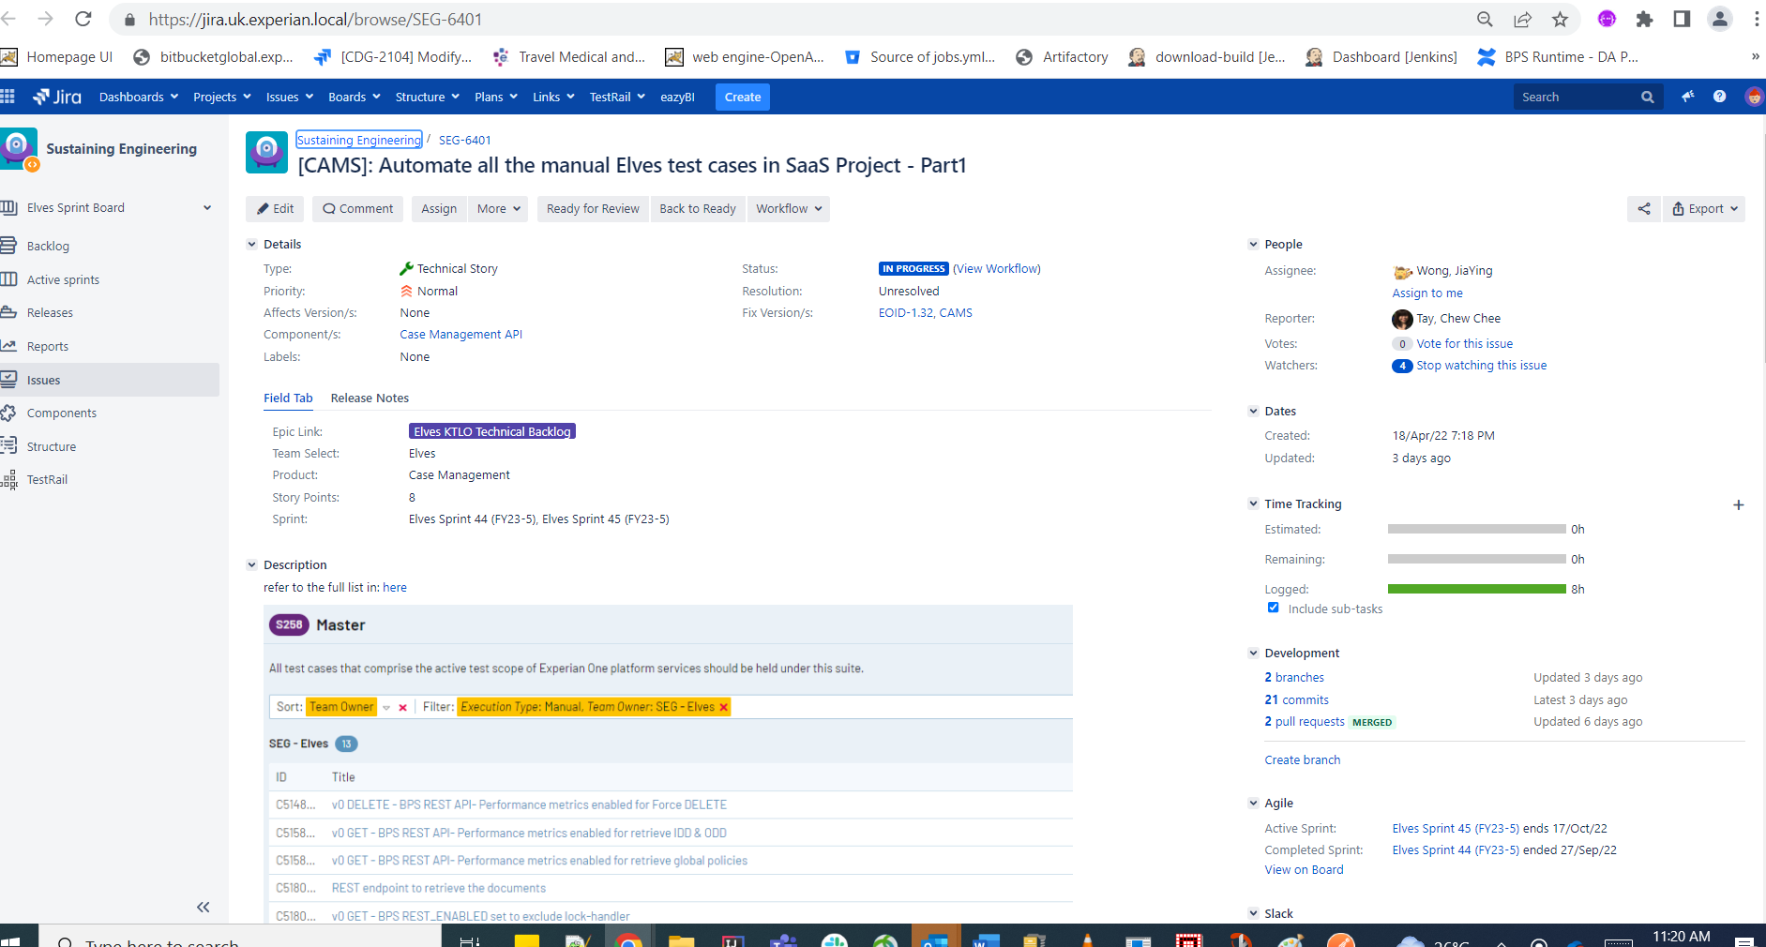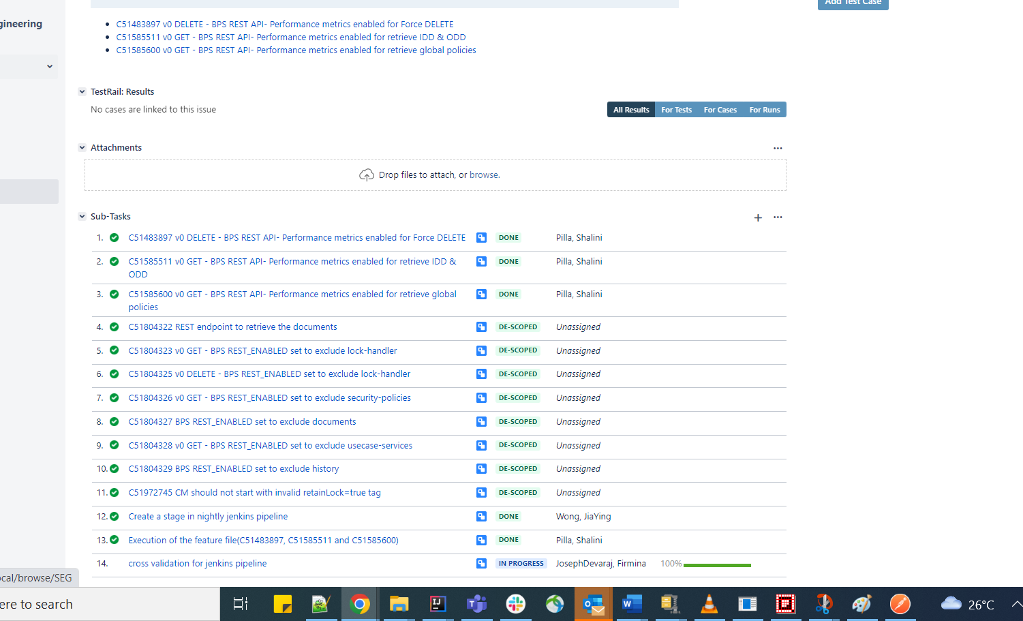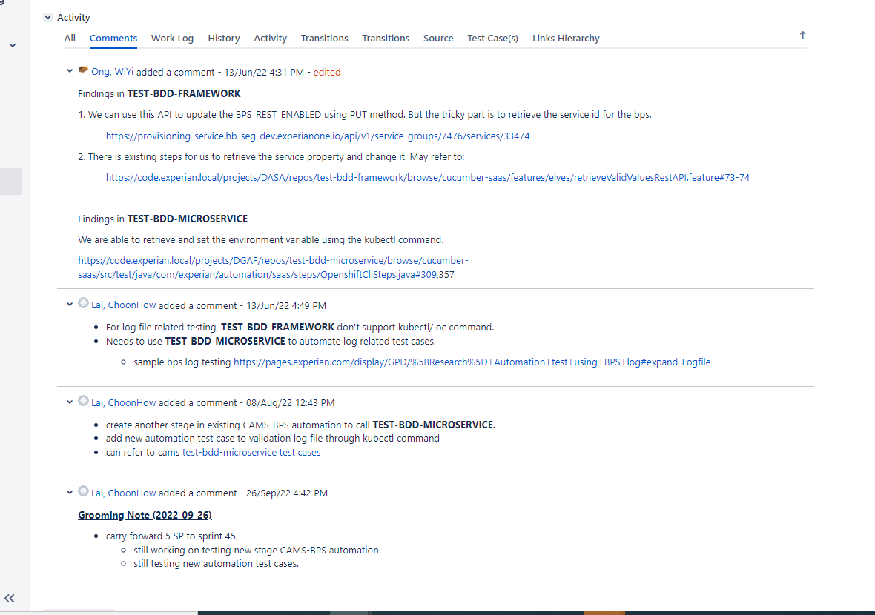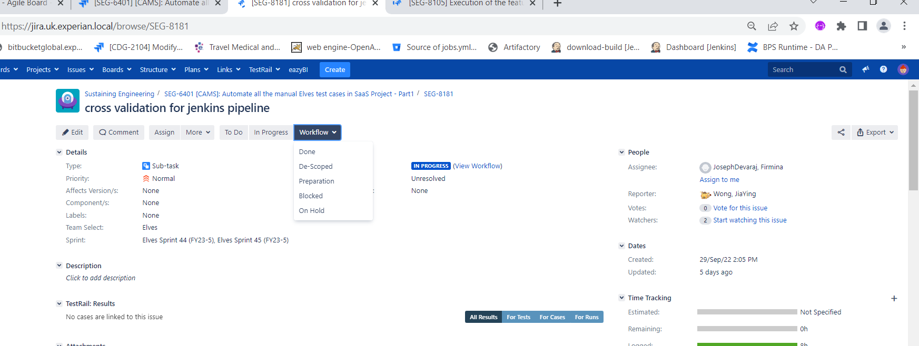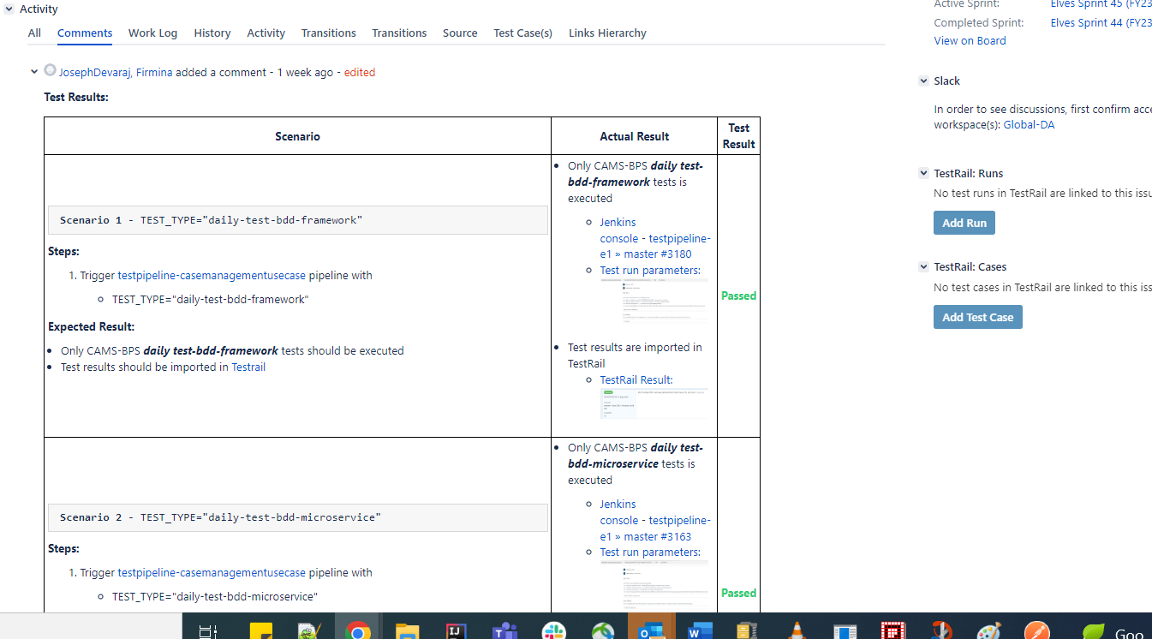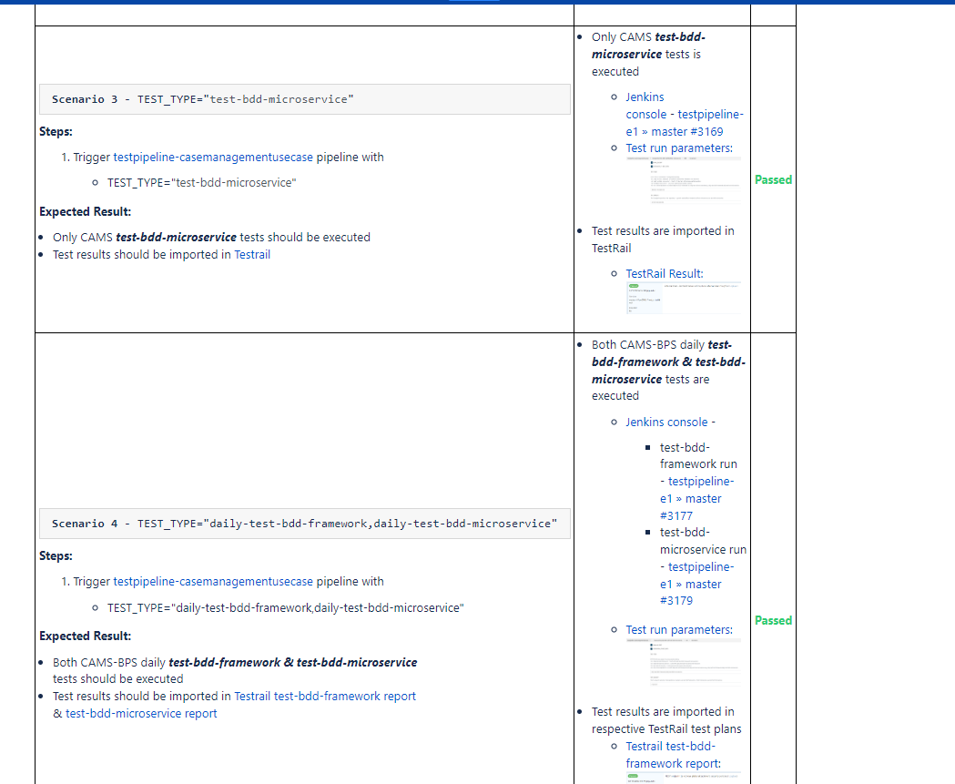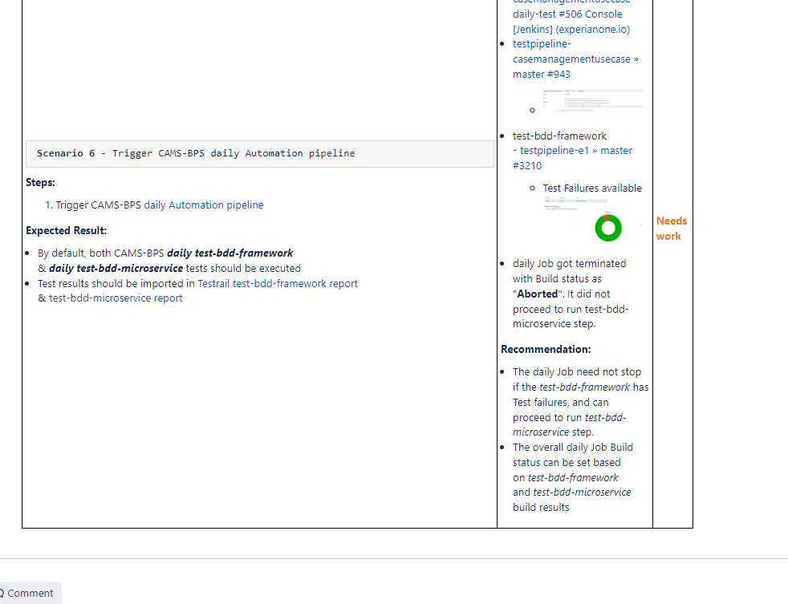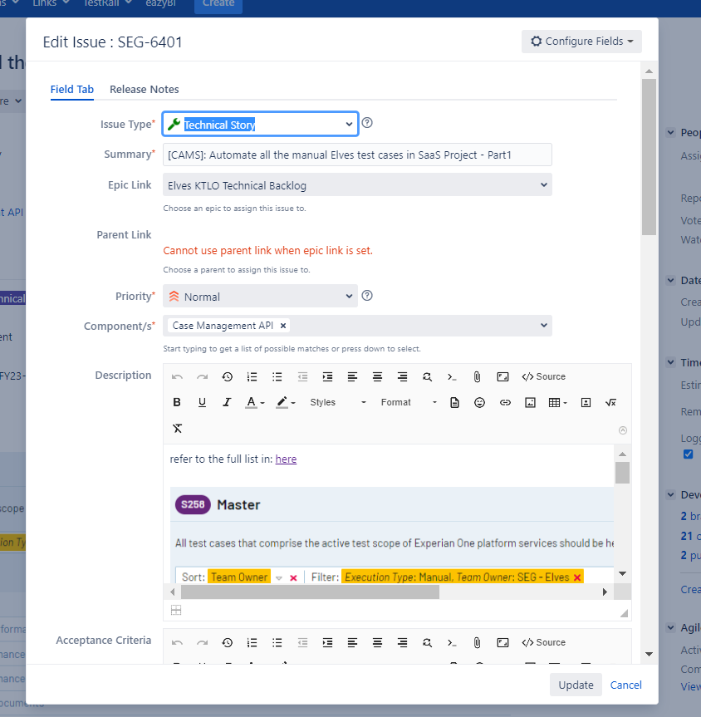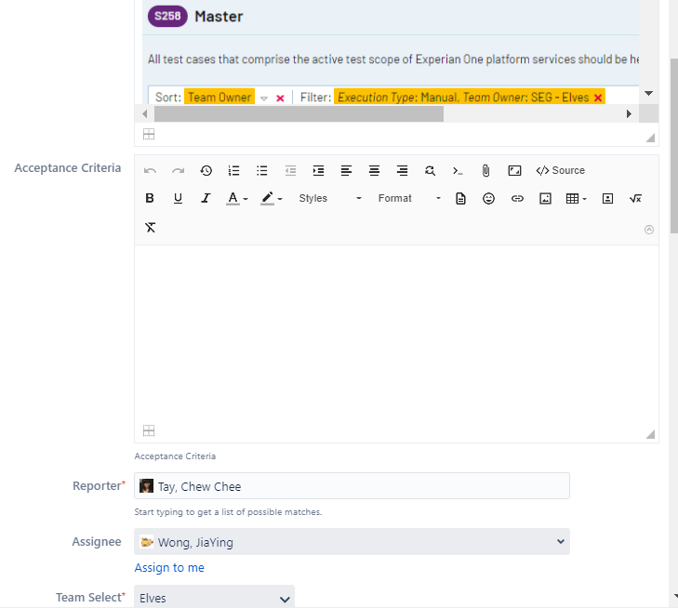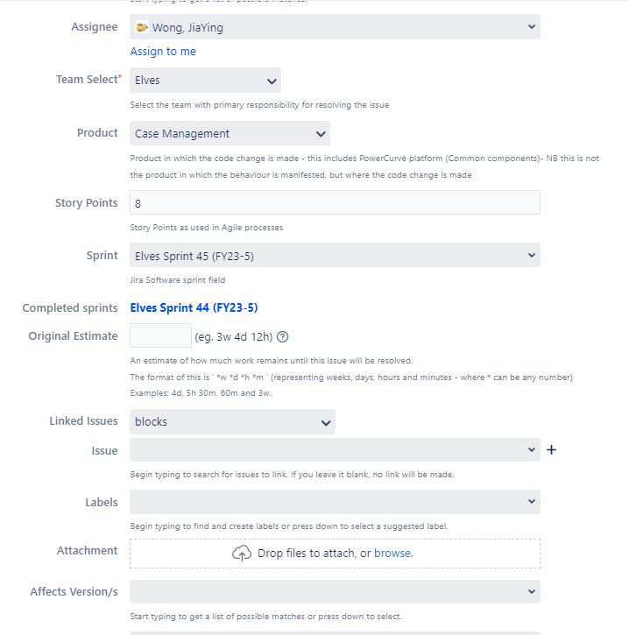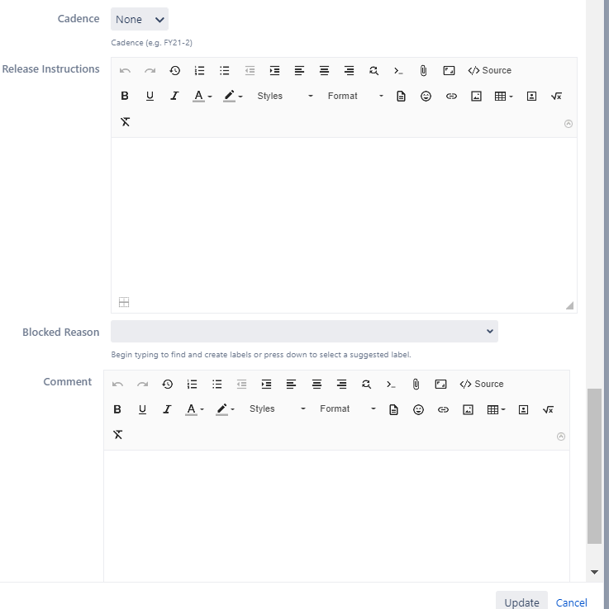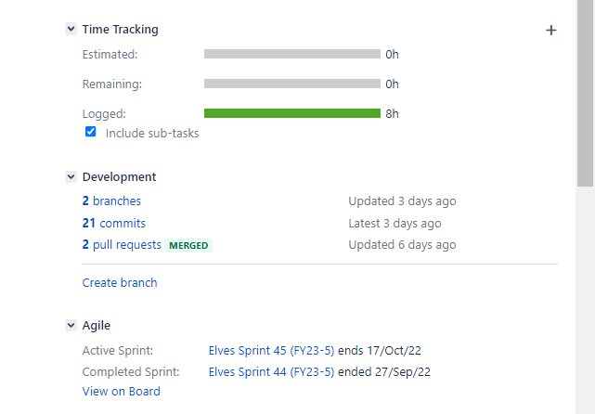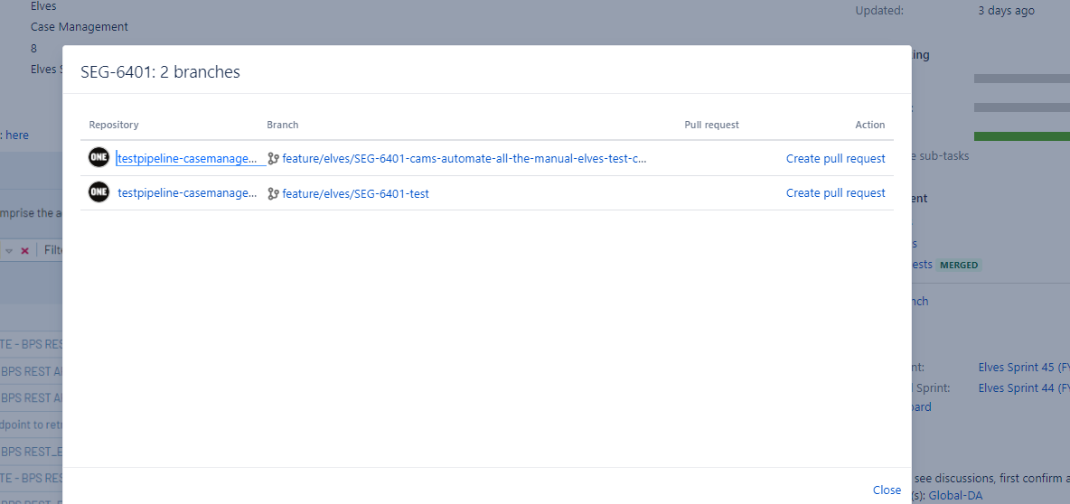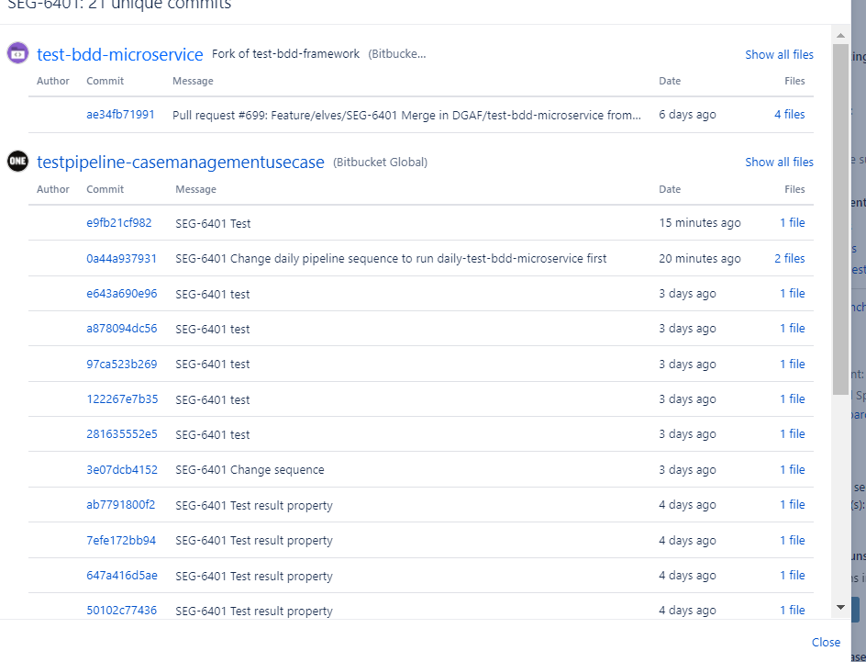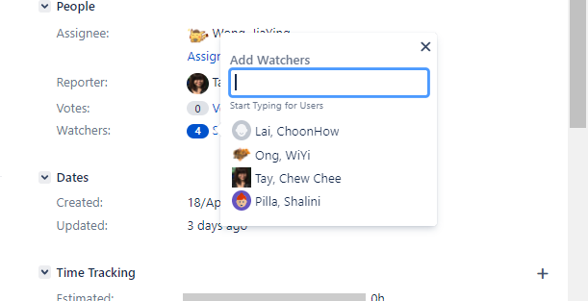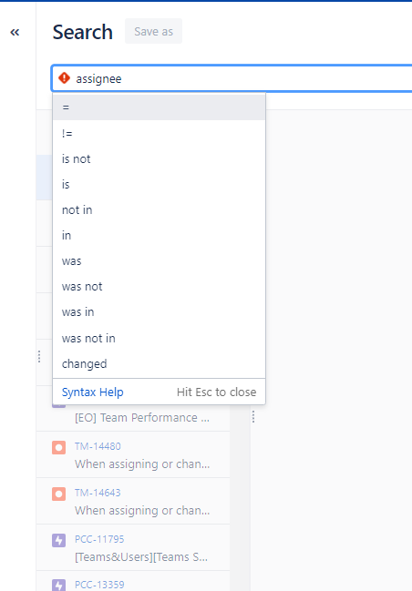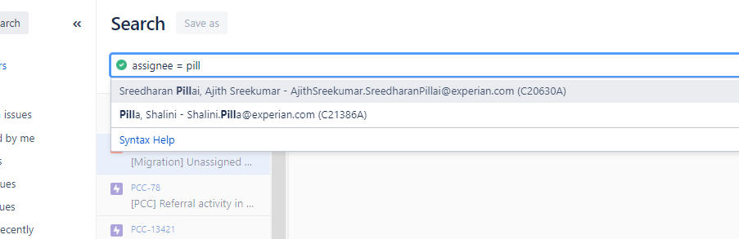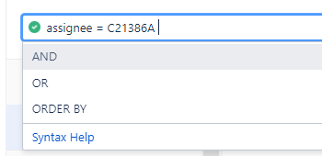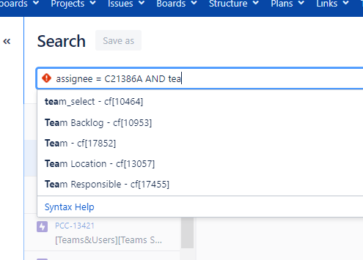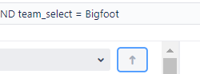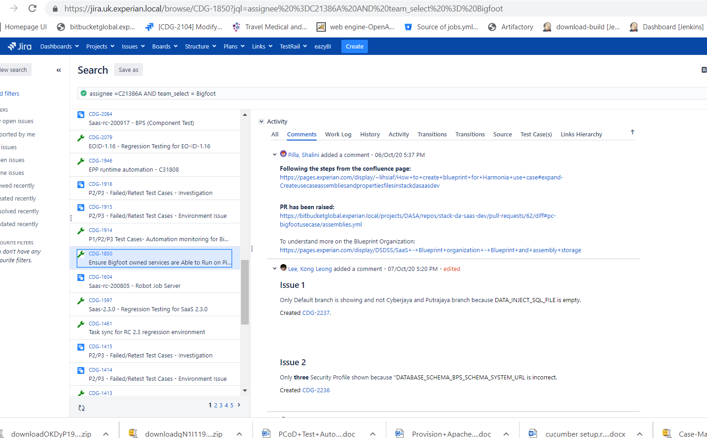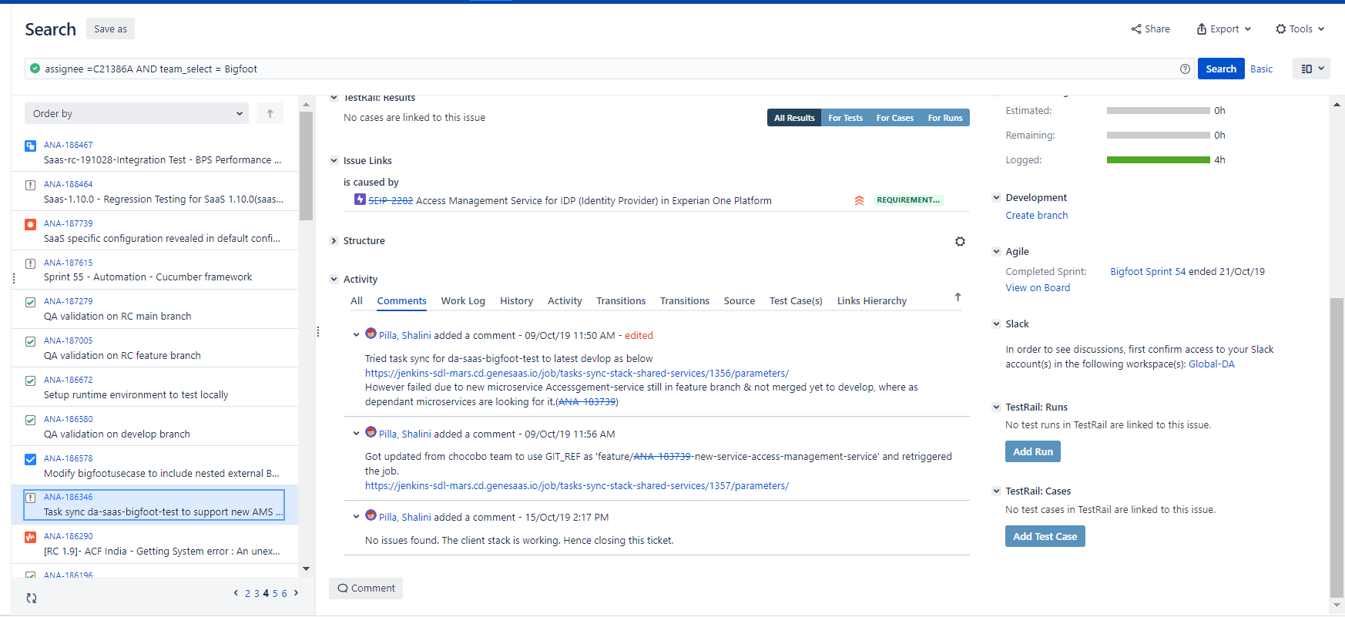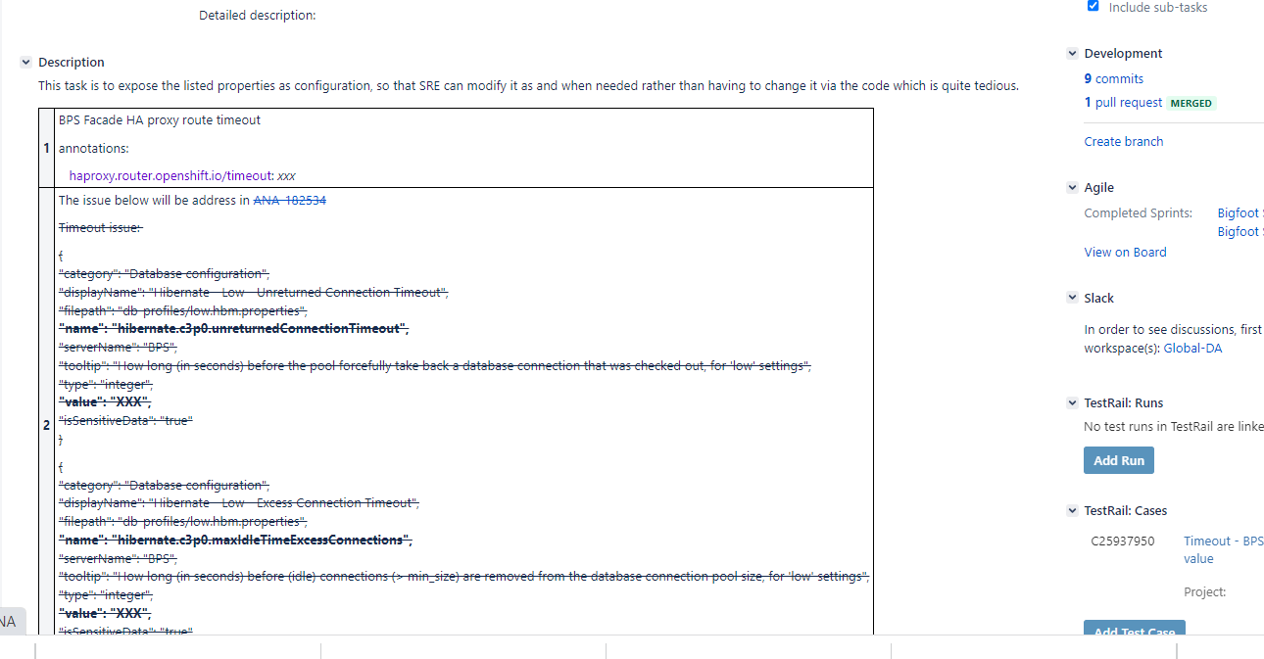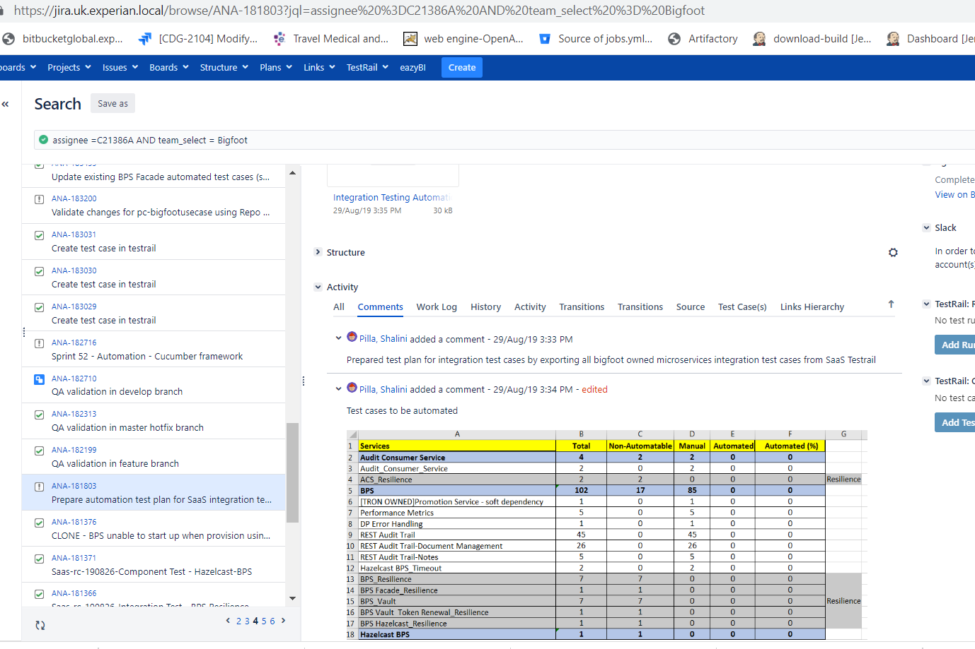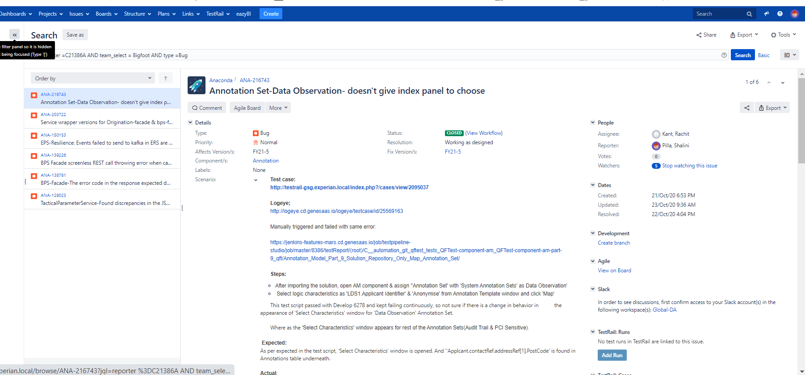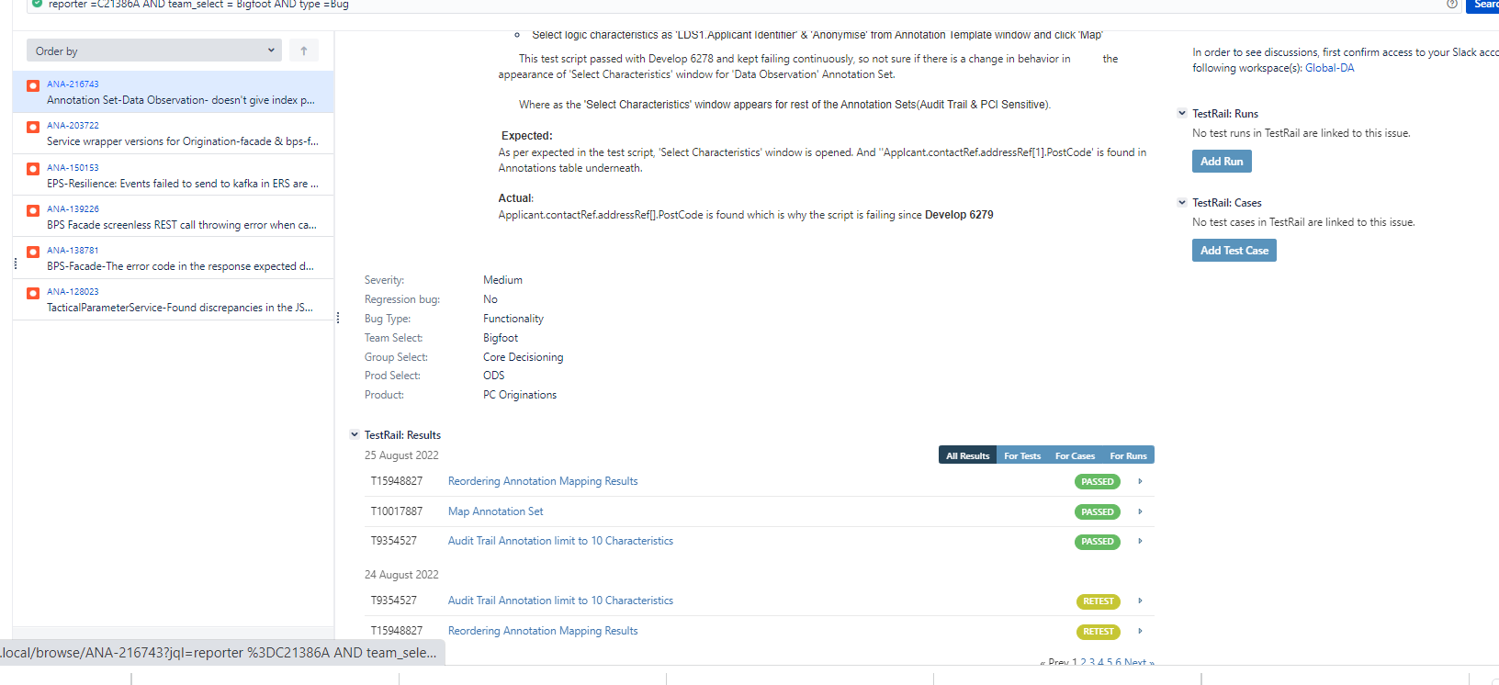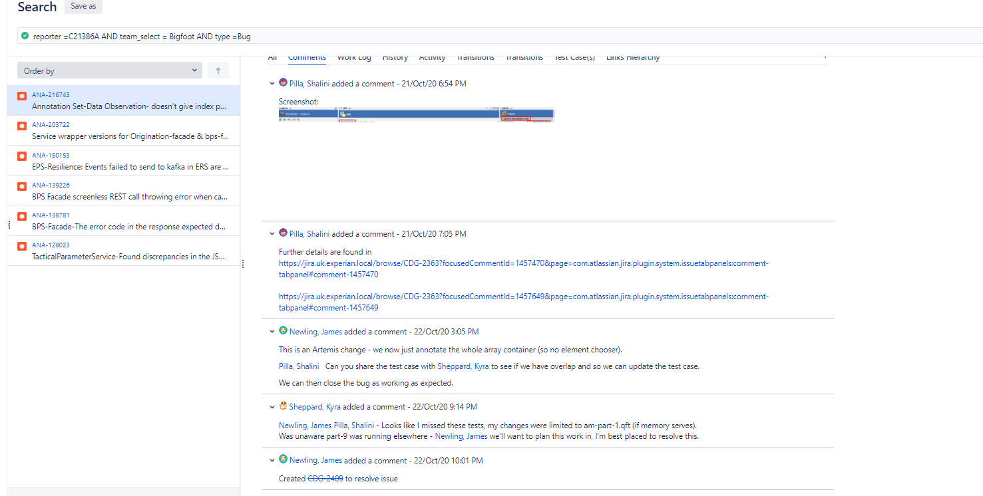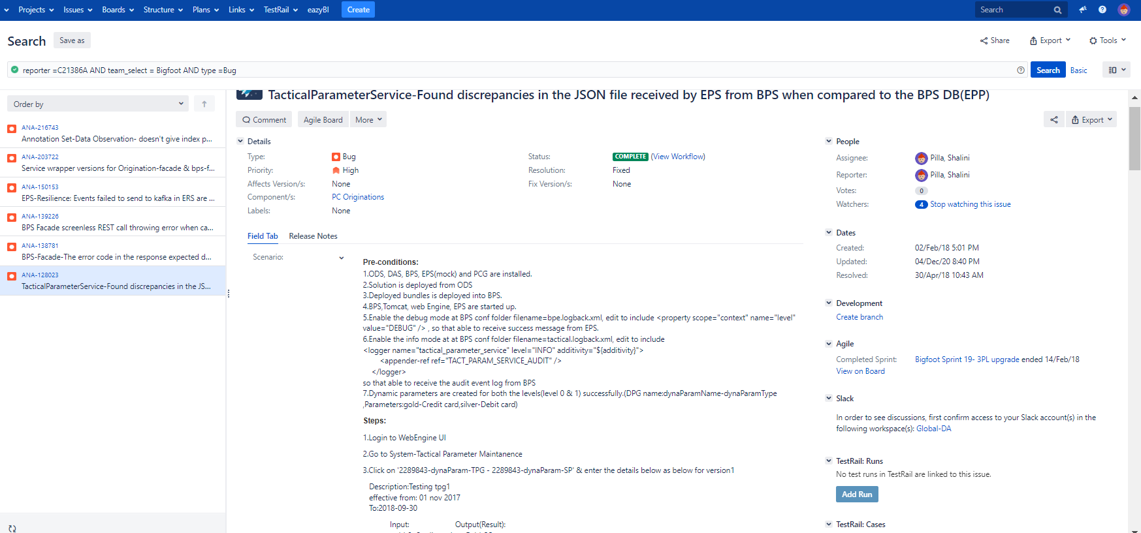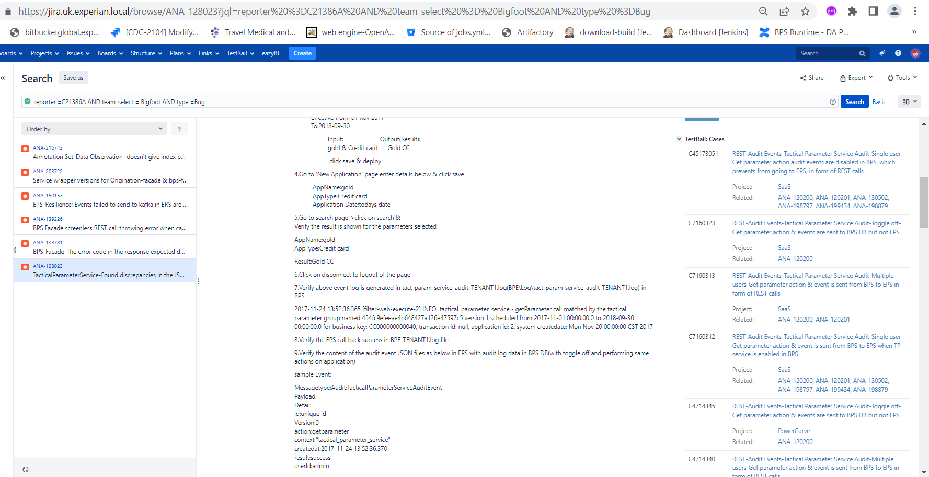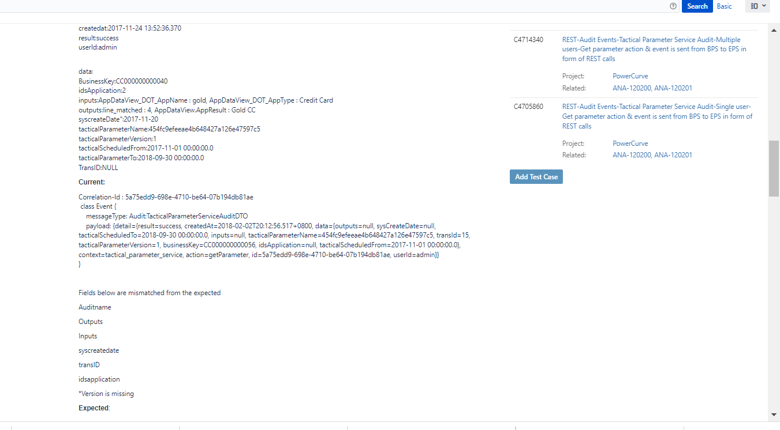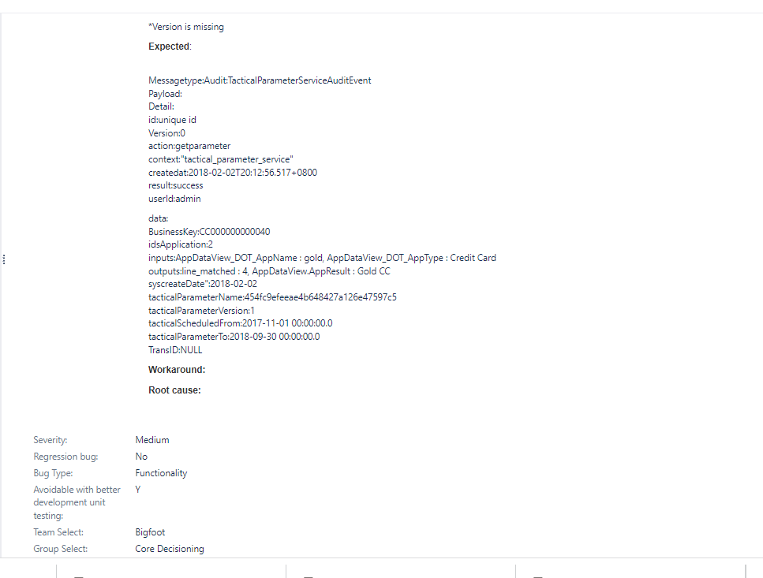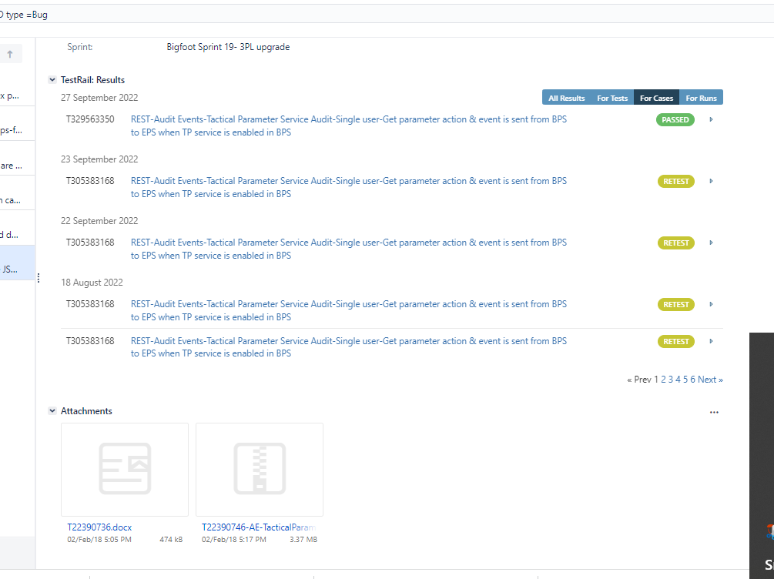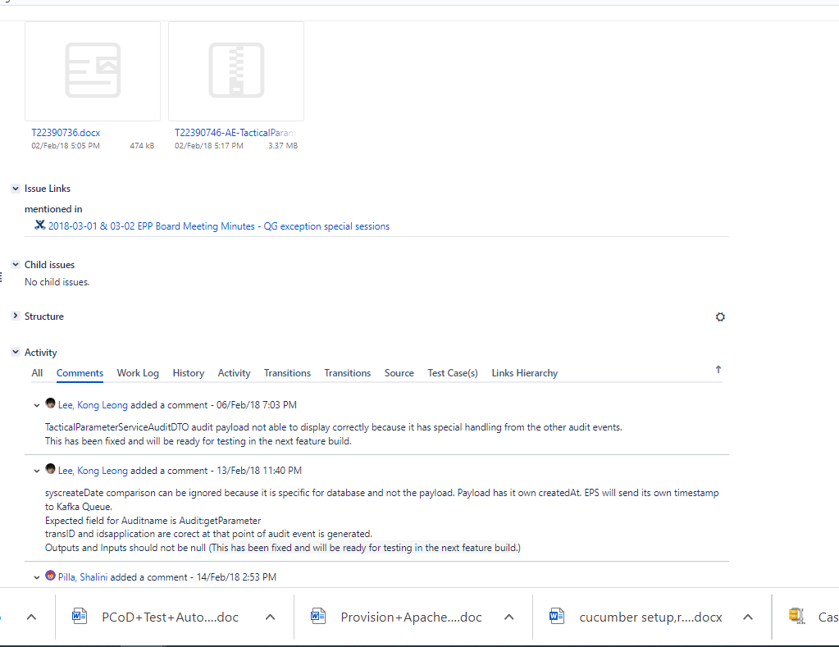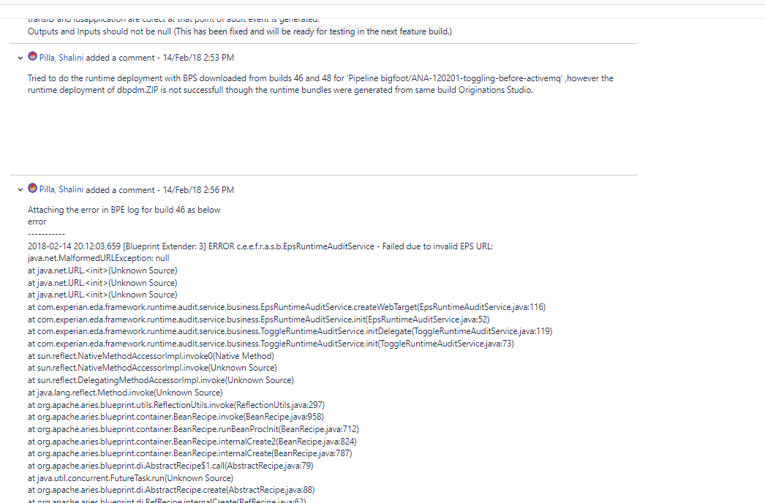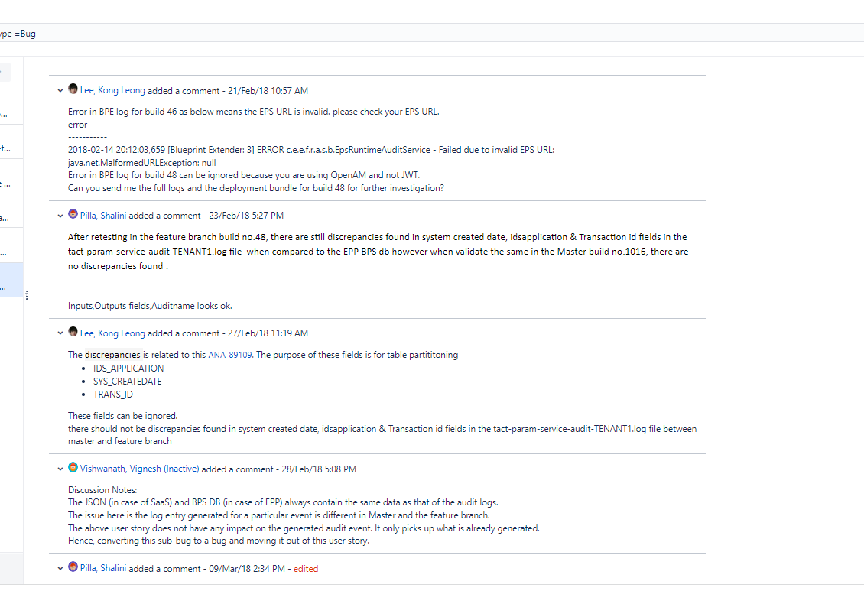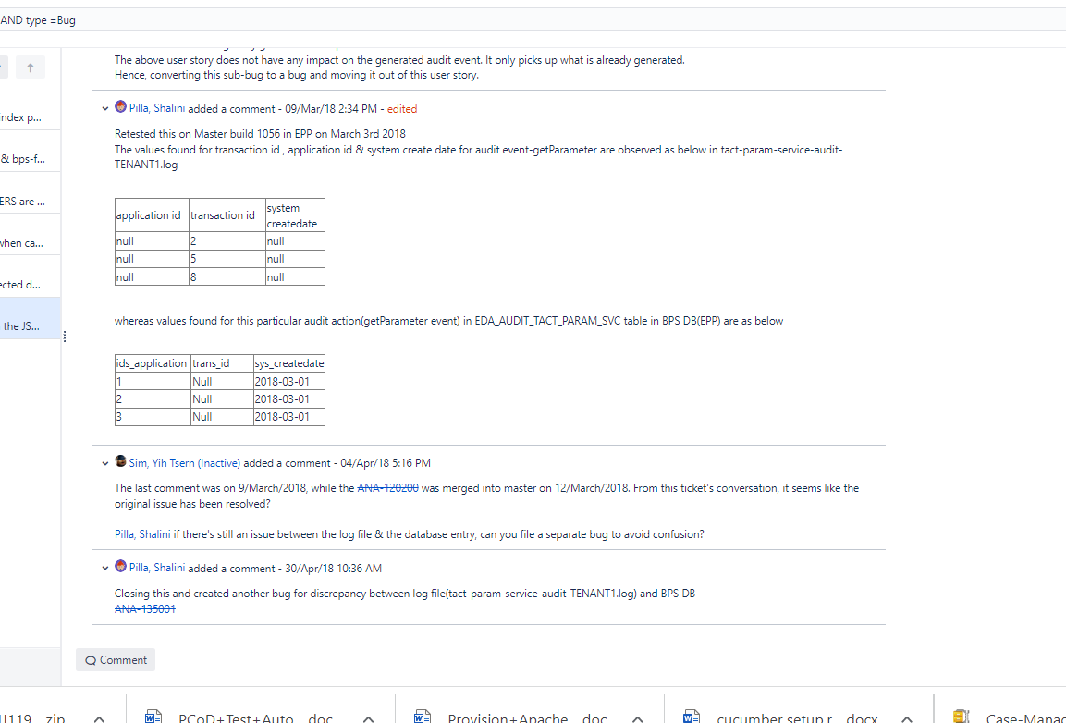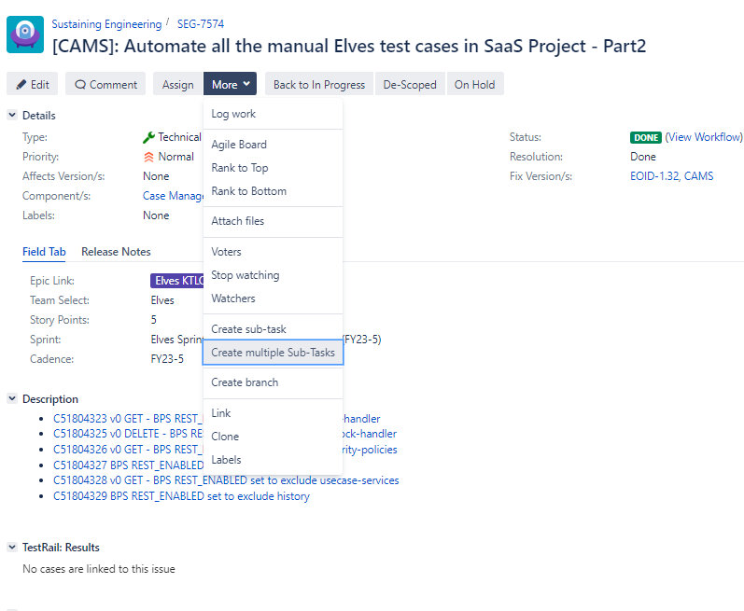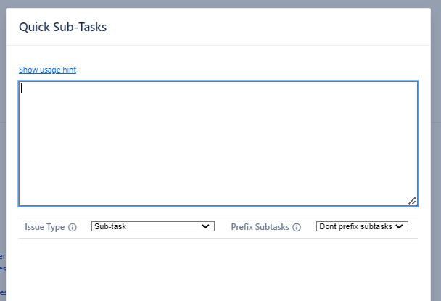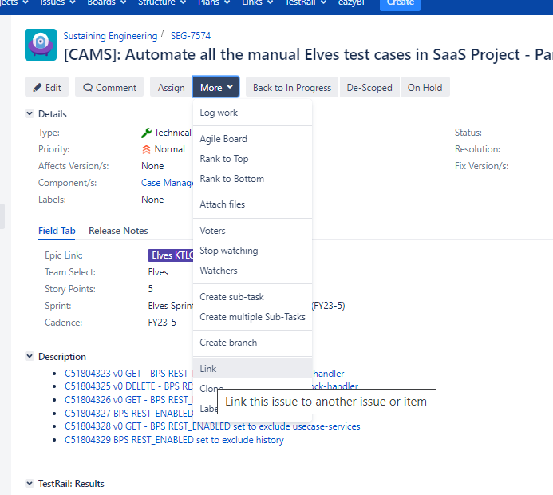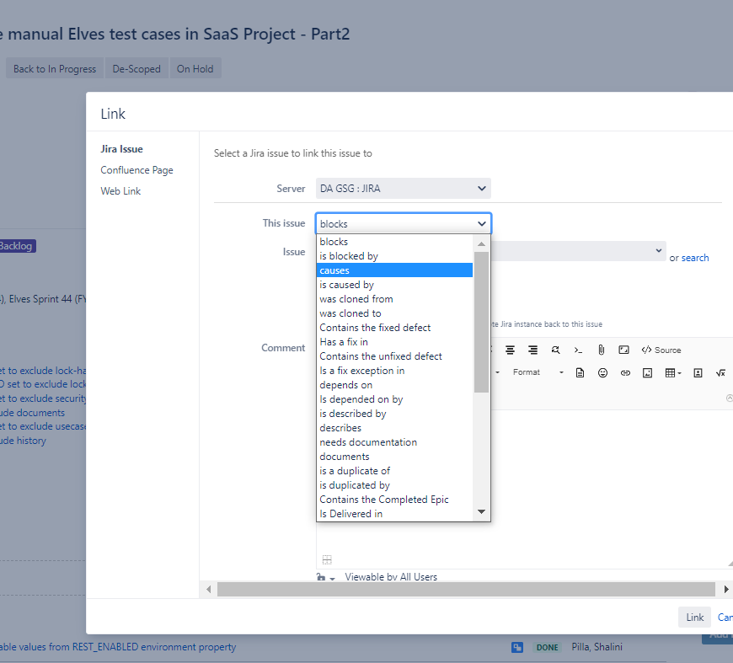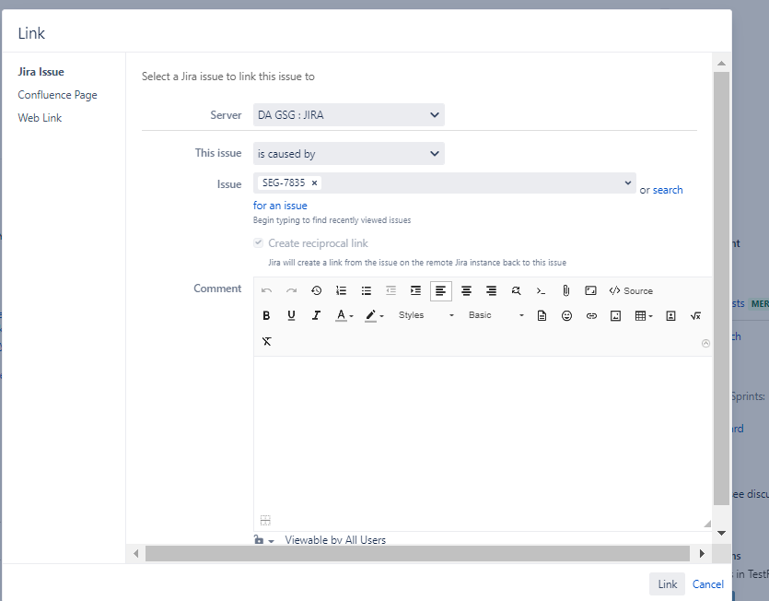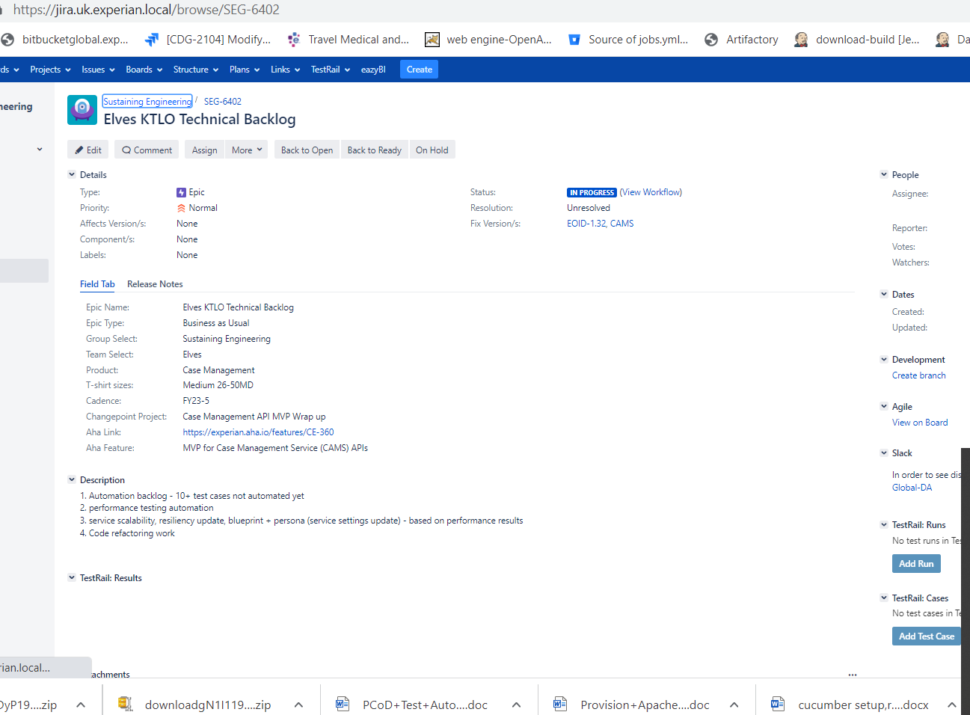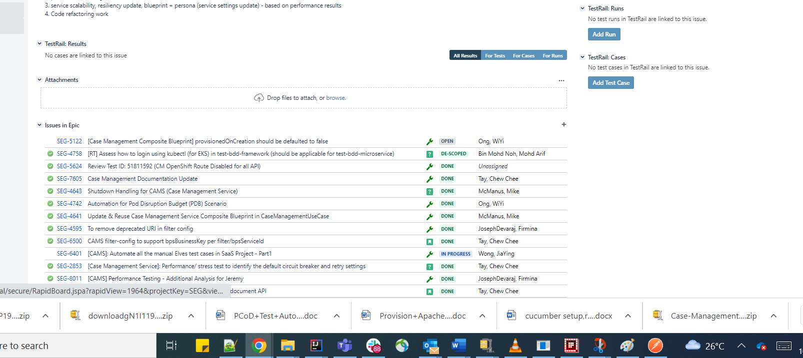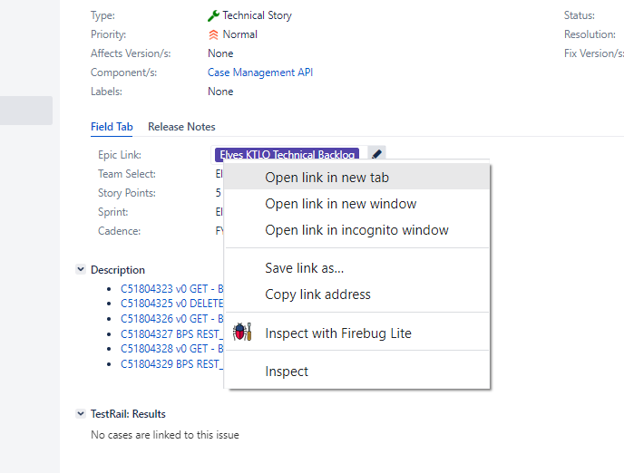



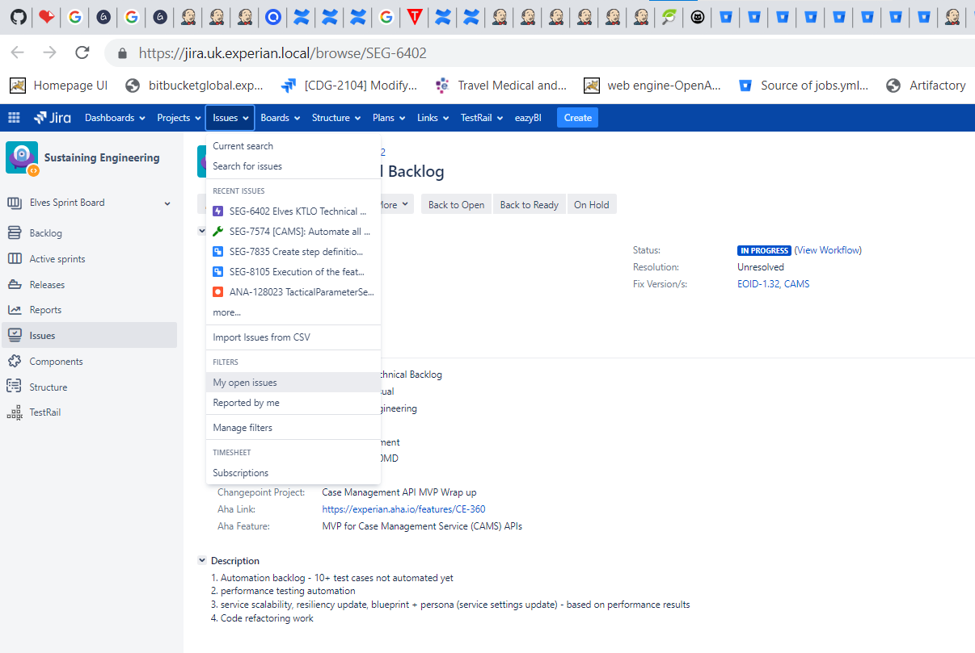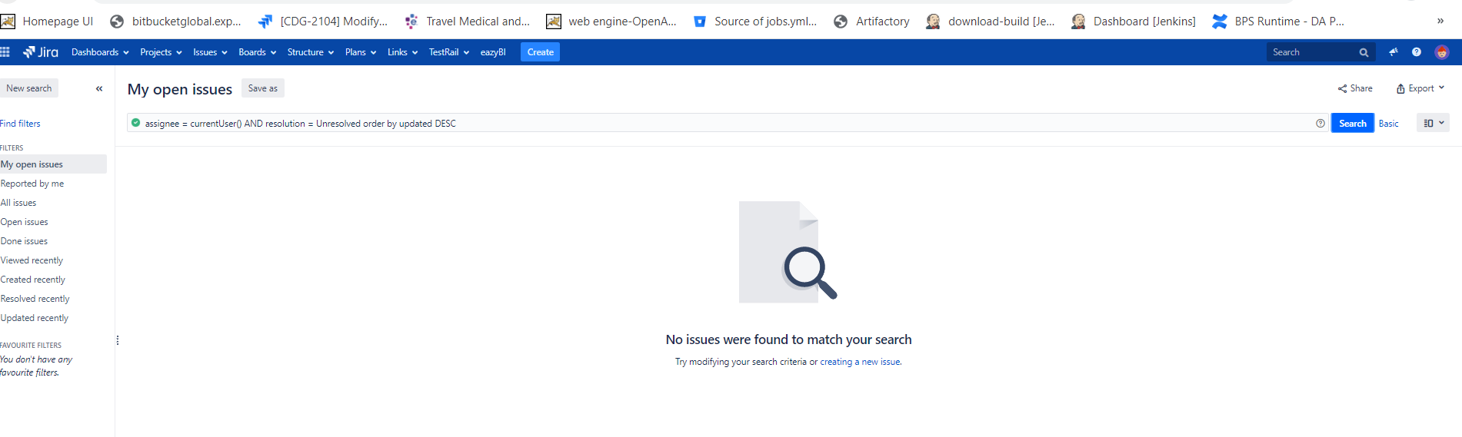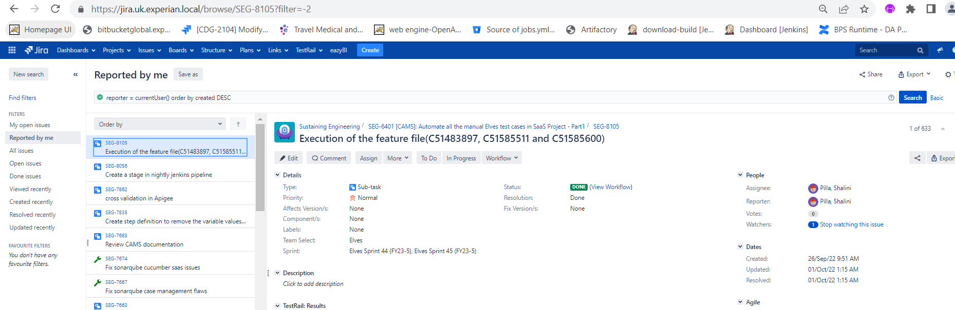

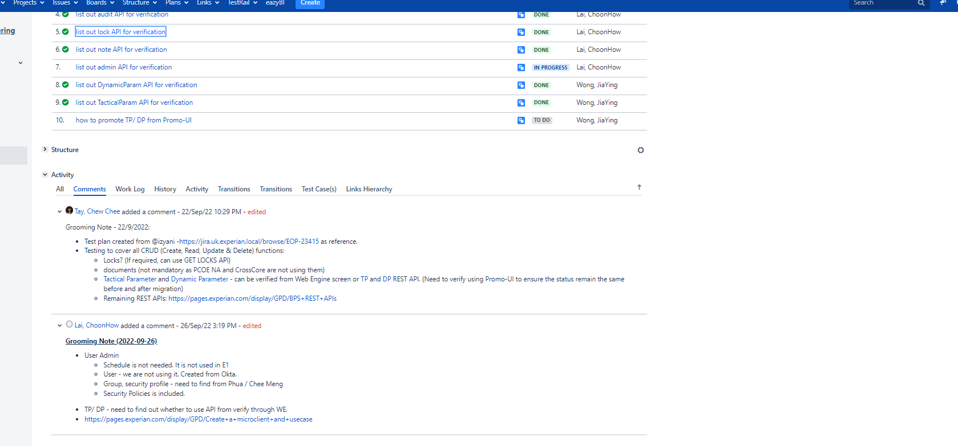

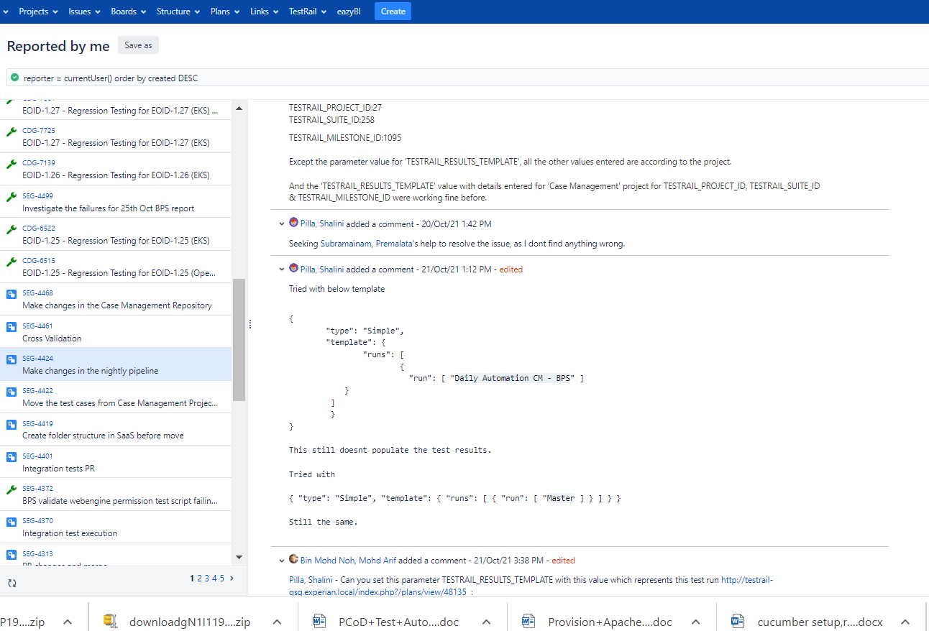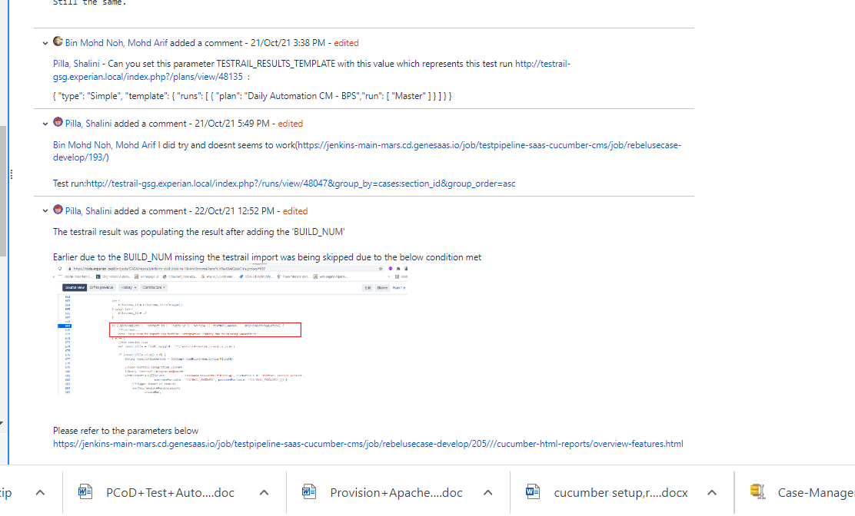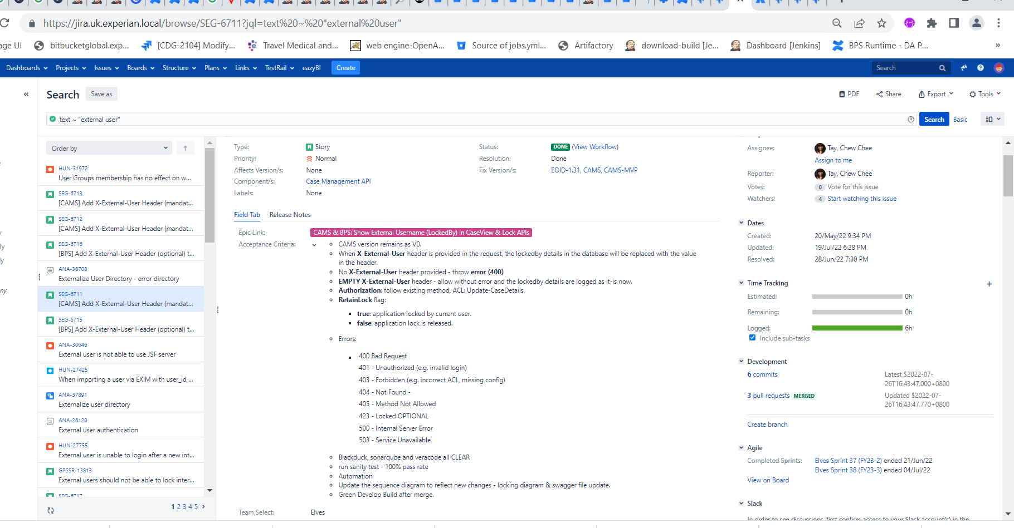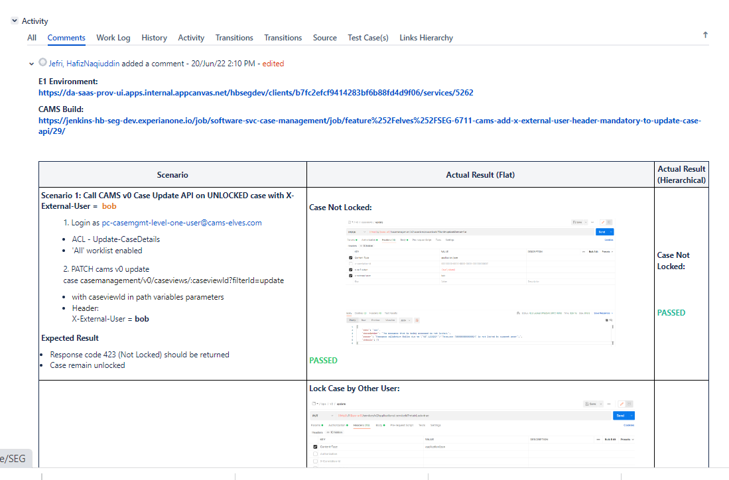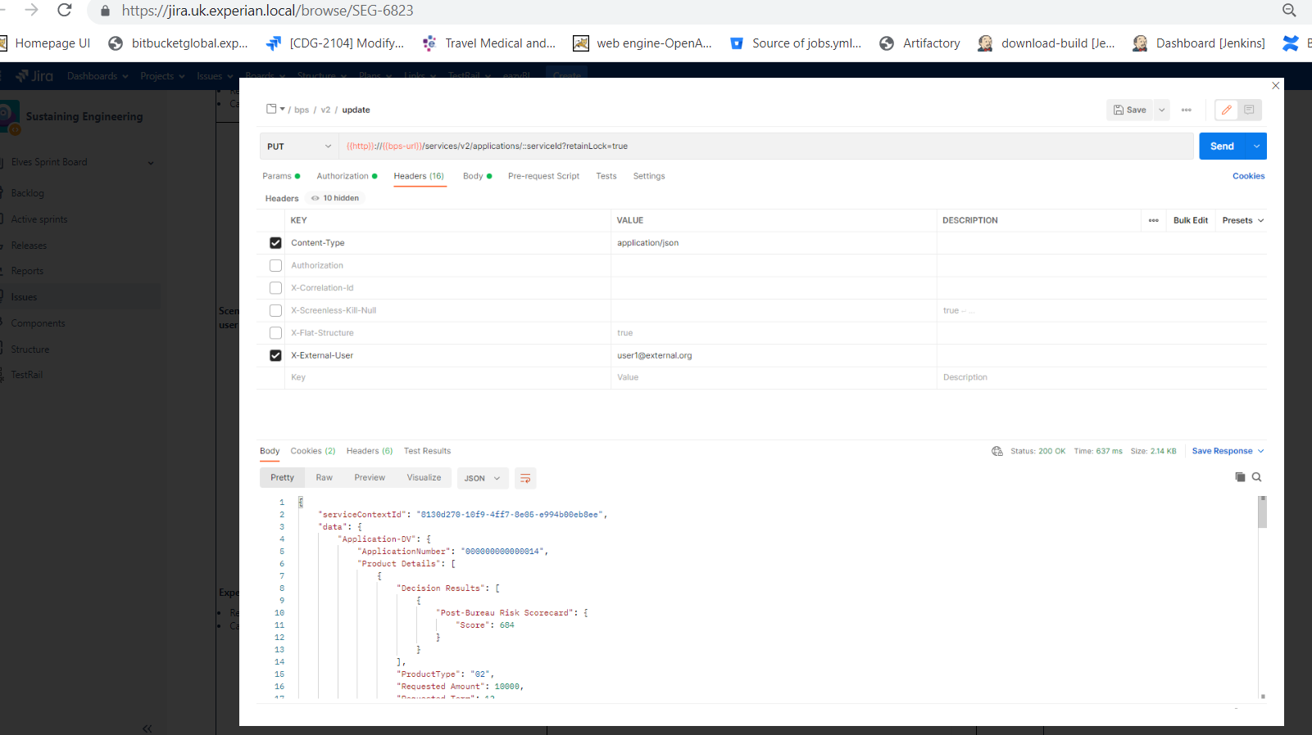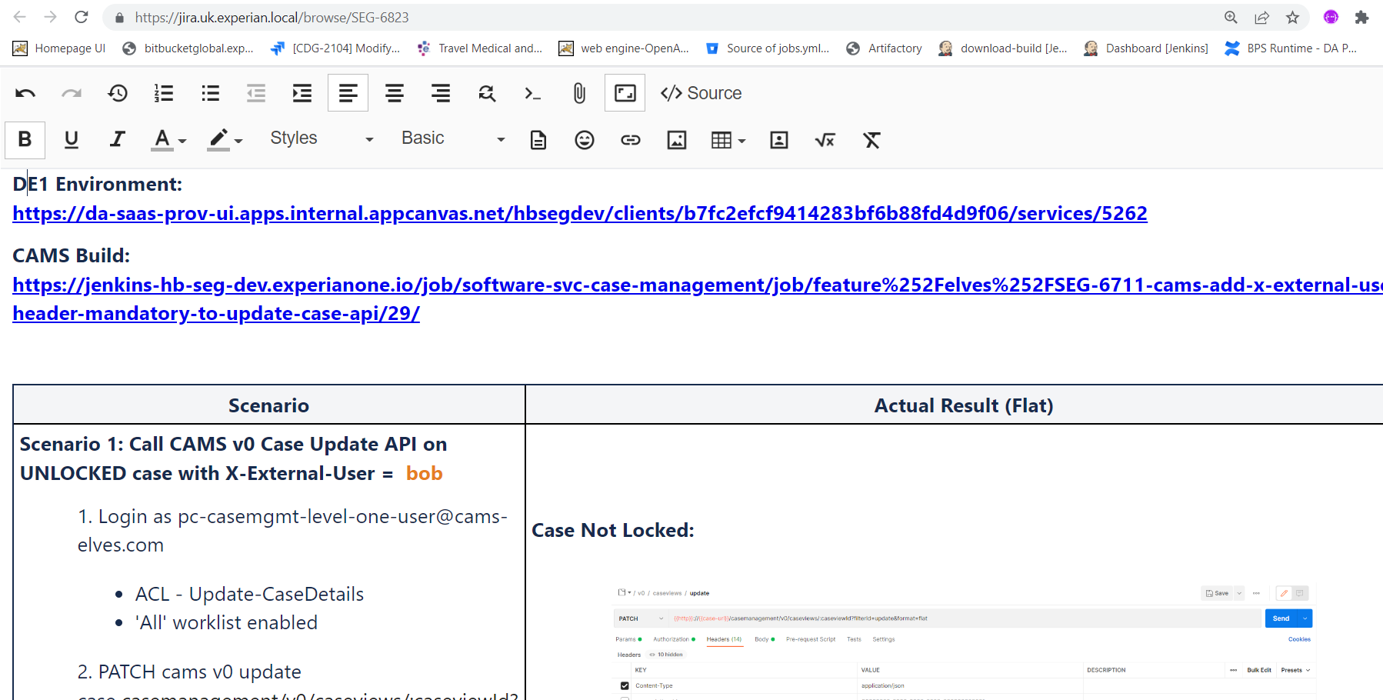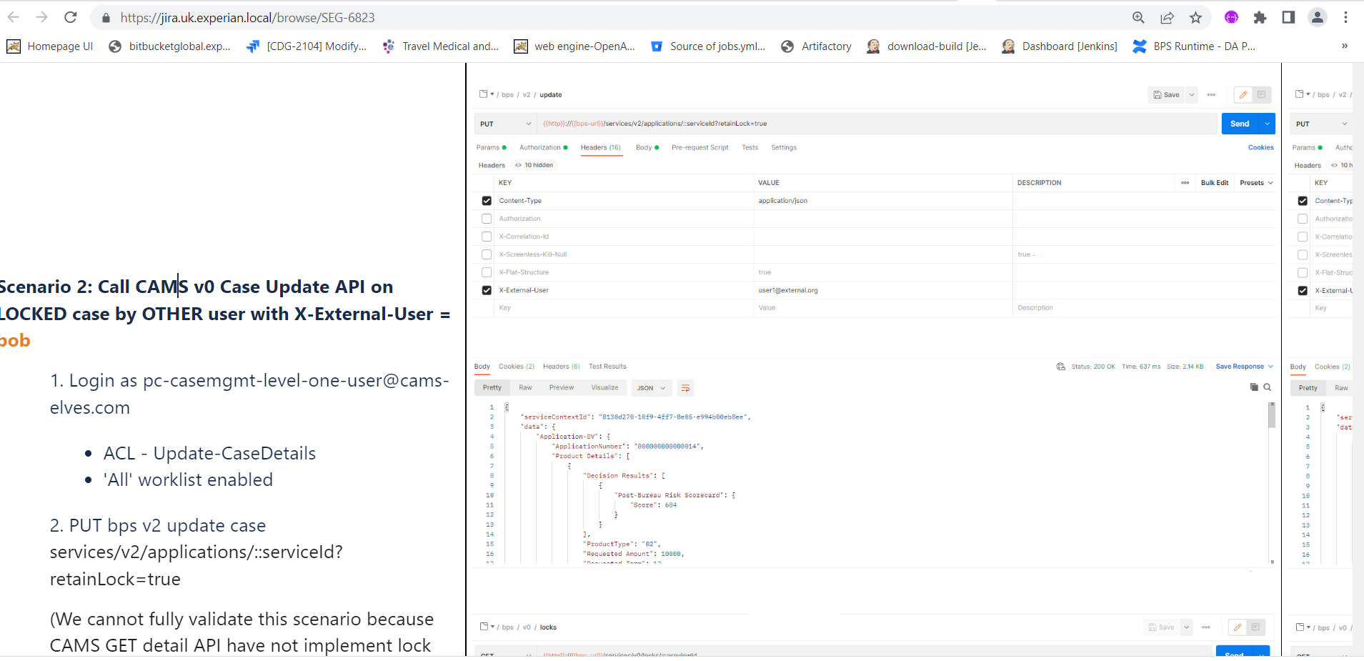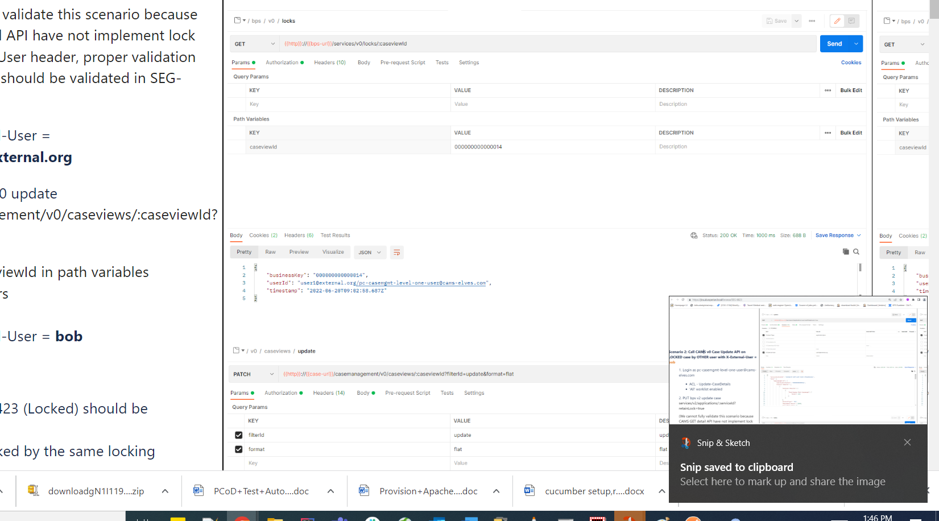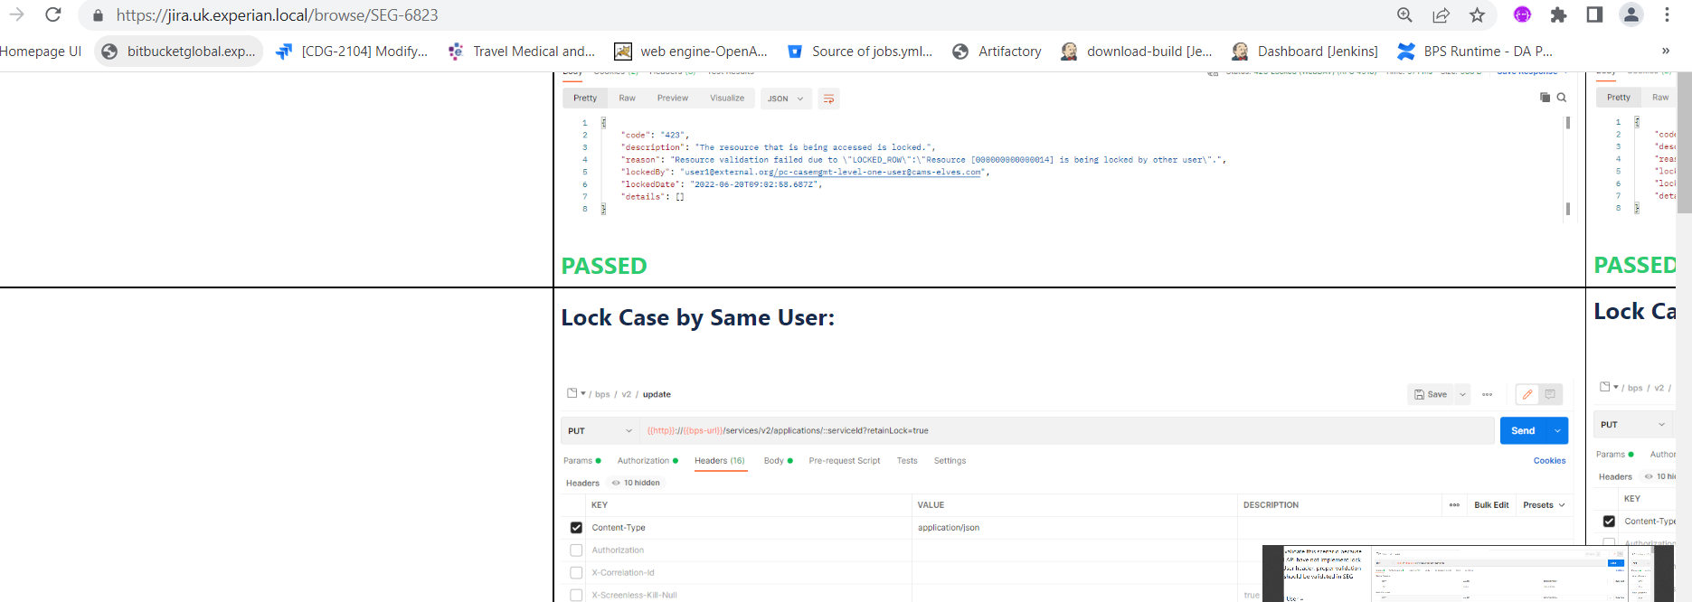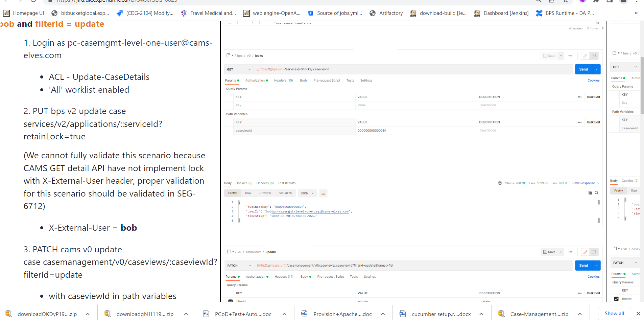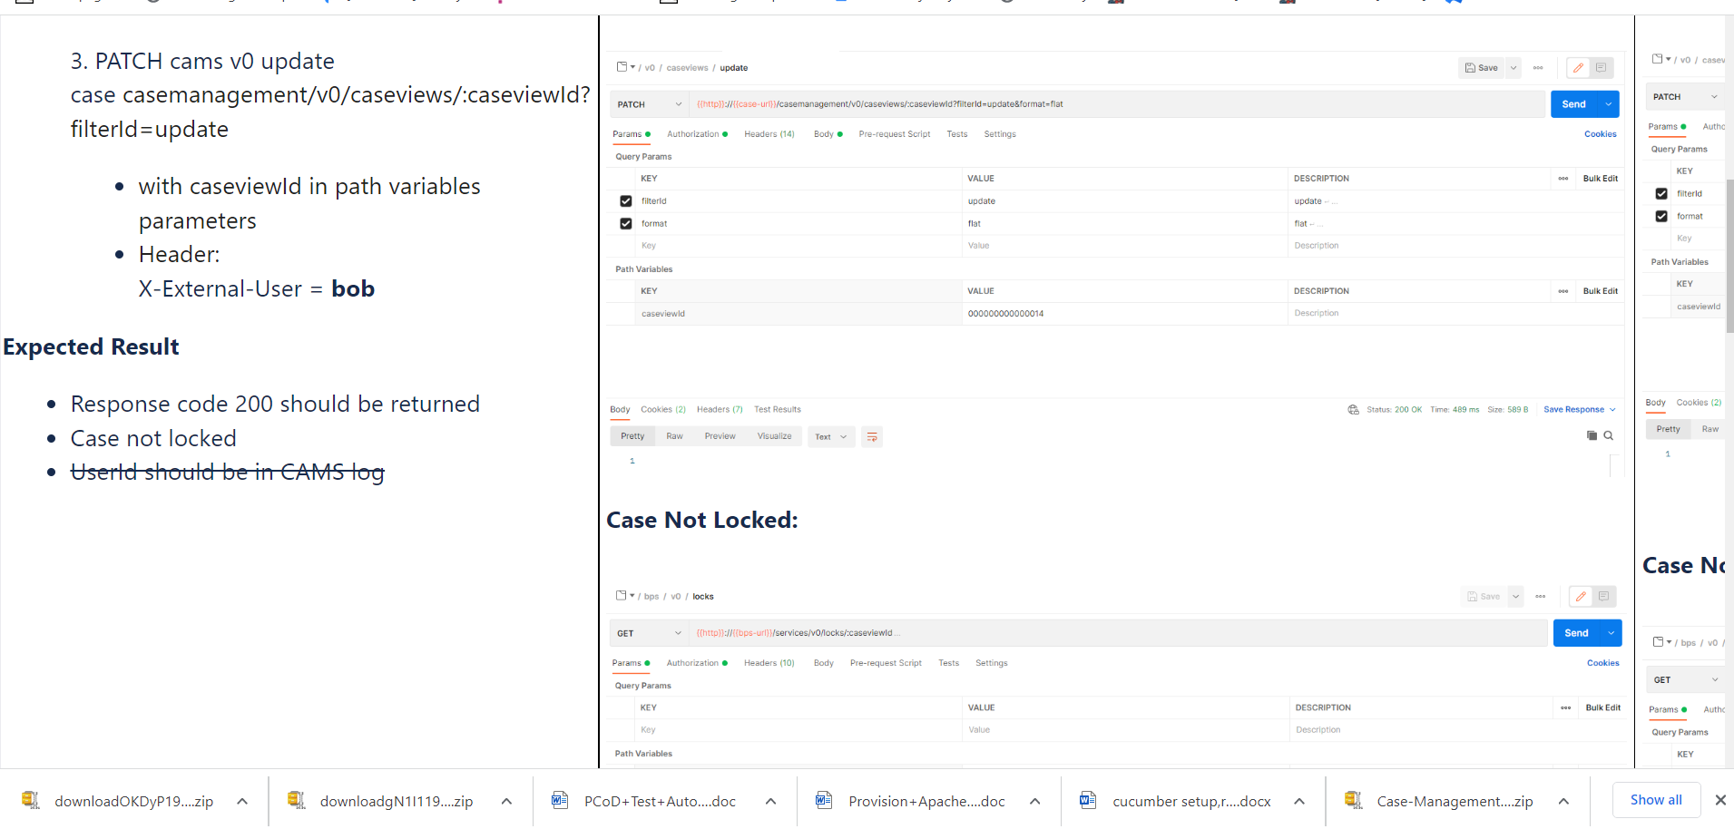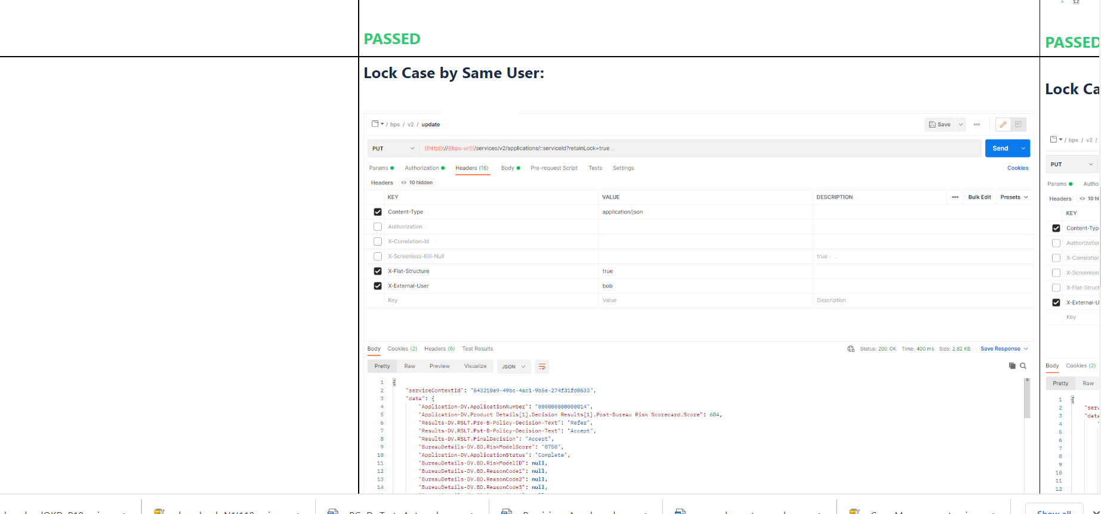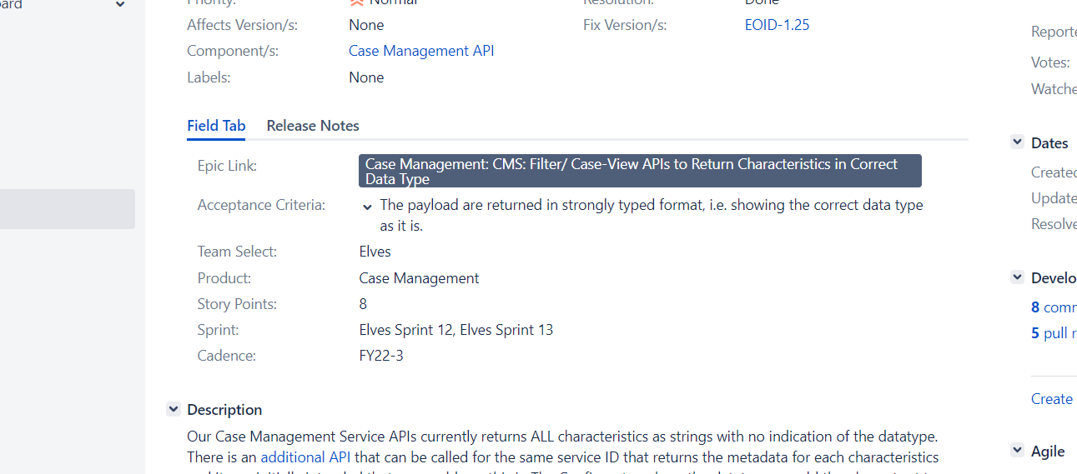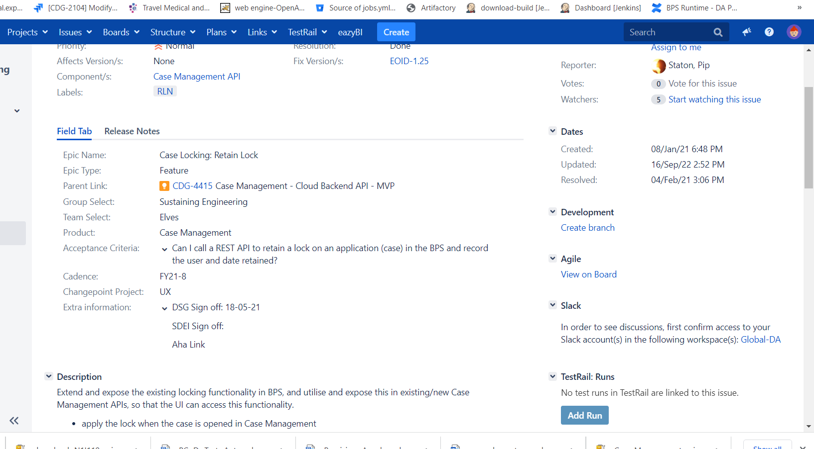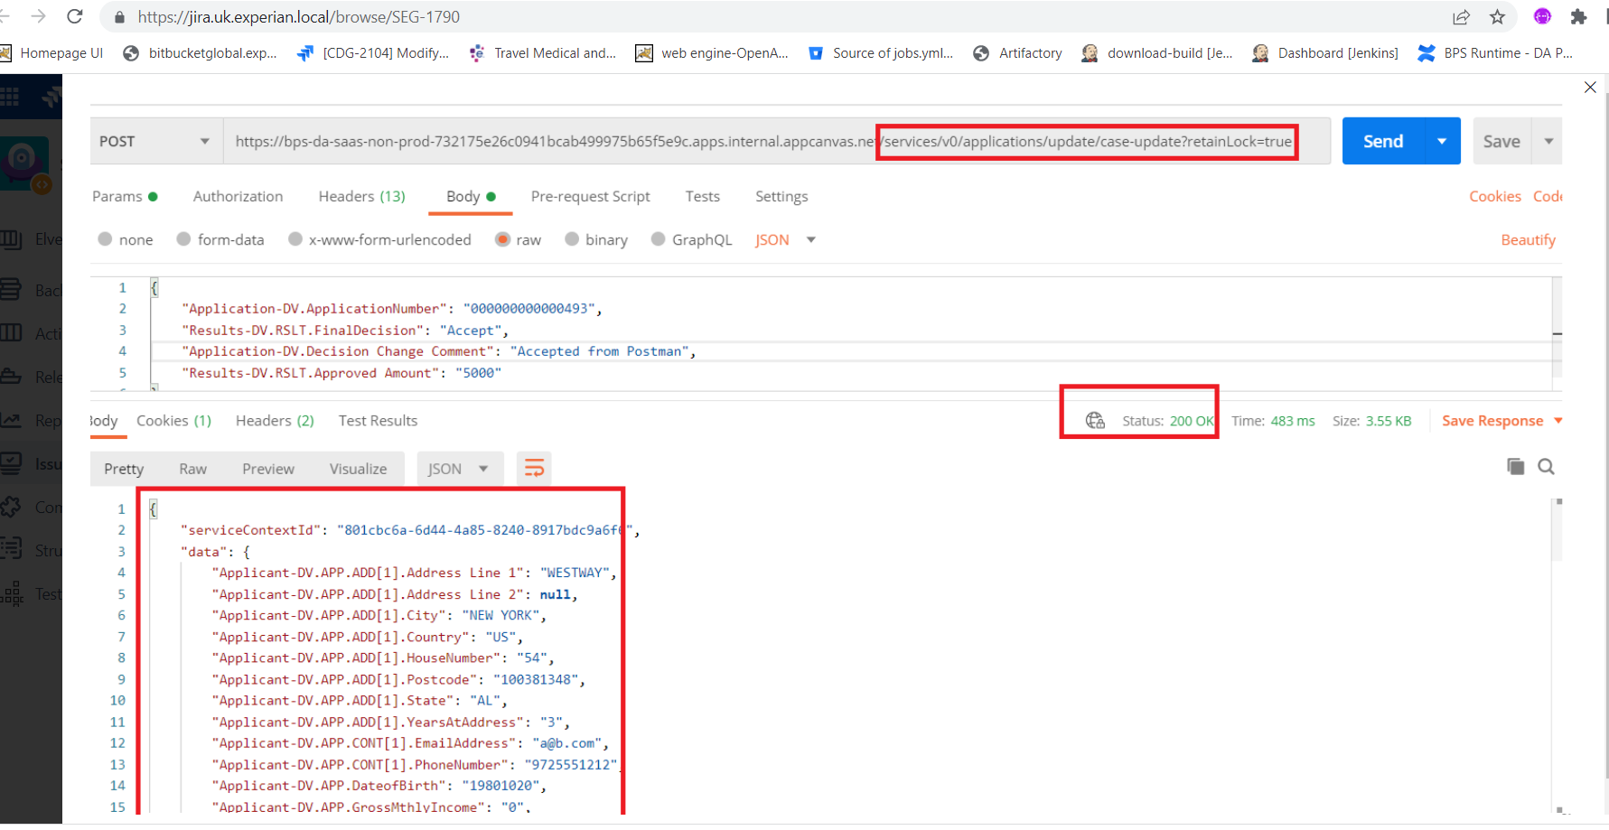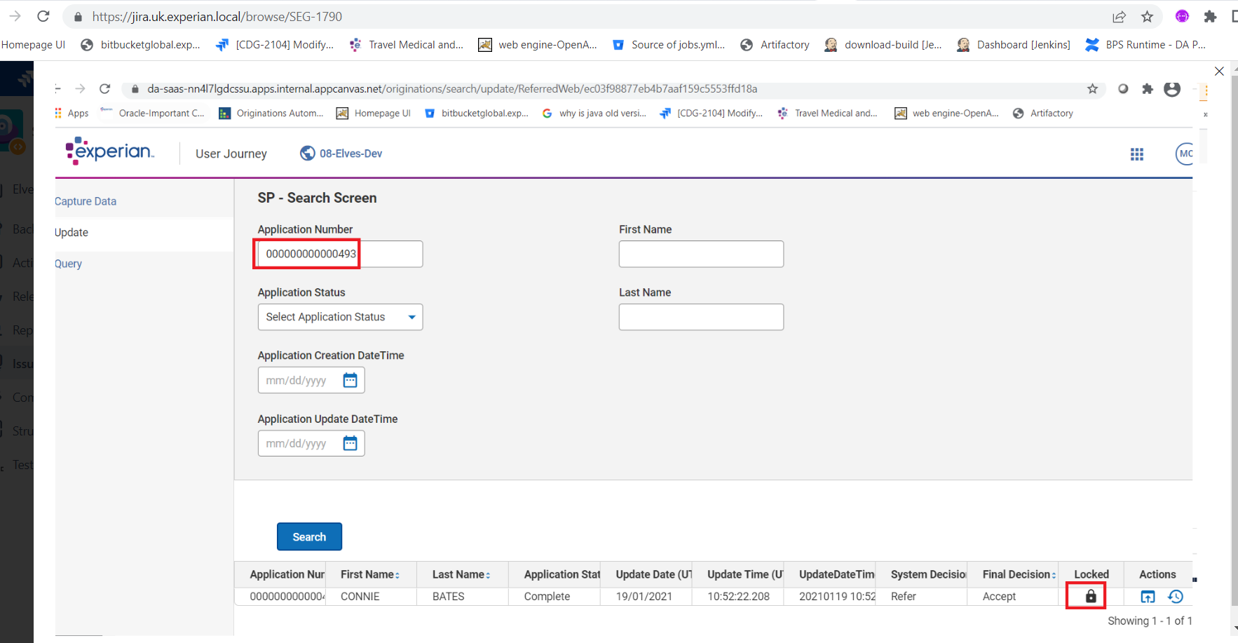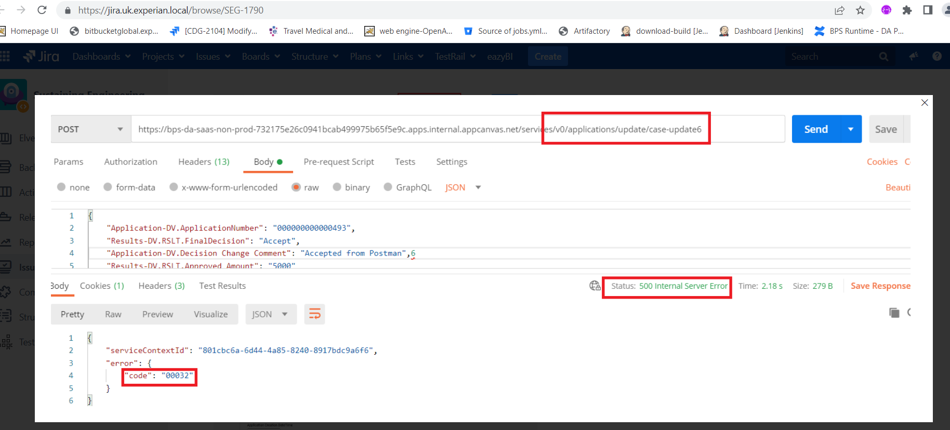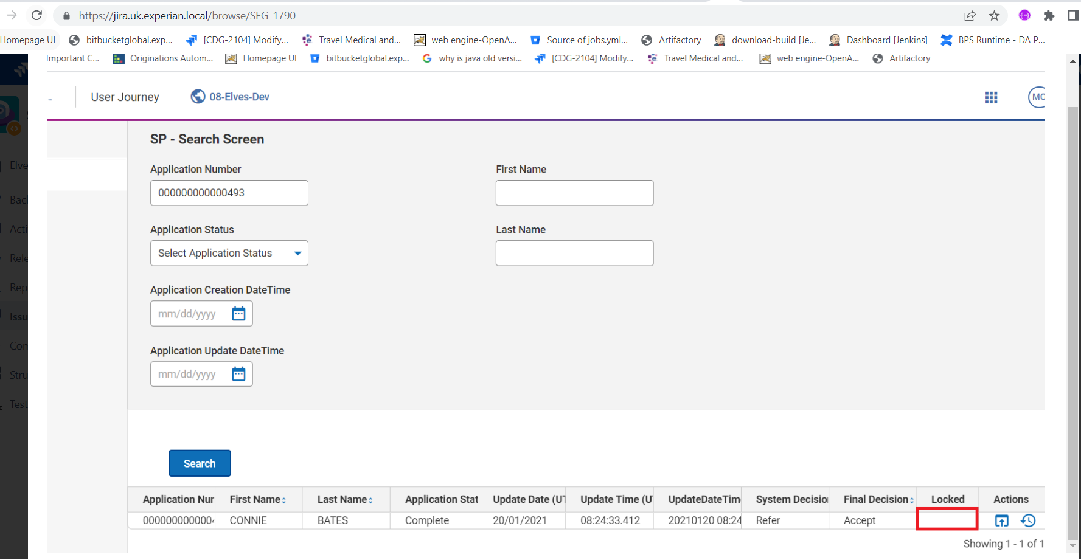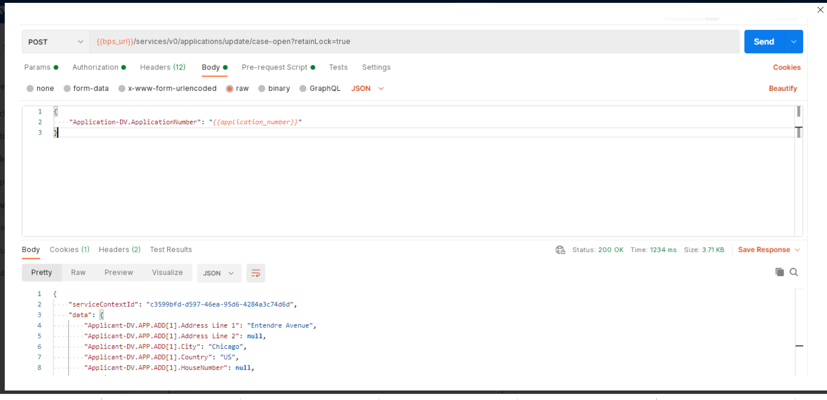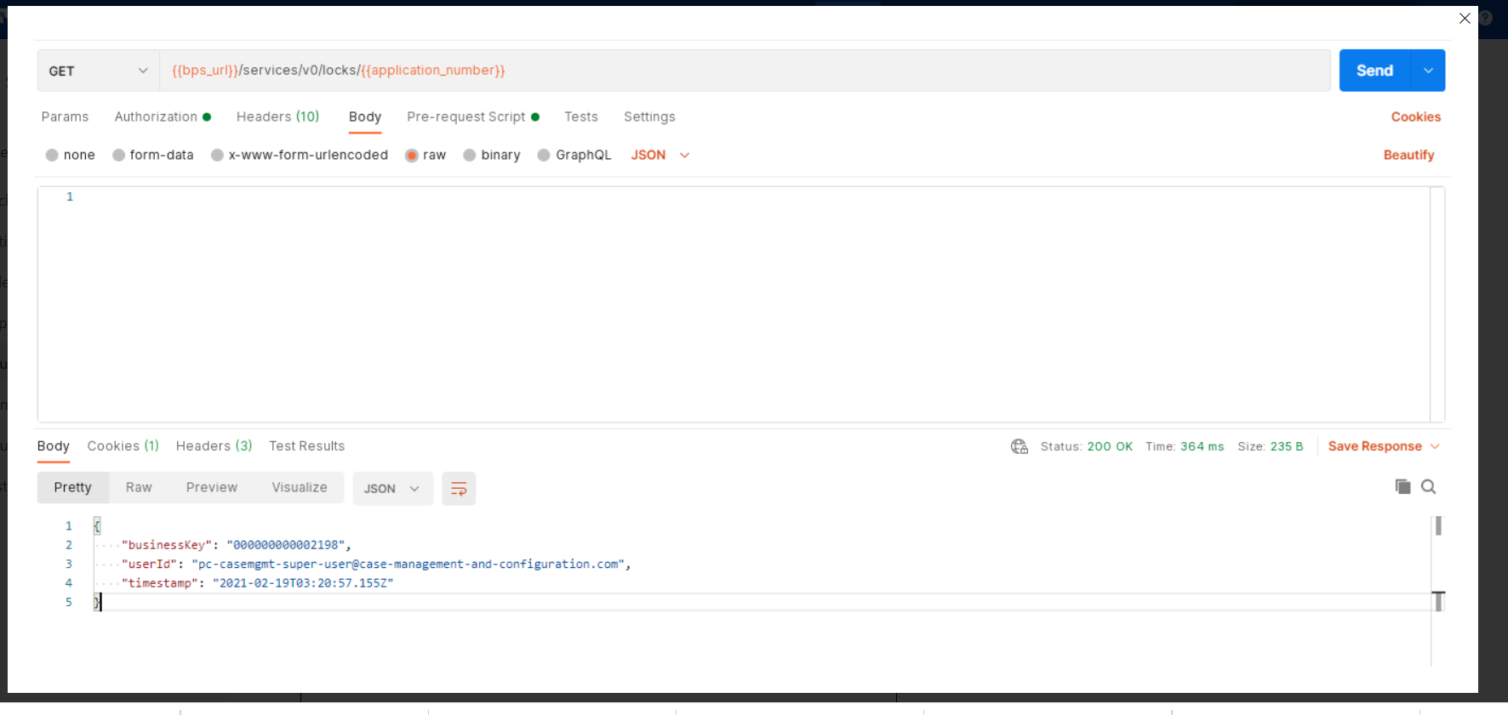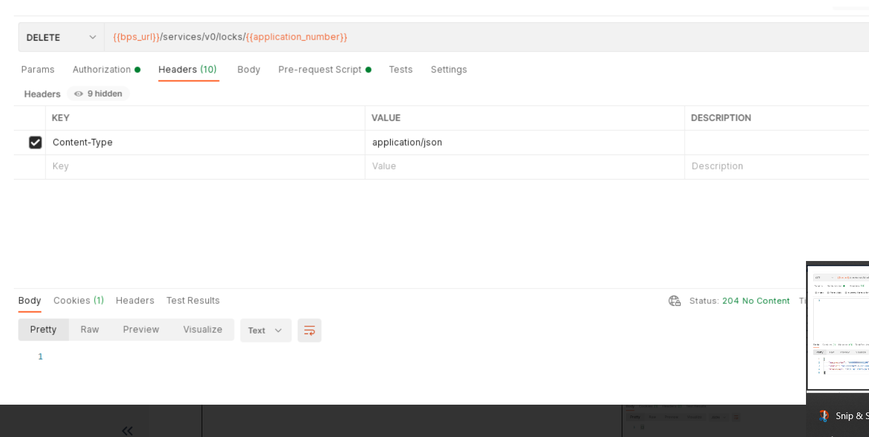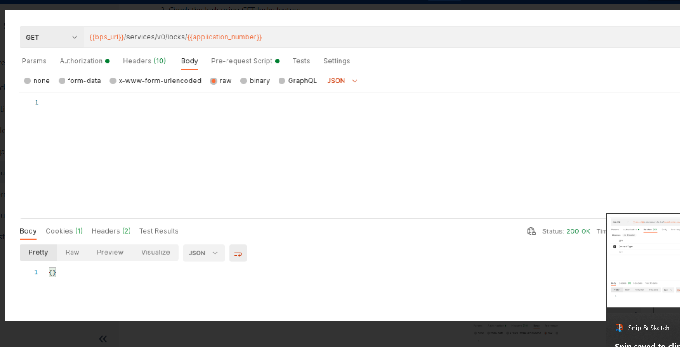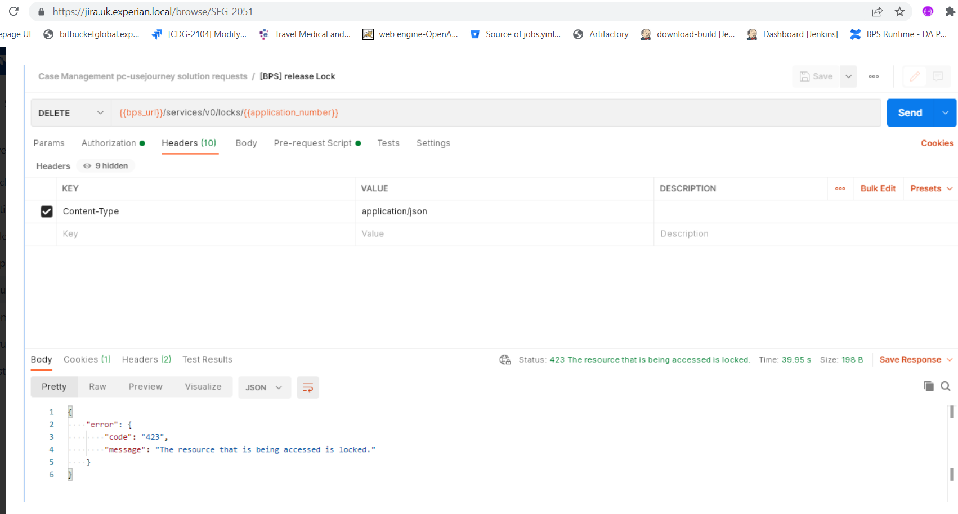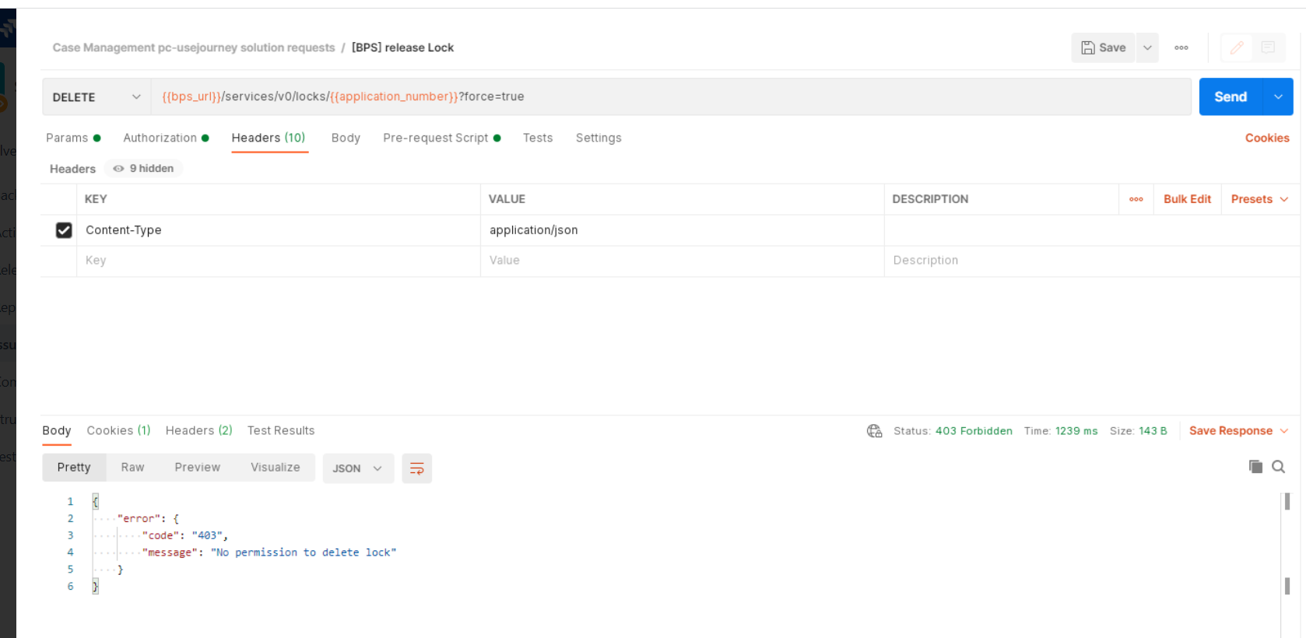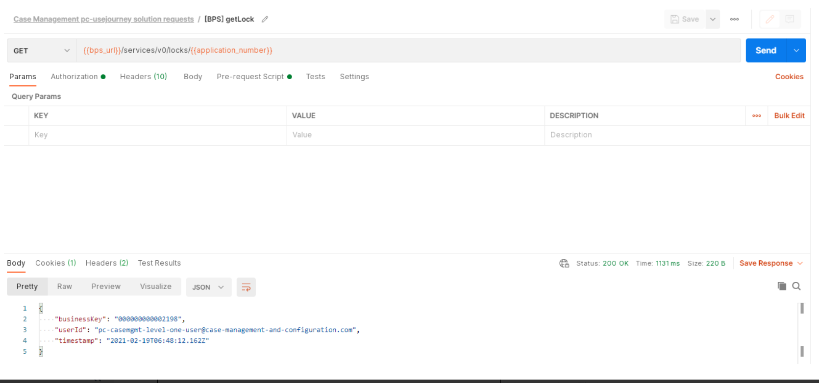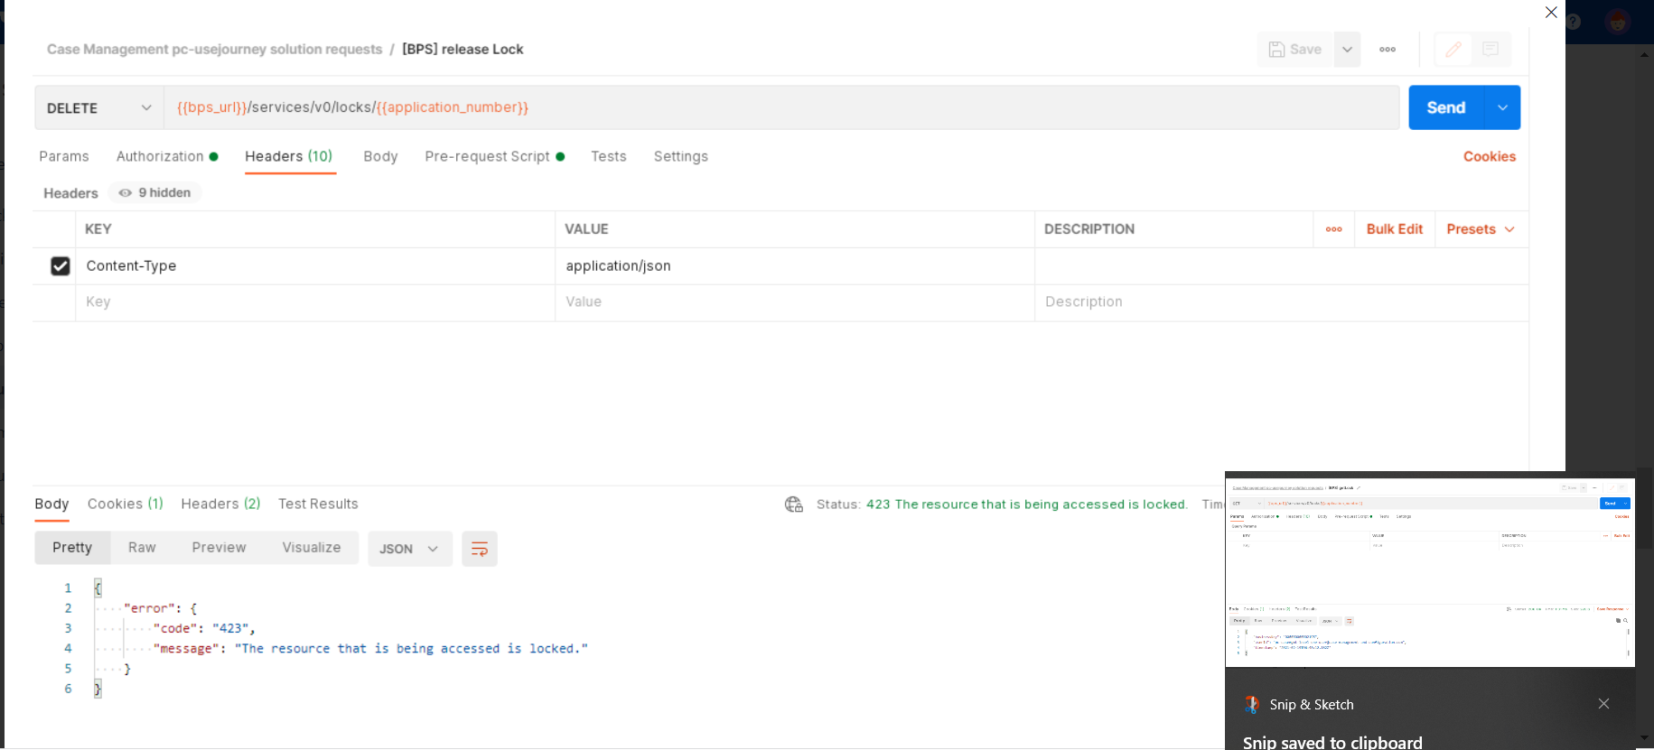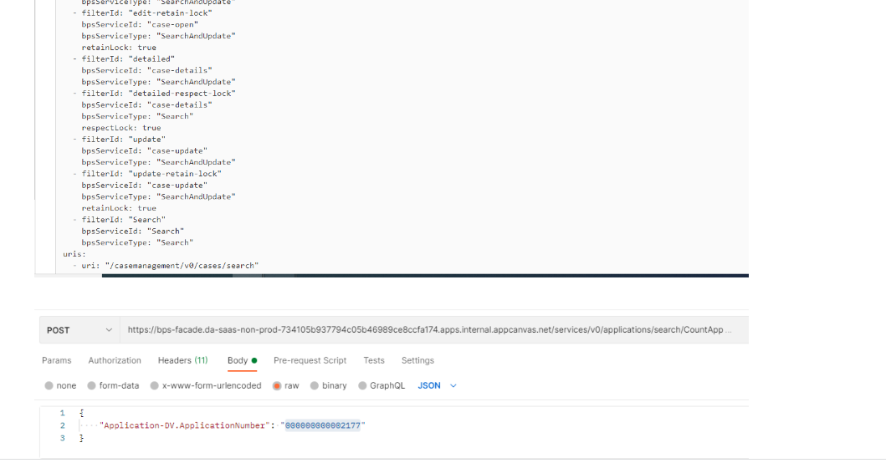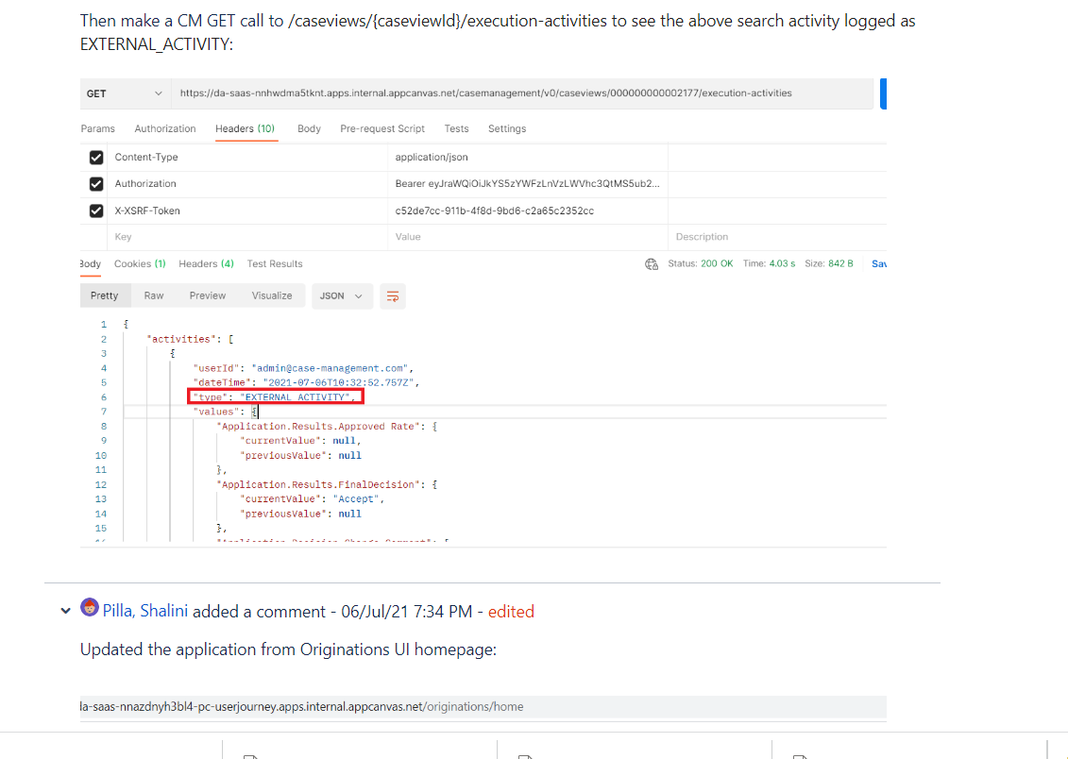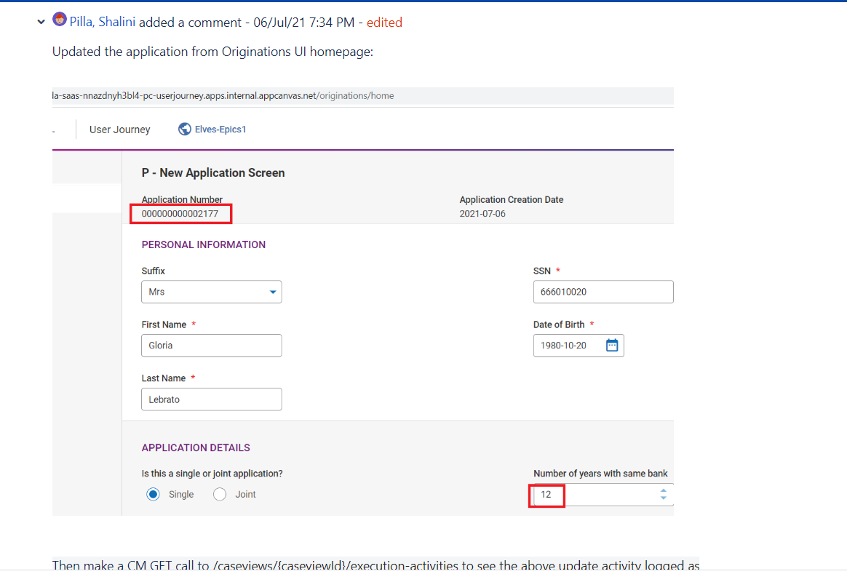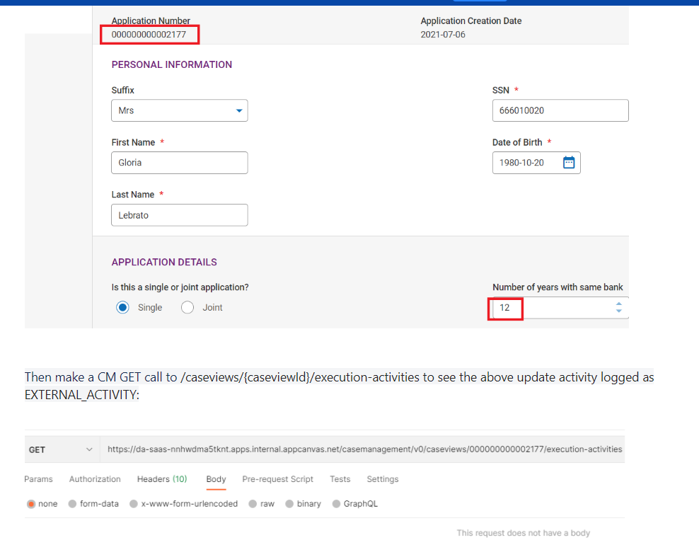

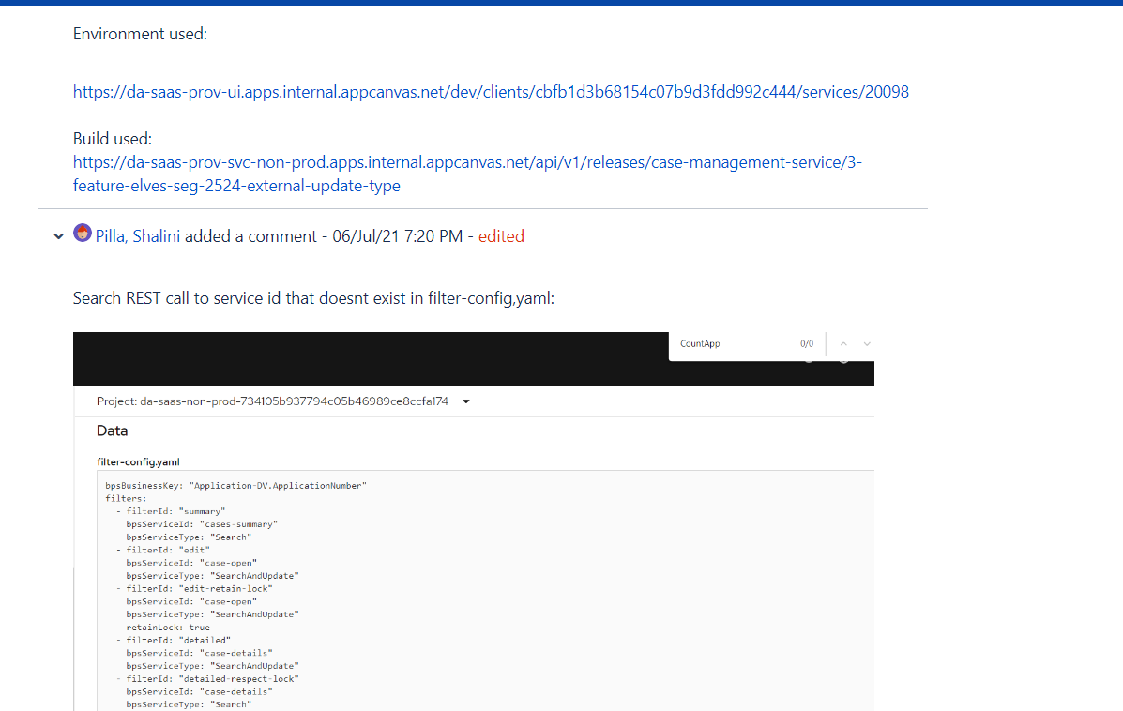

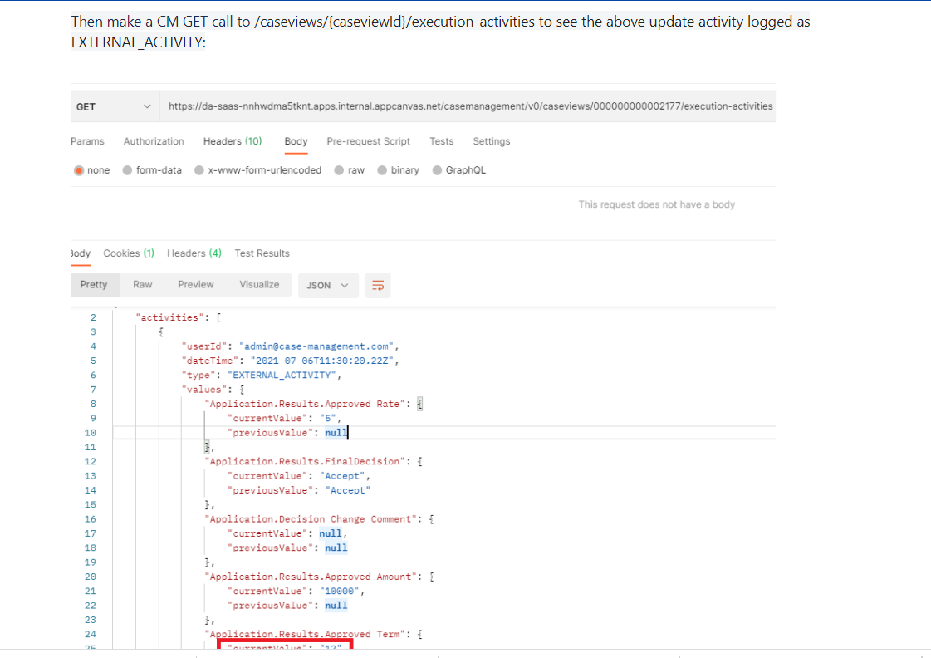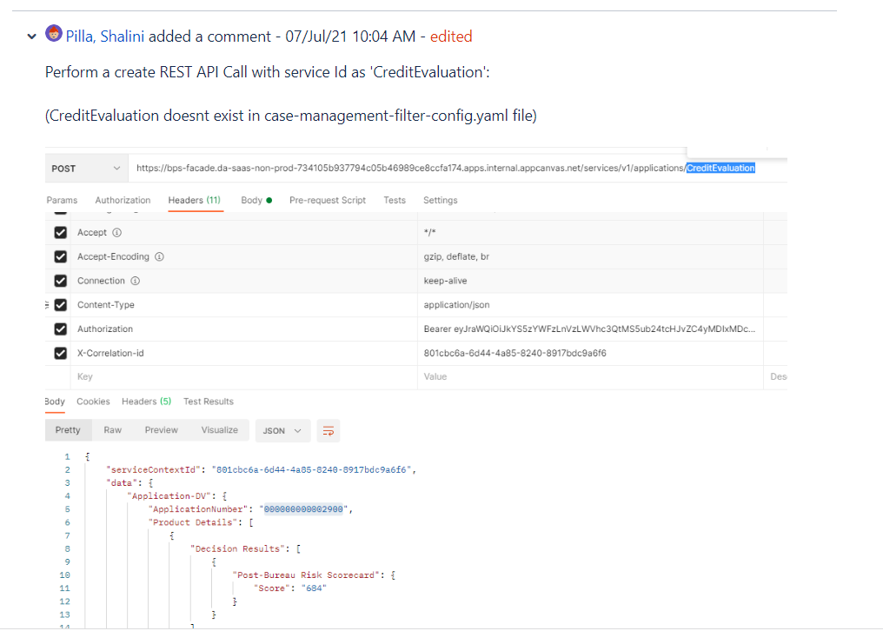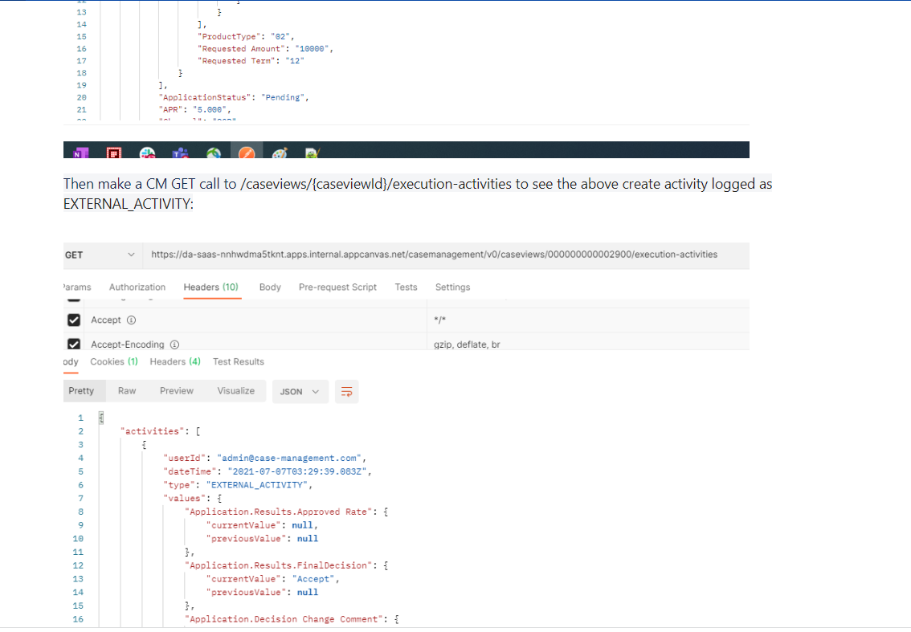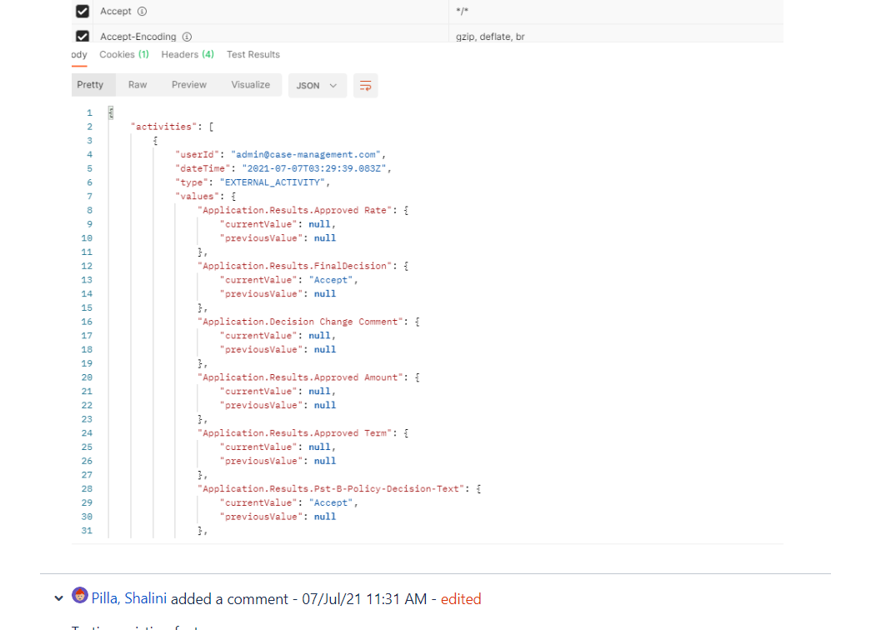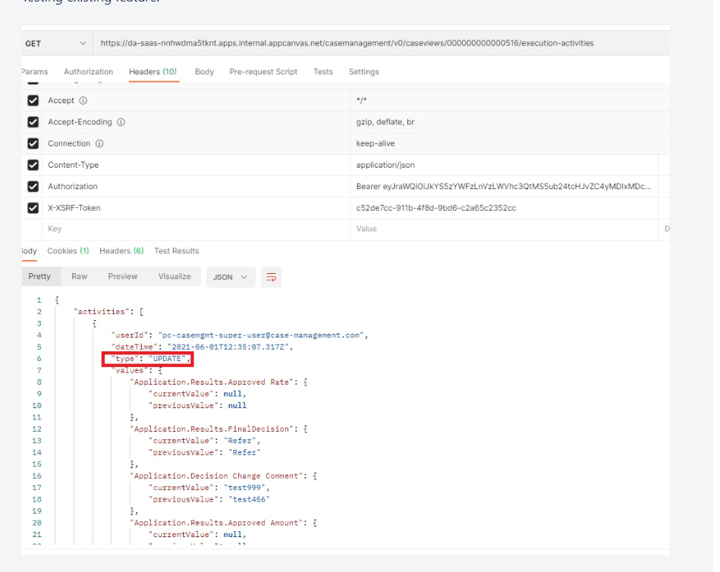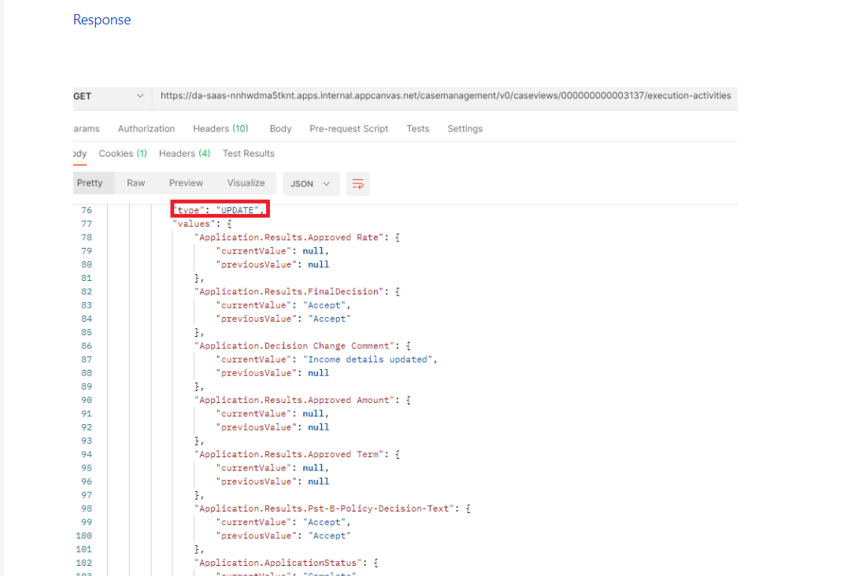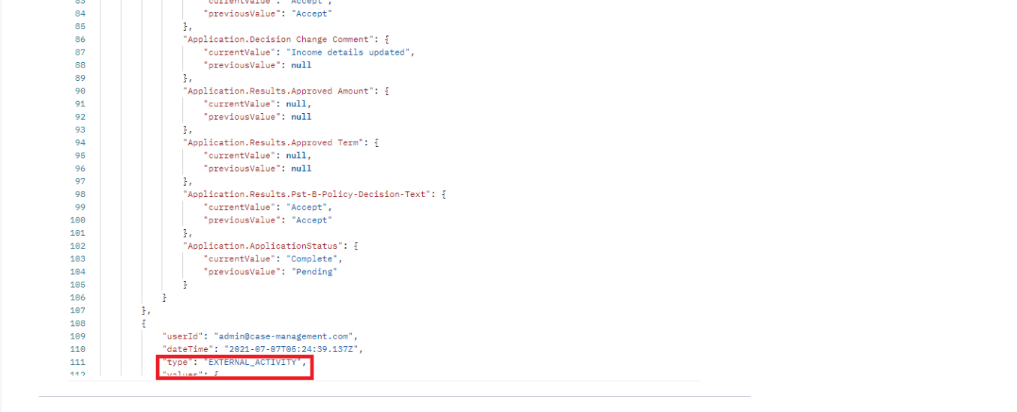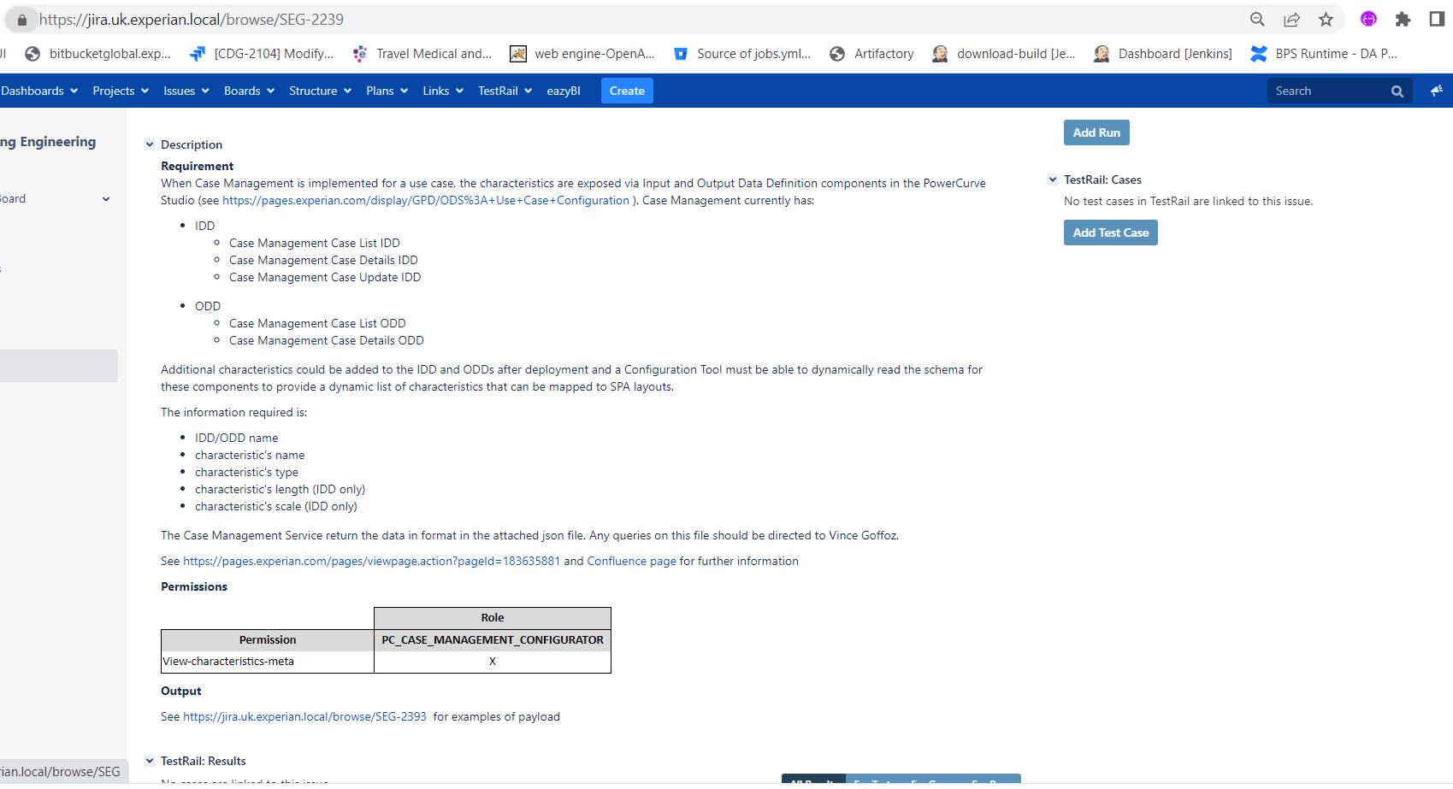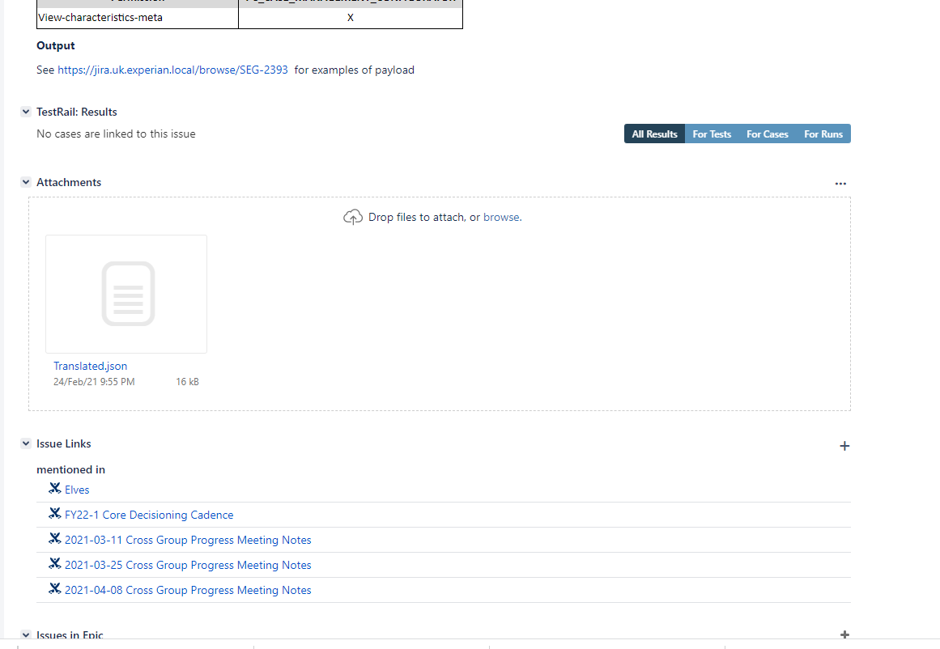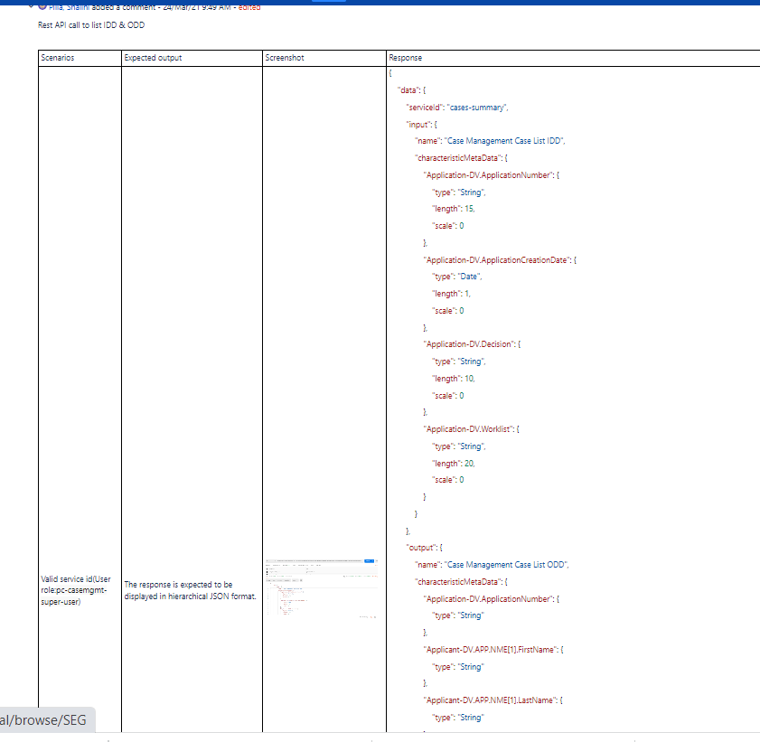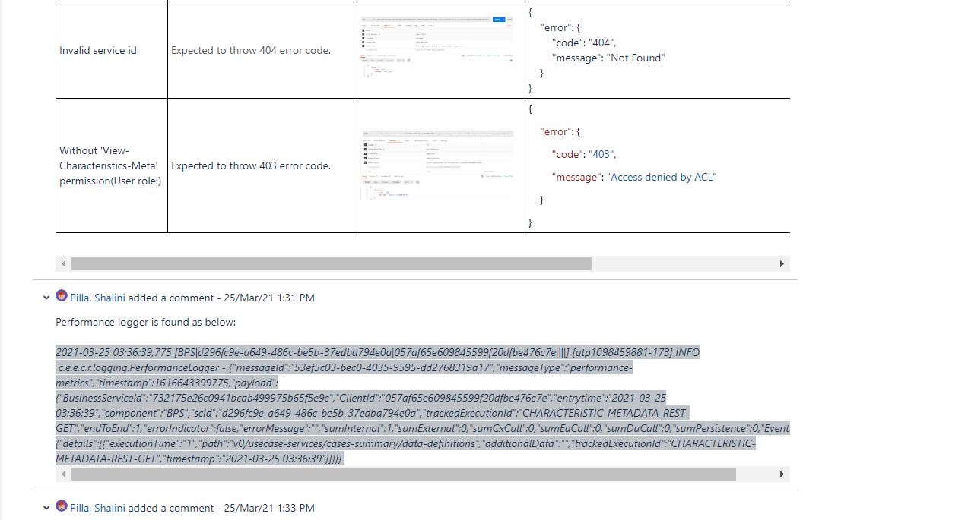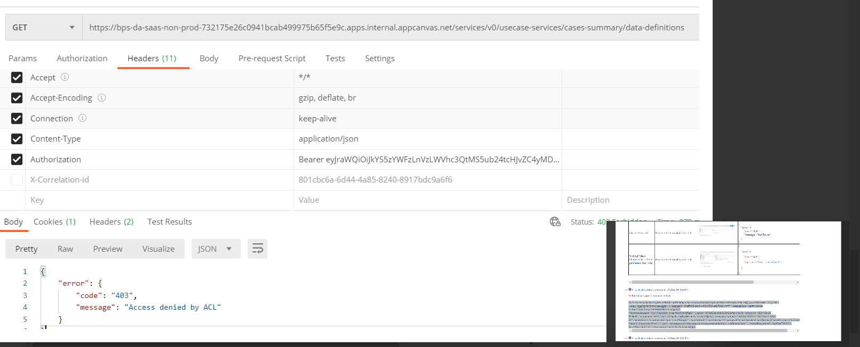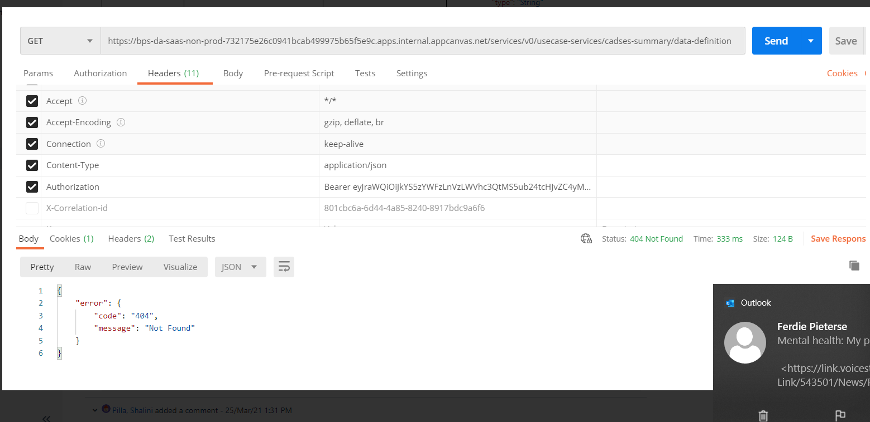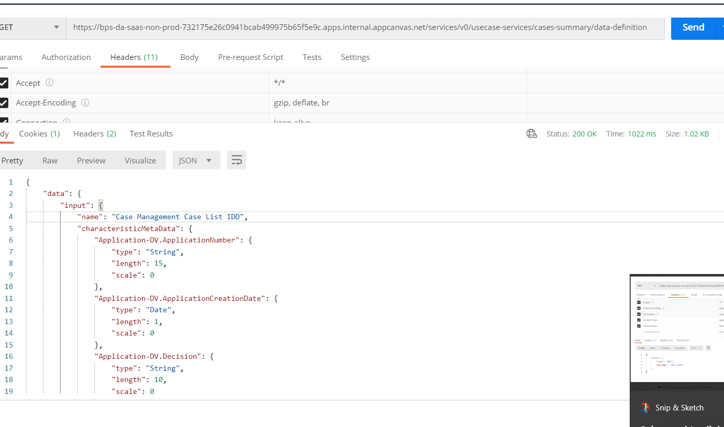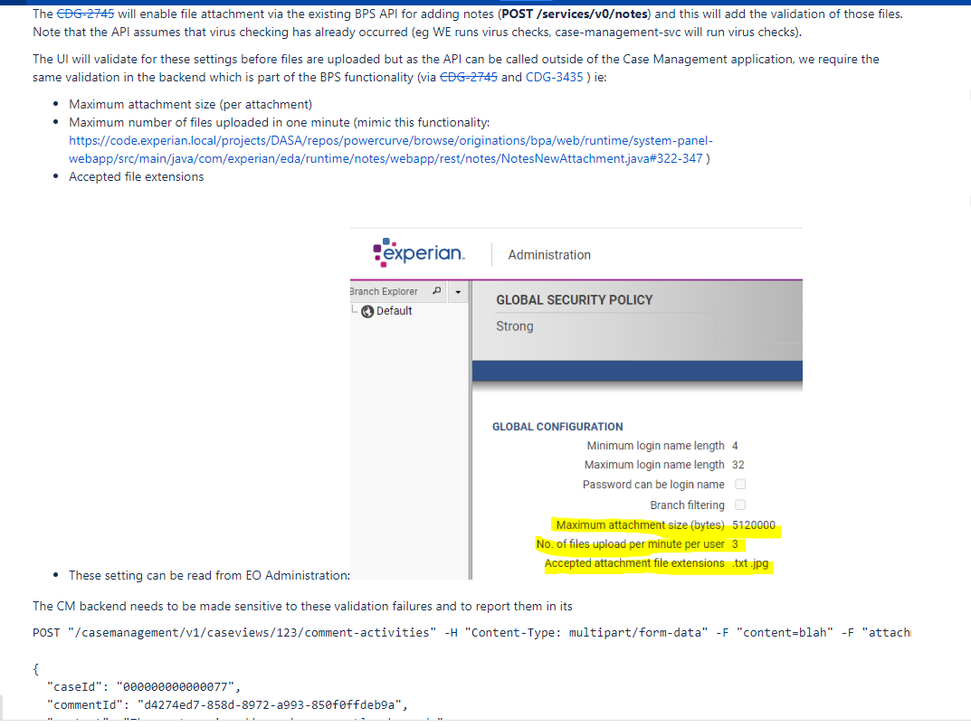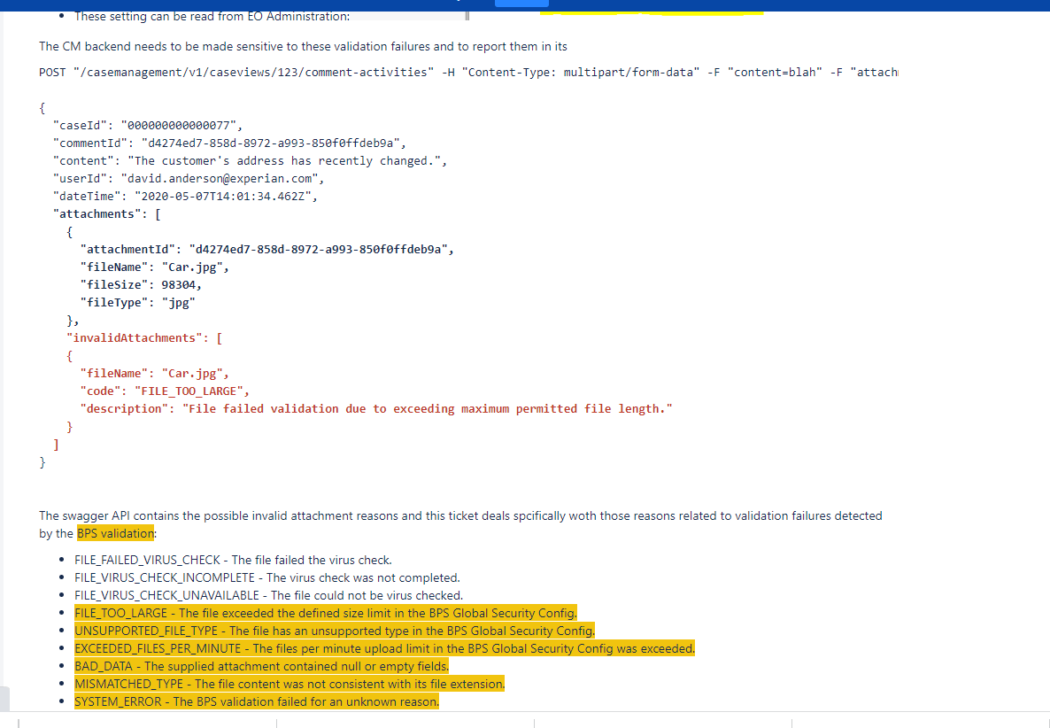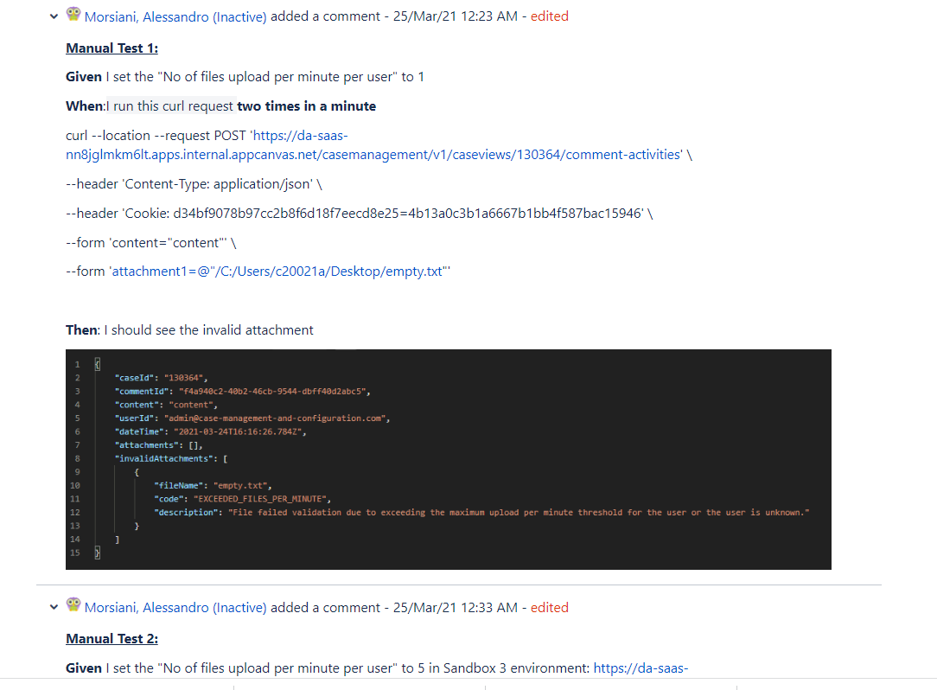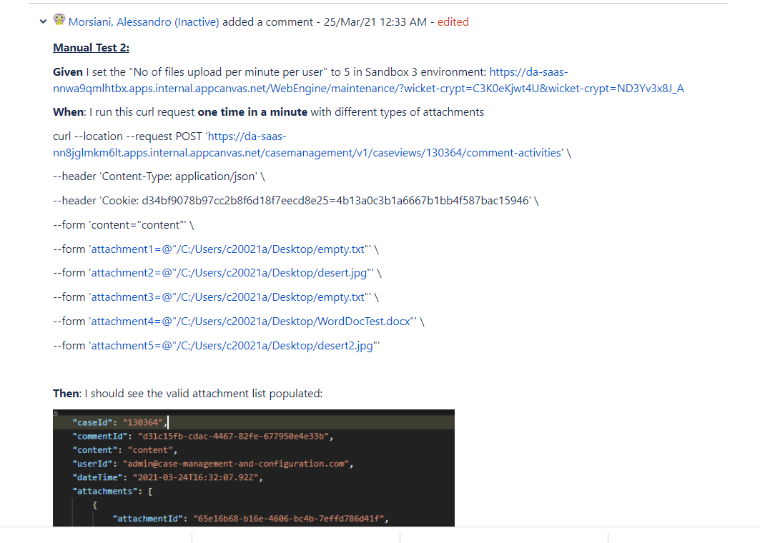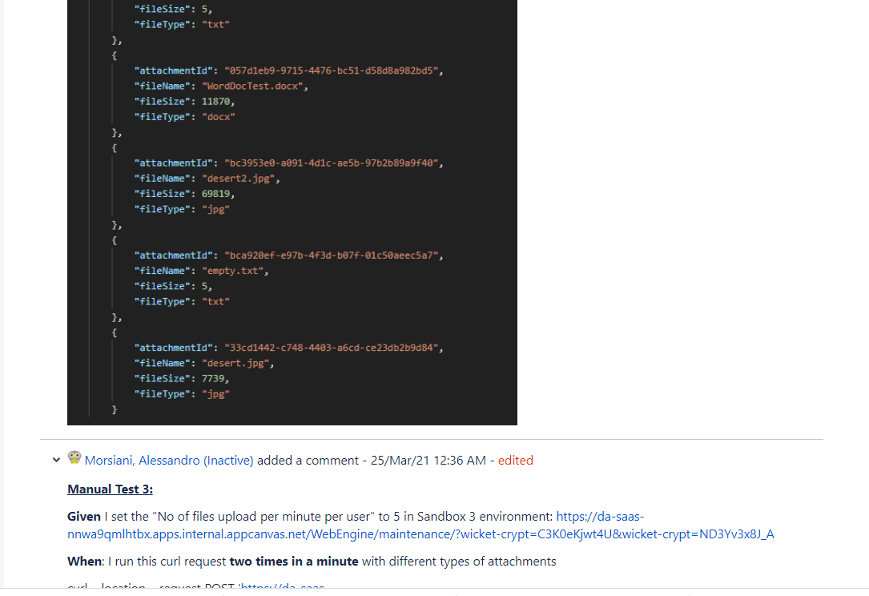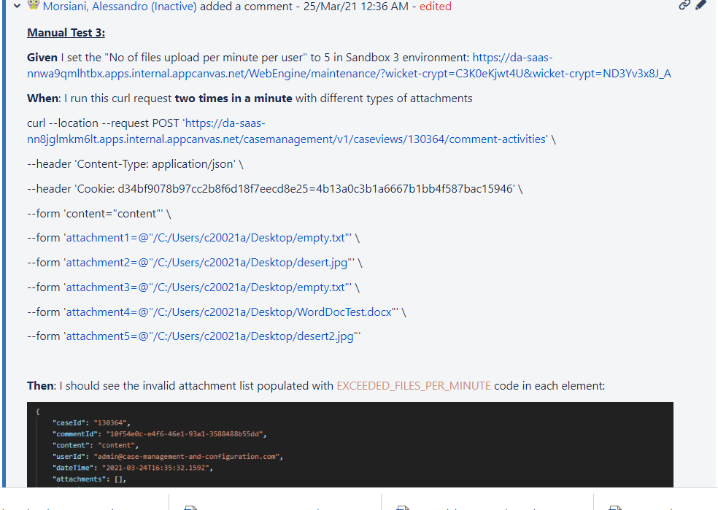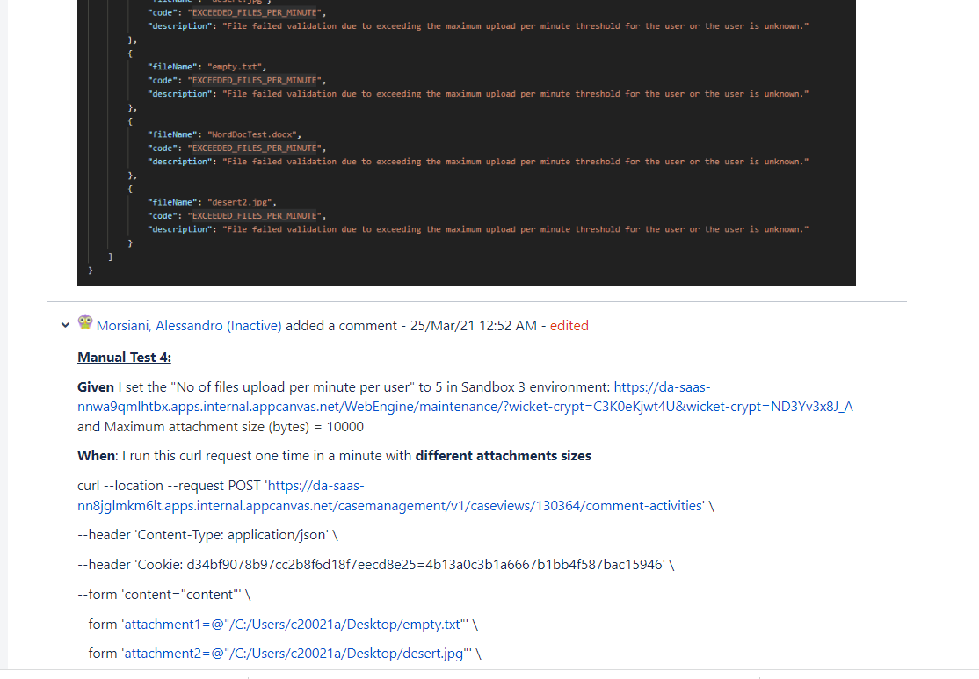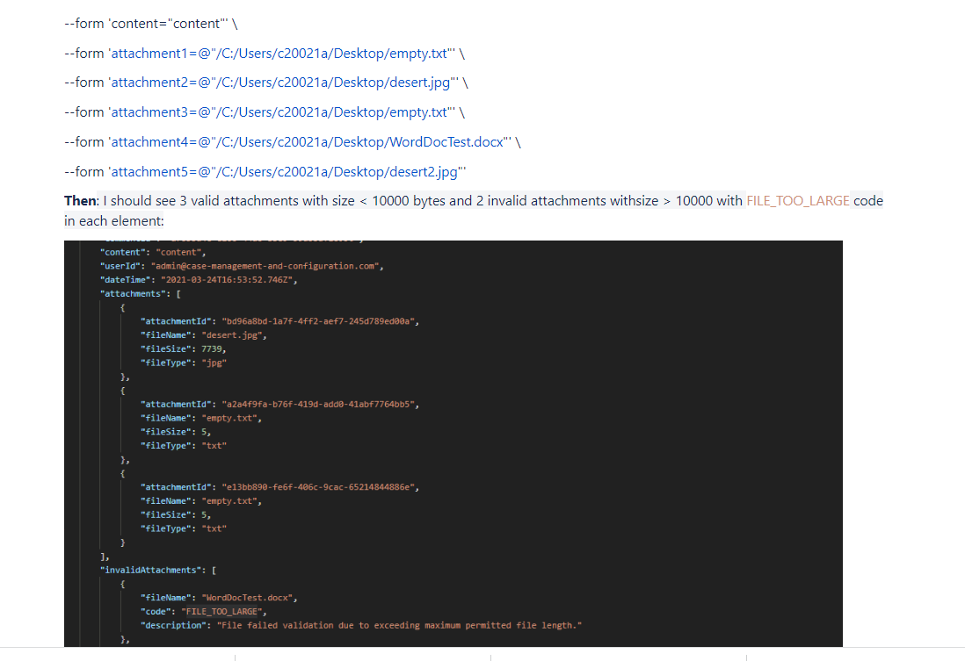

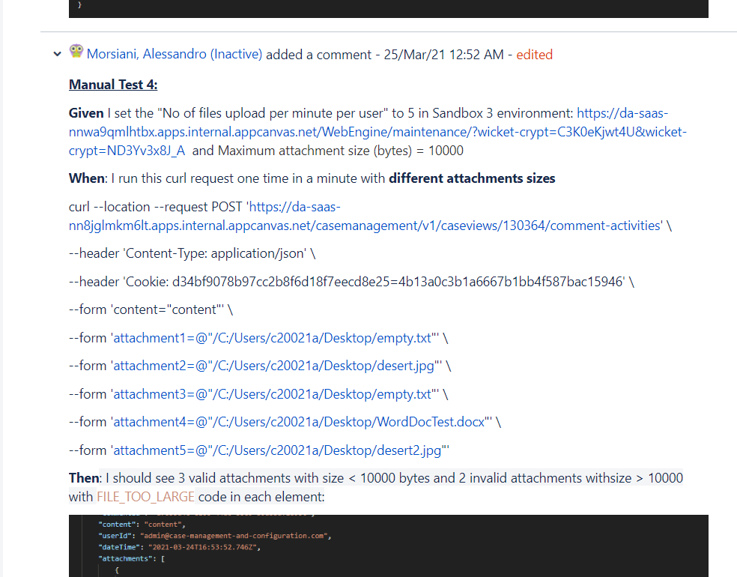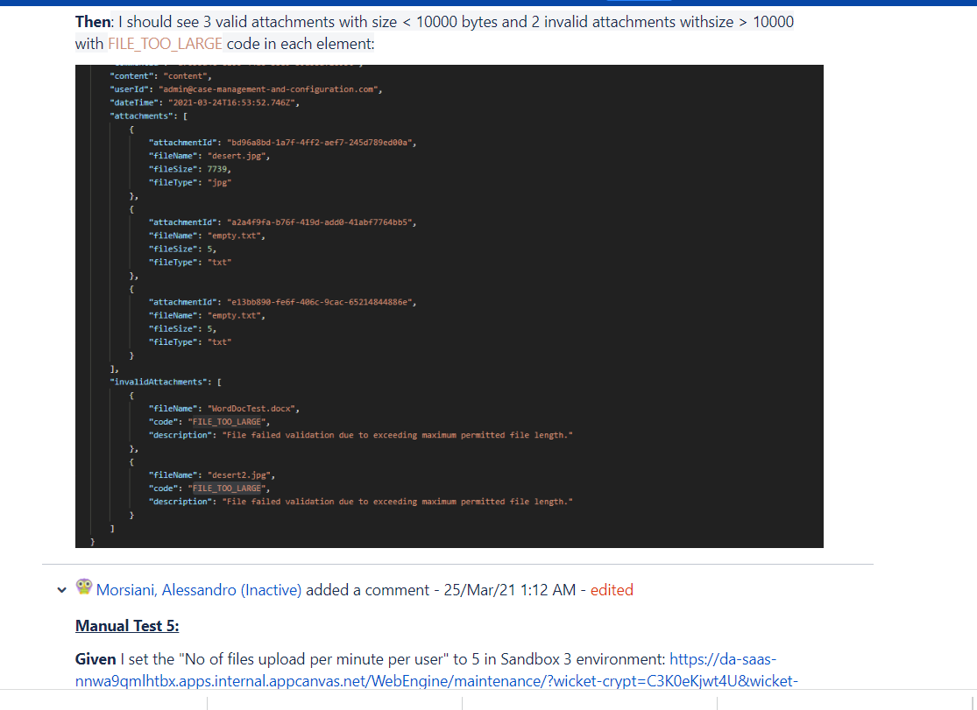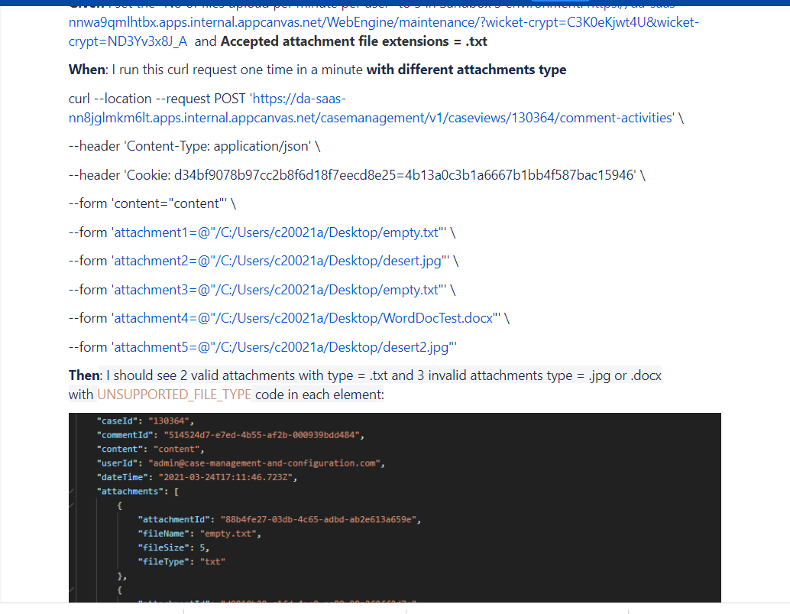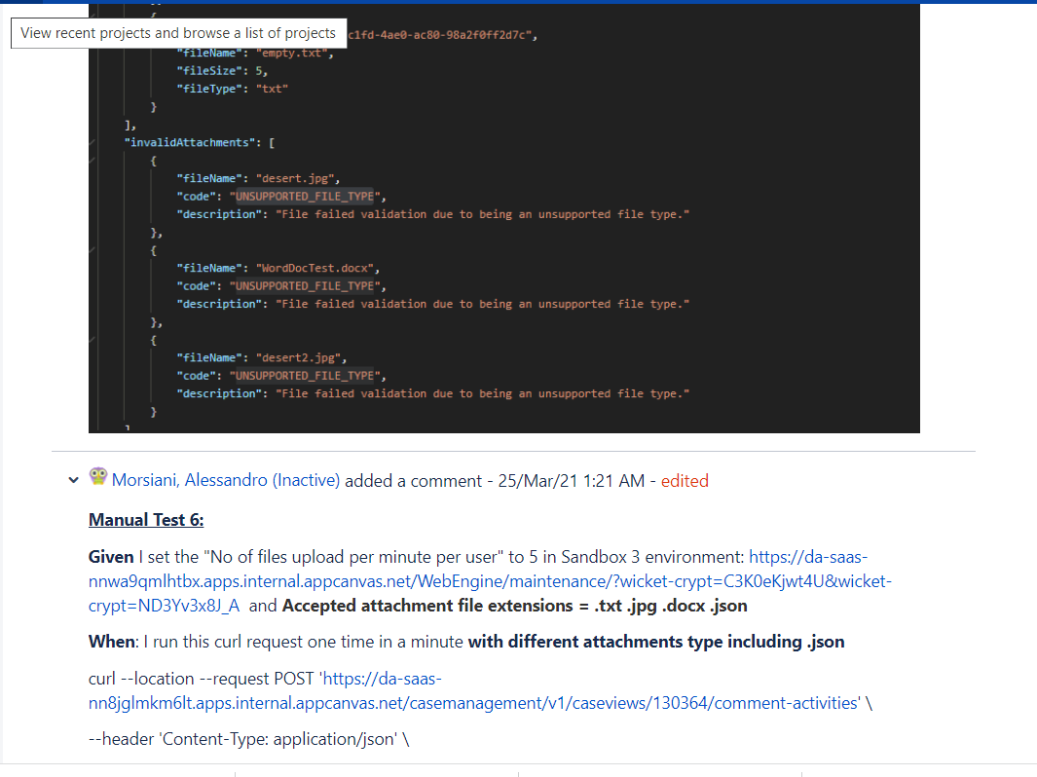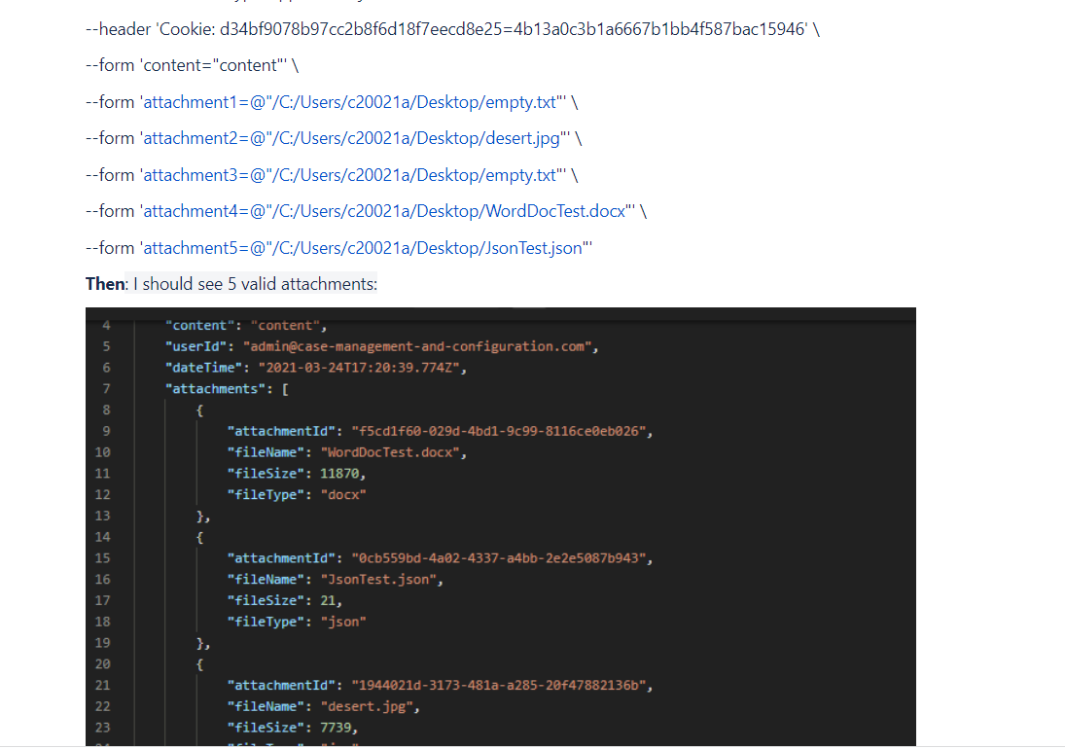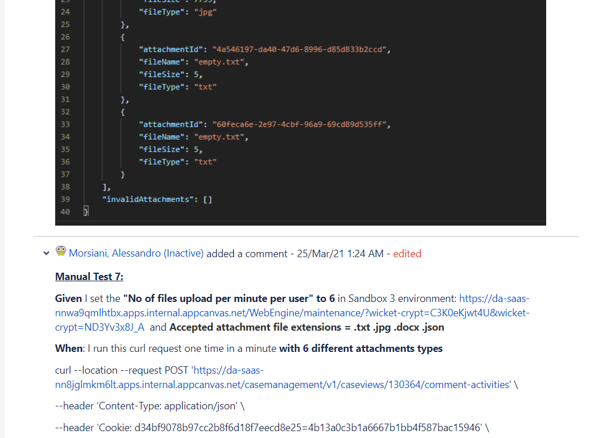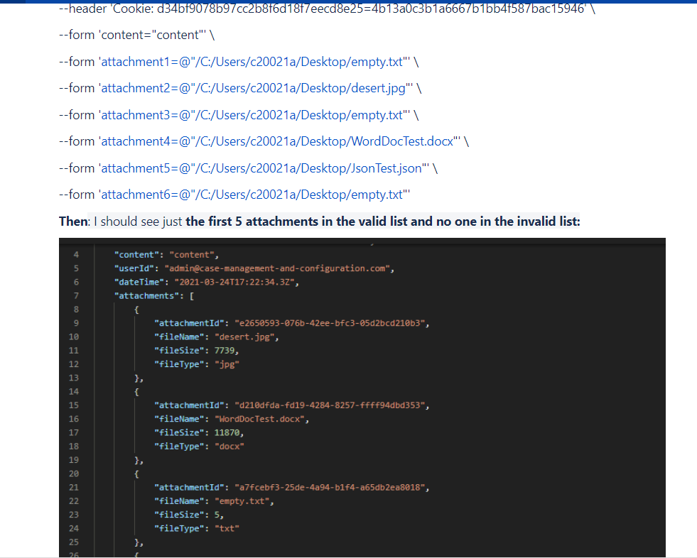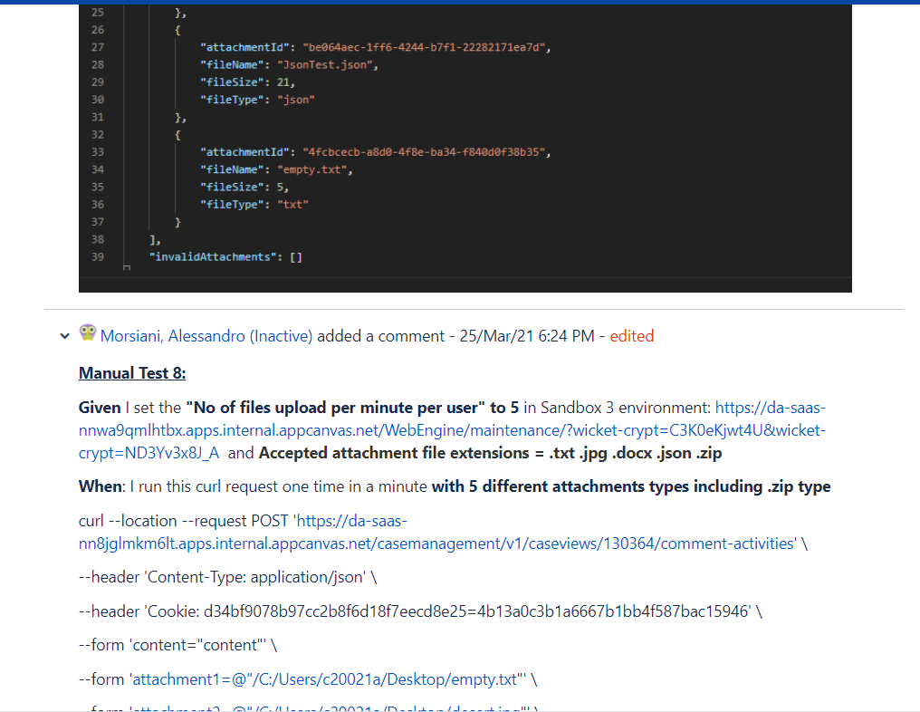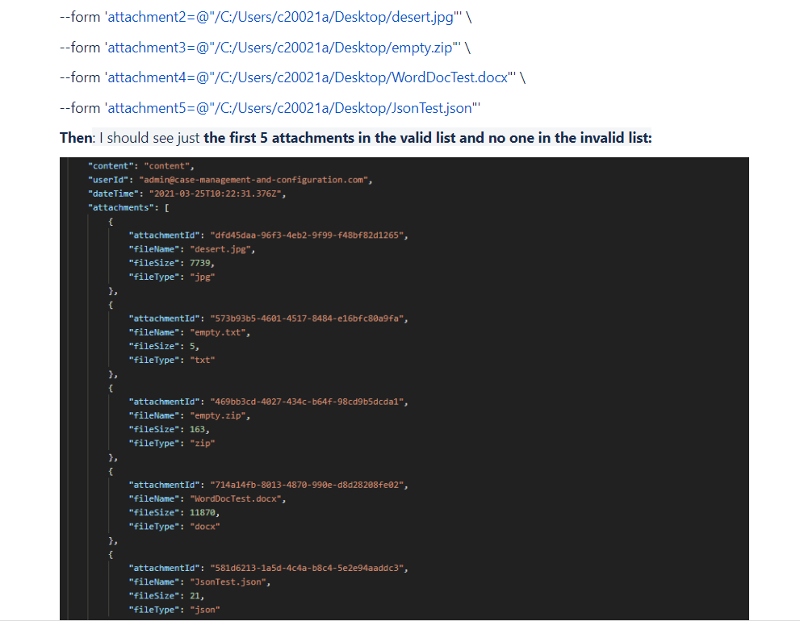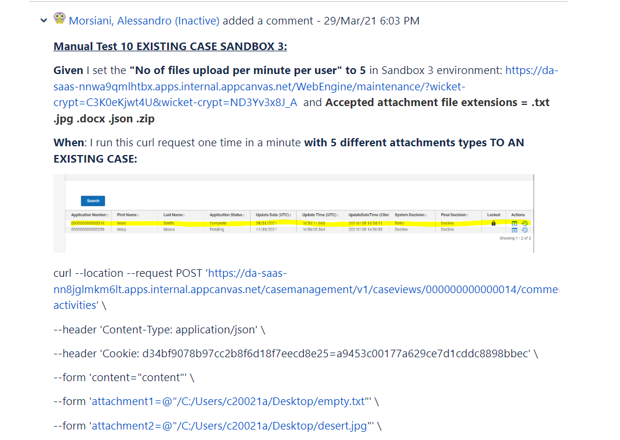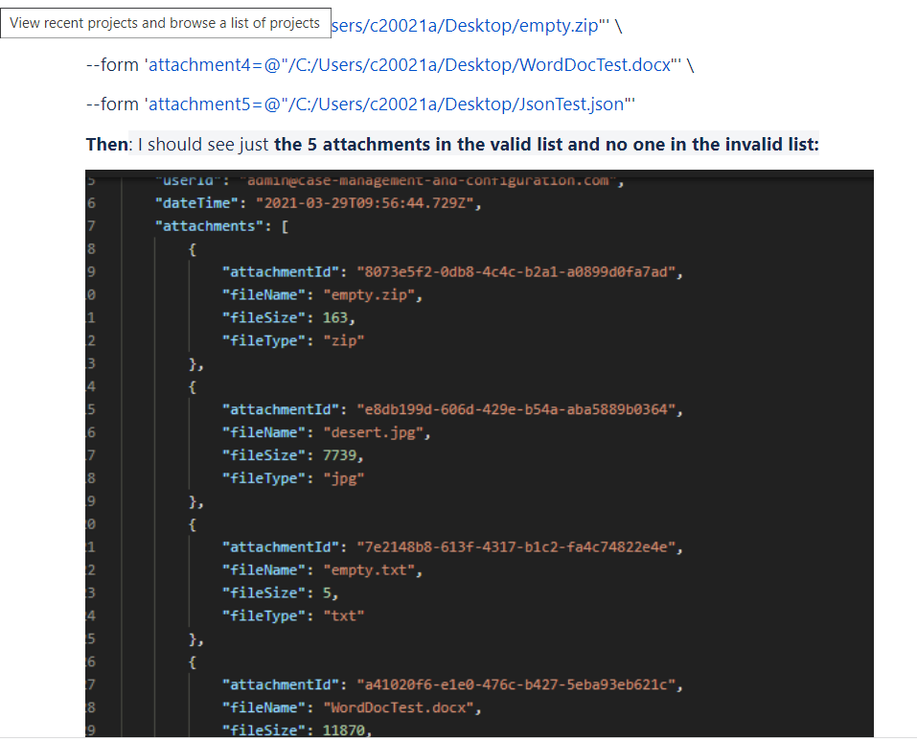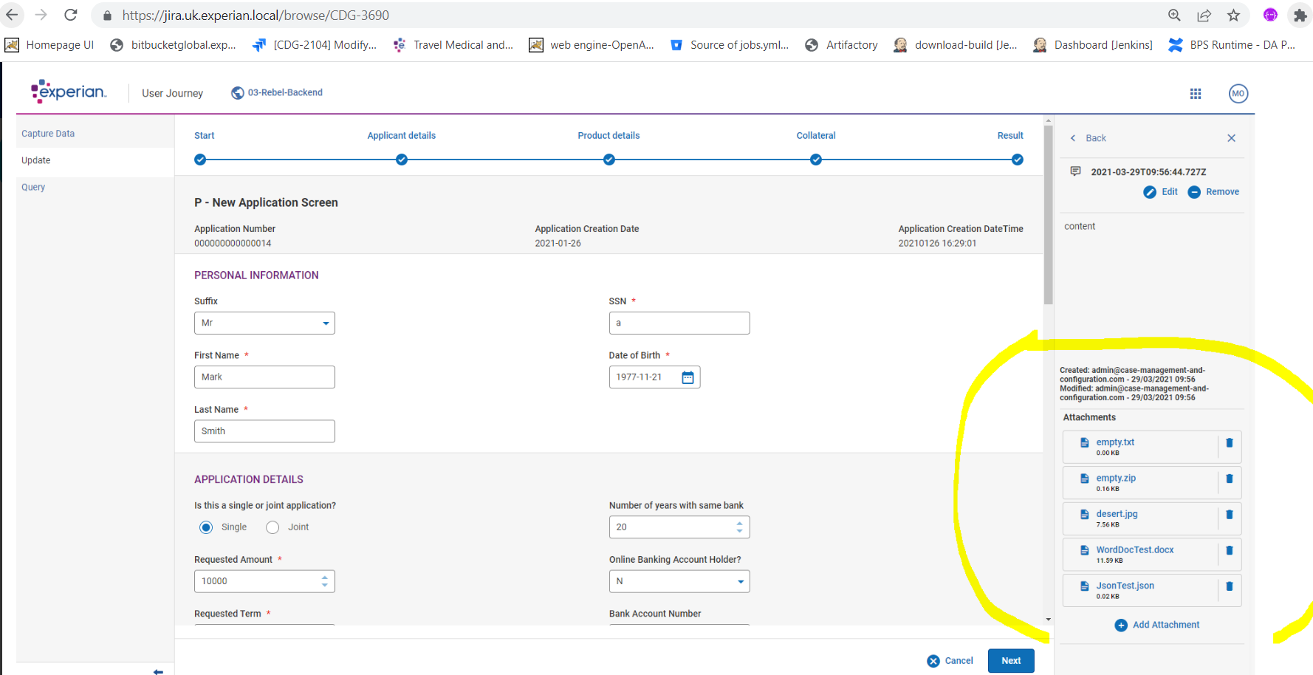

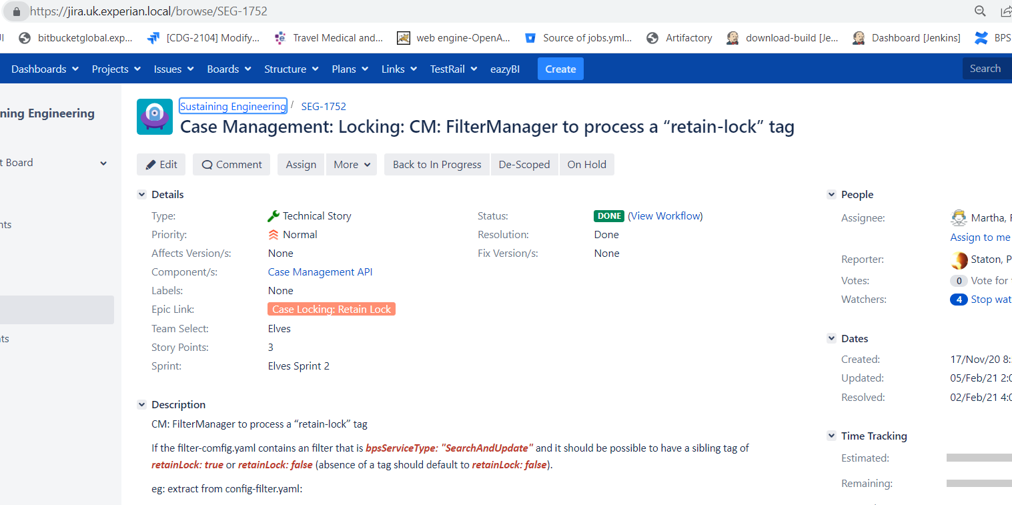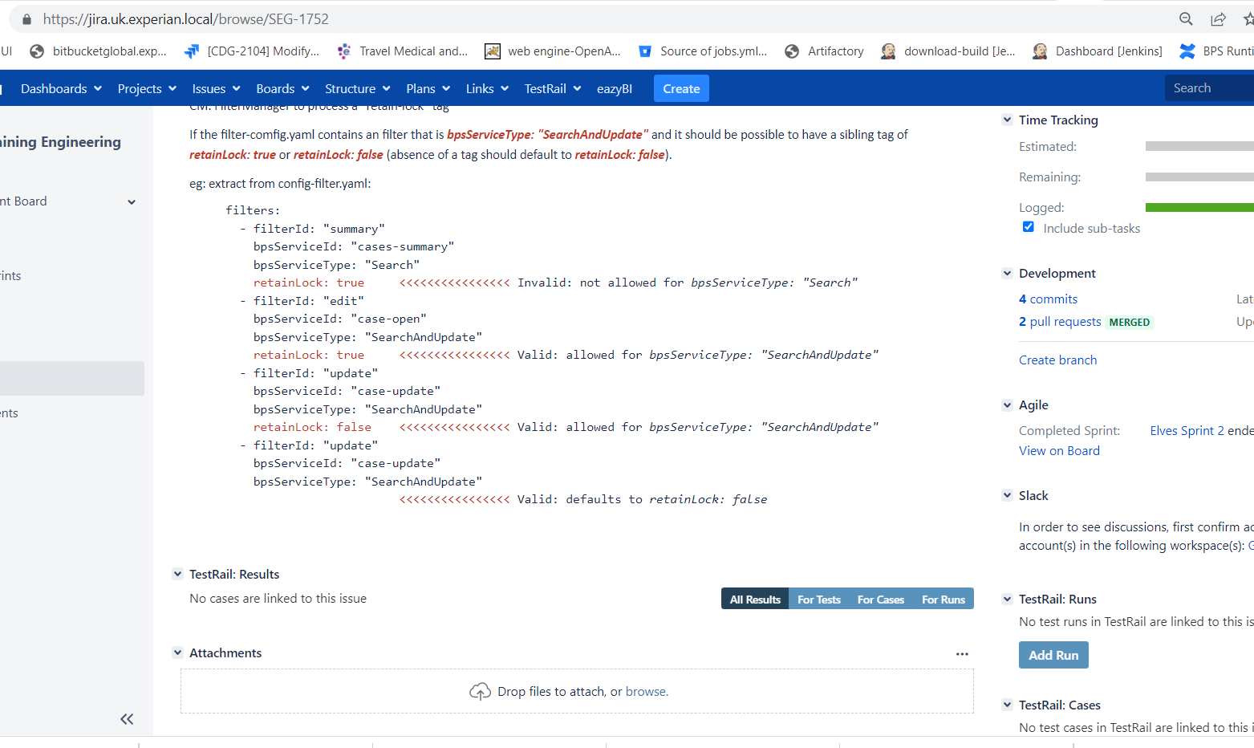

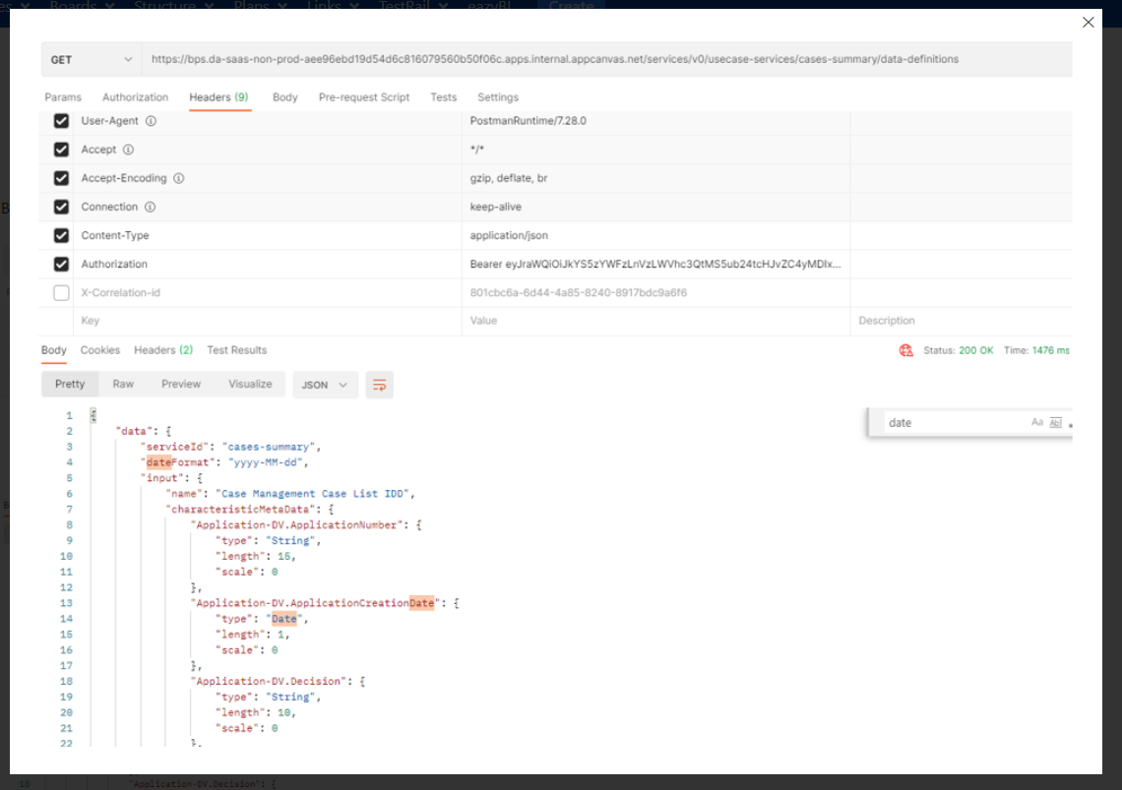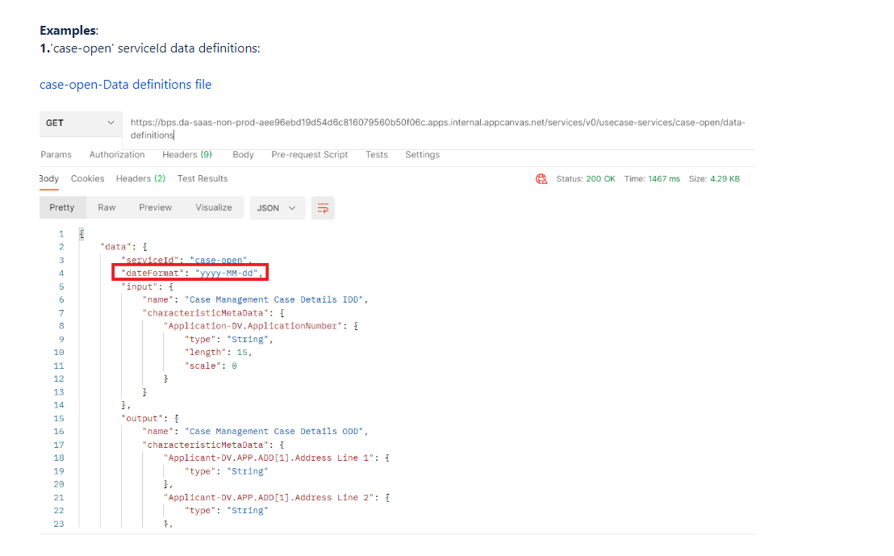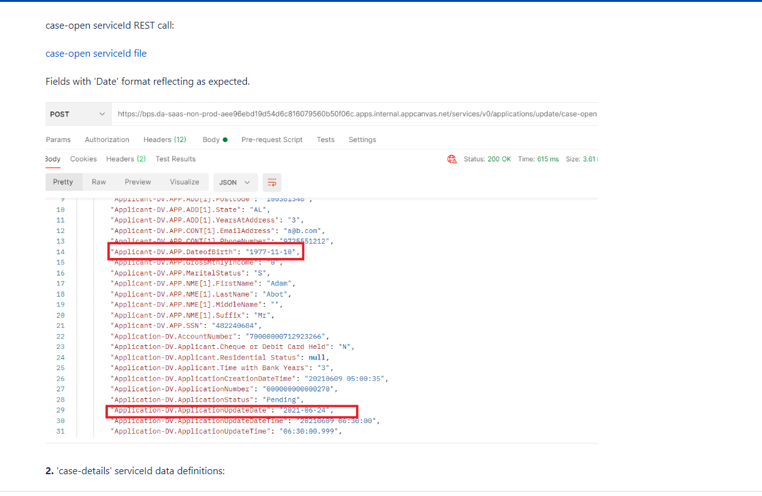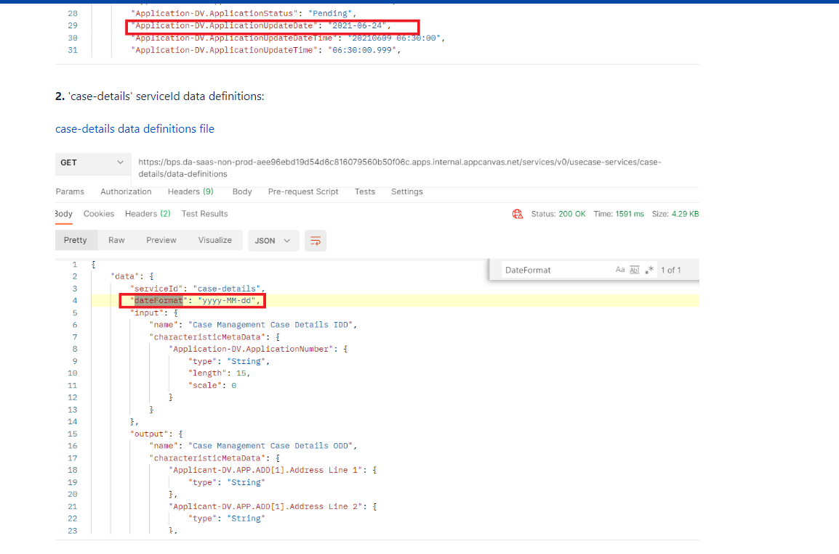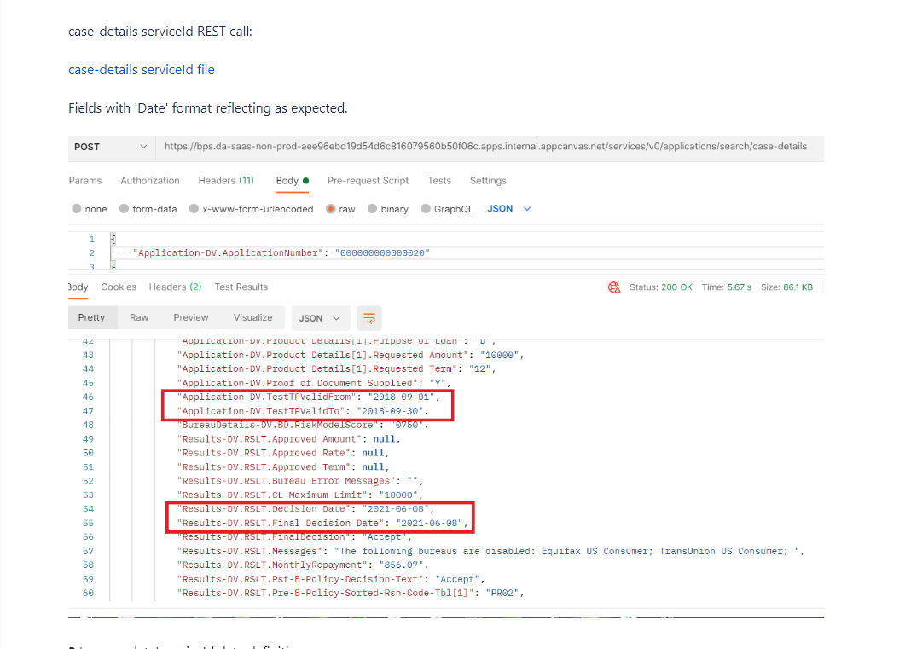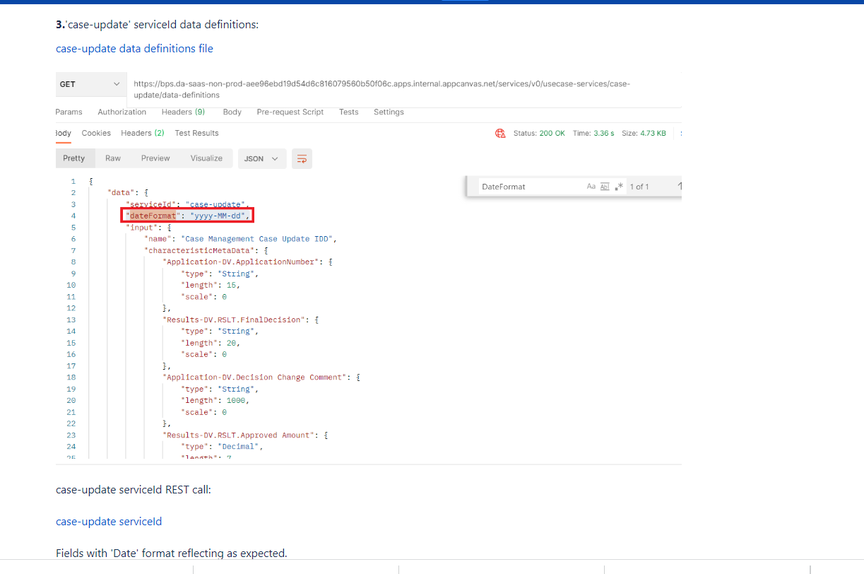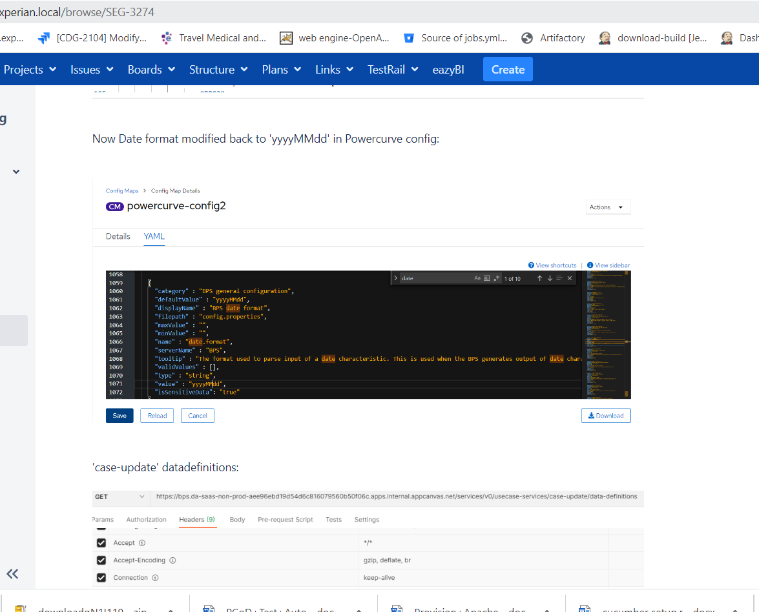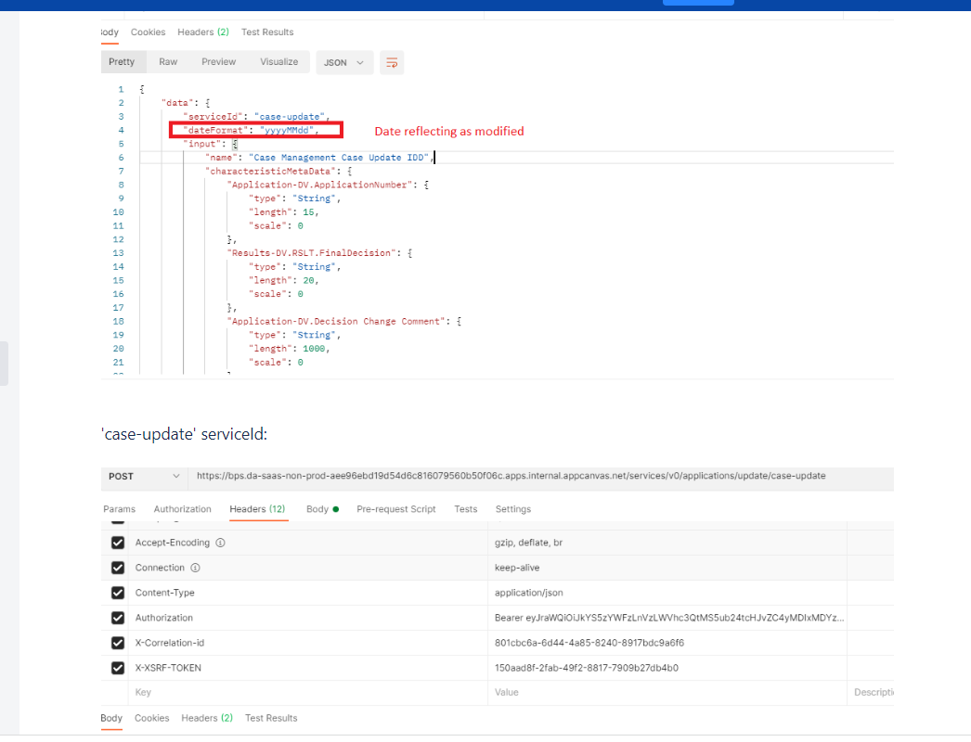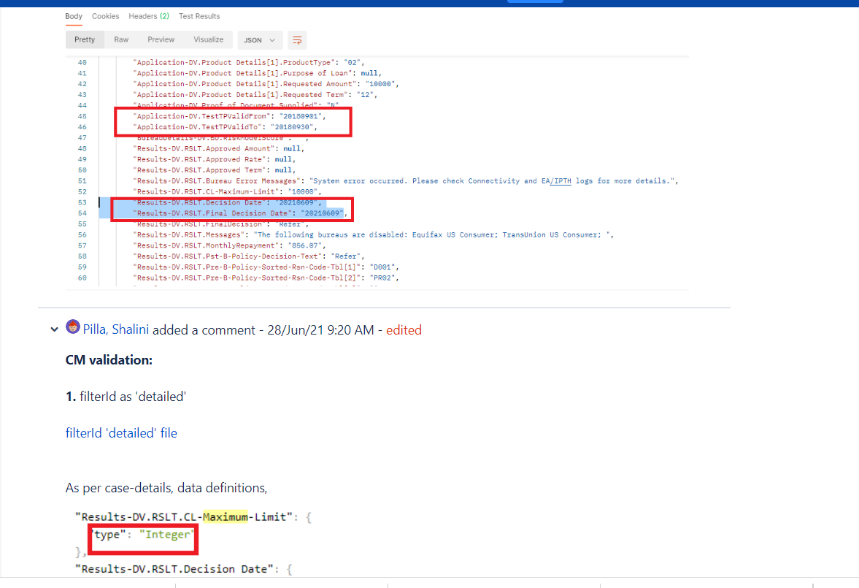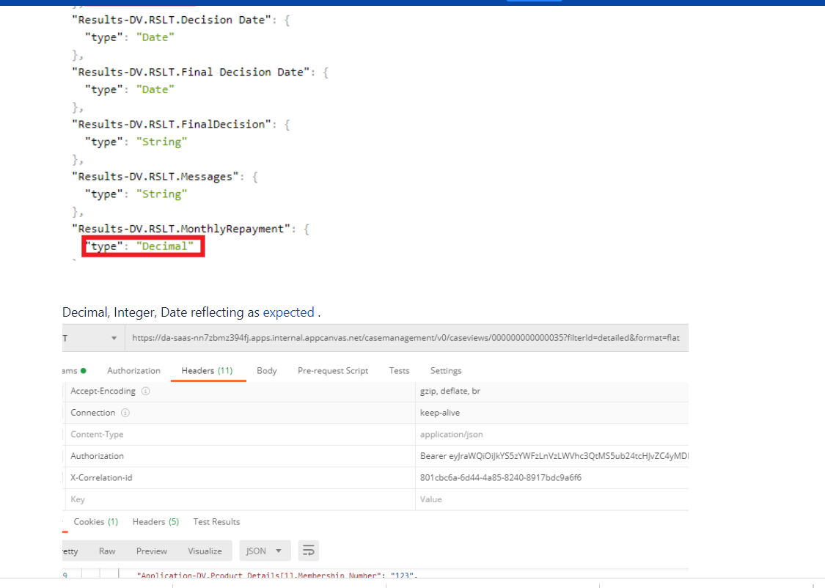

Expected is referring to

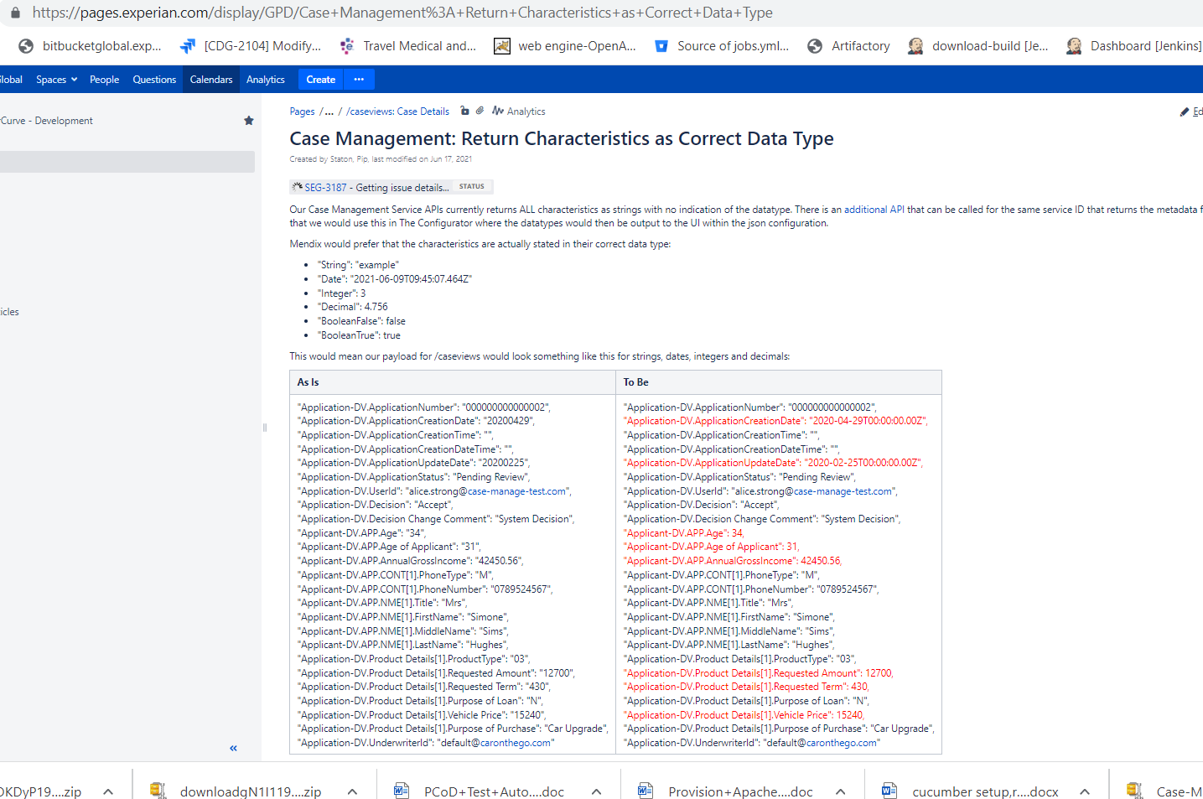

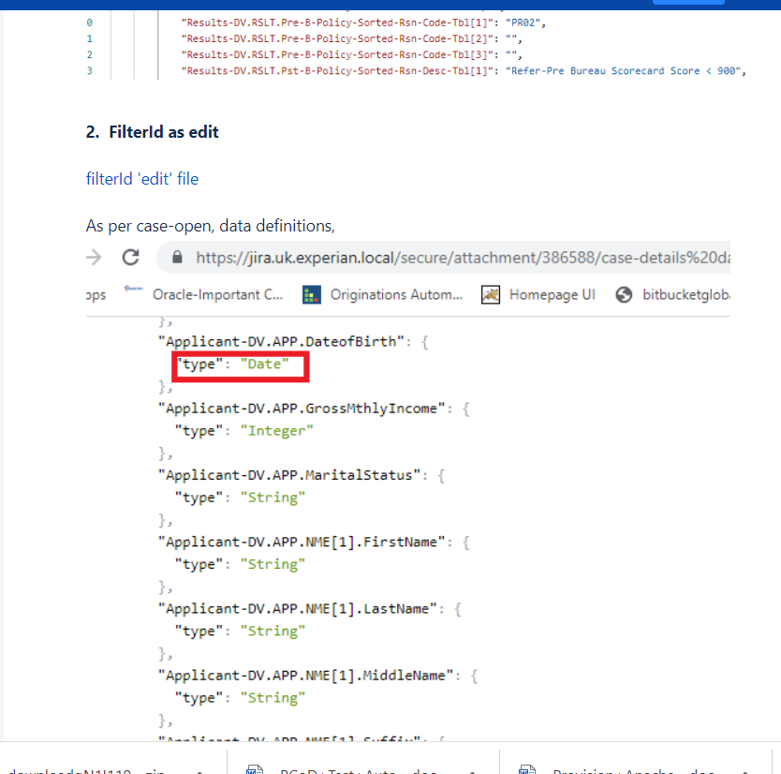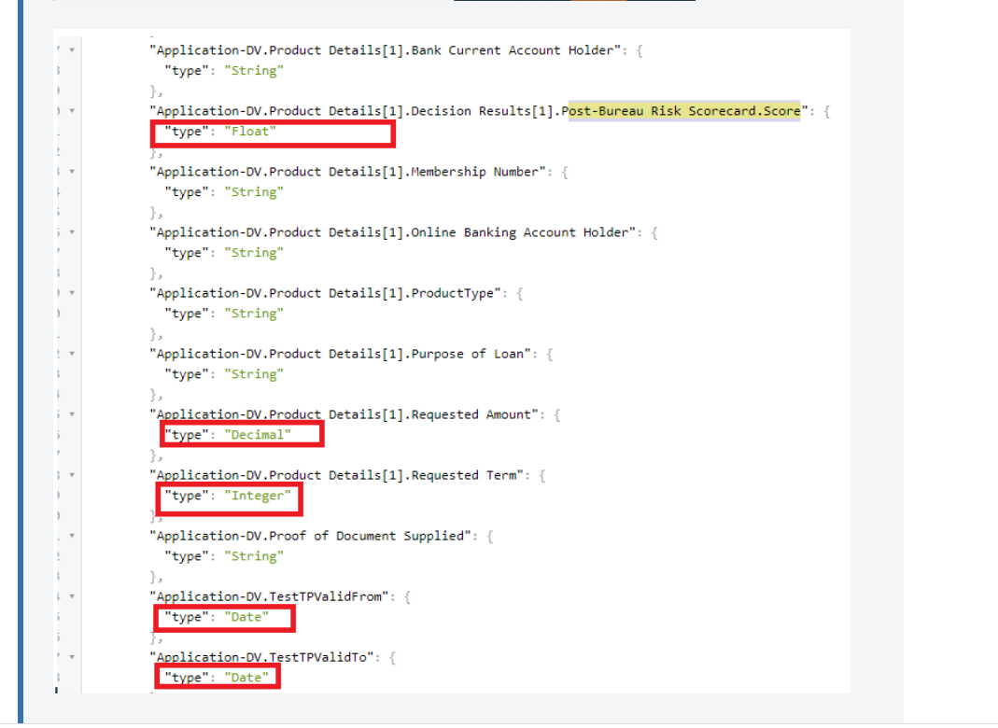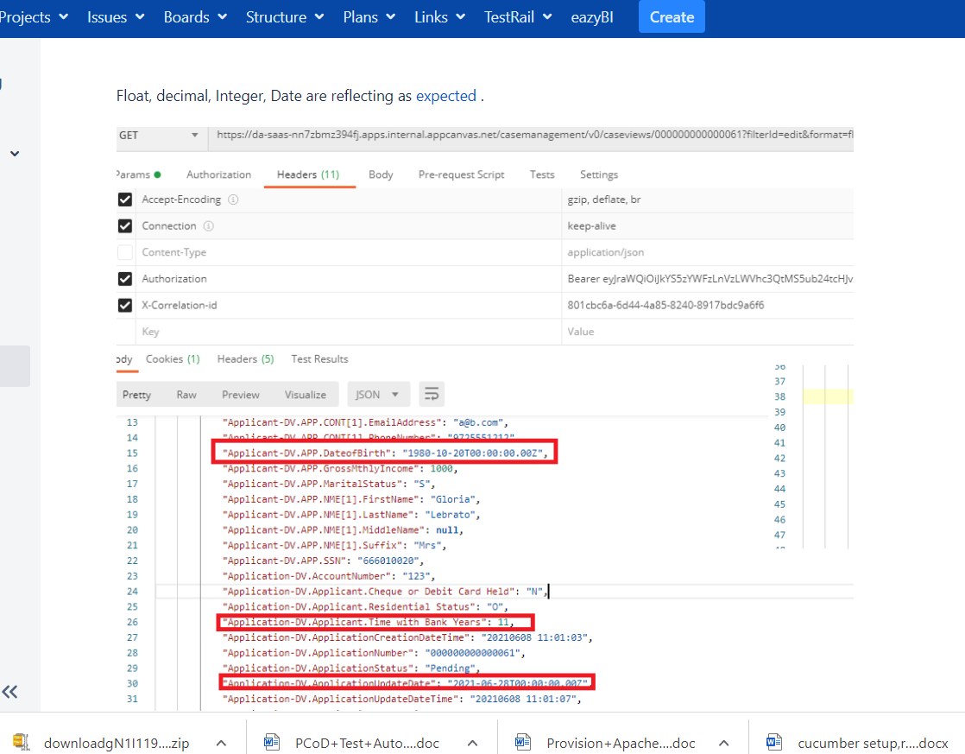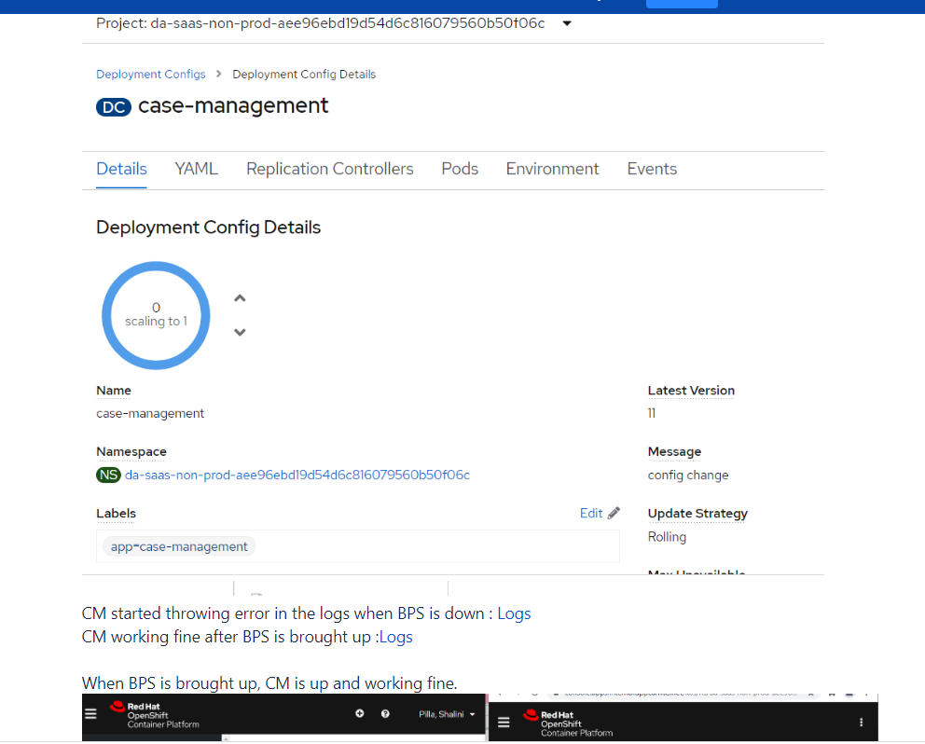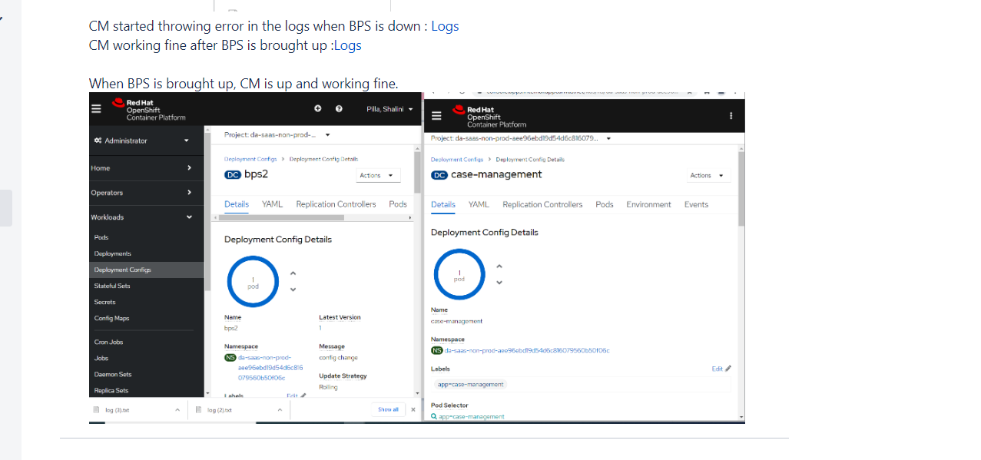

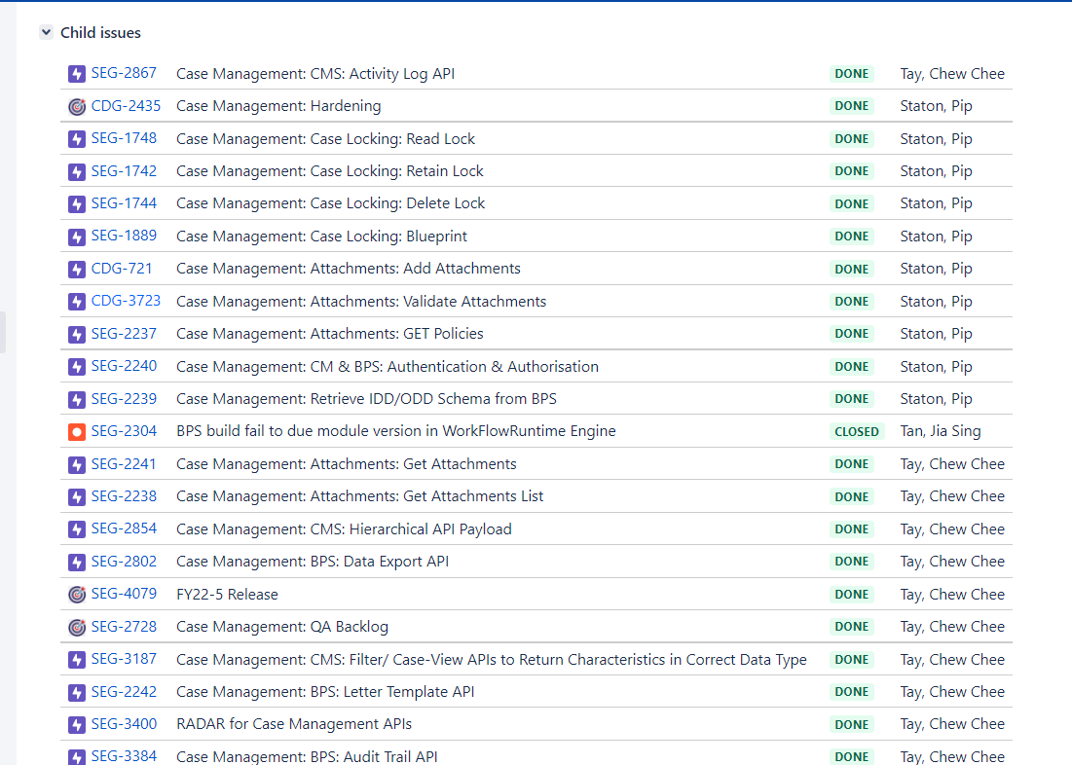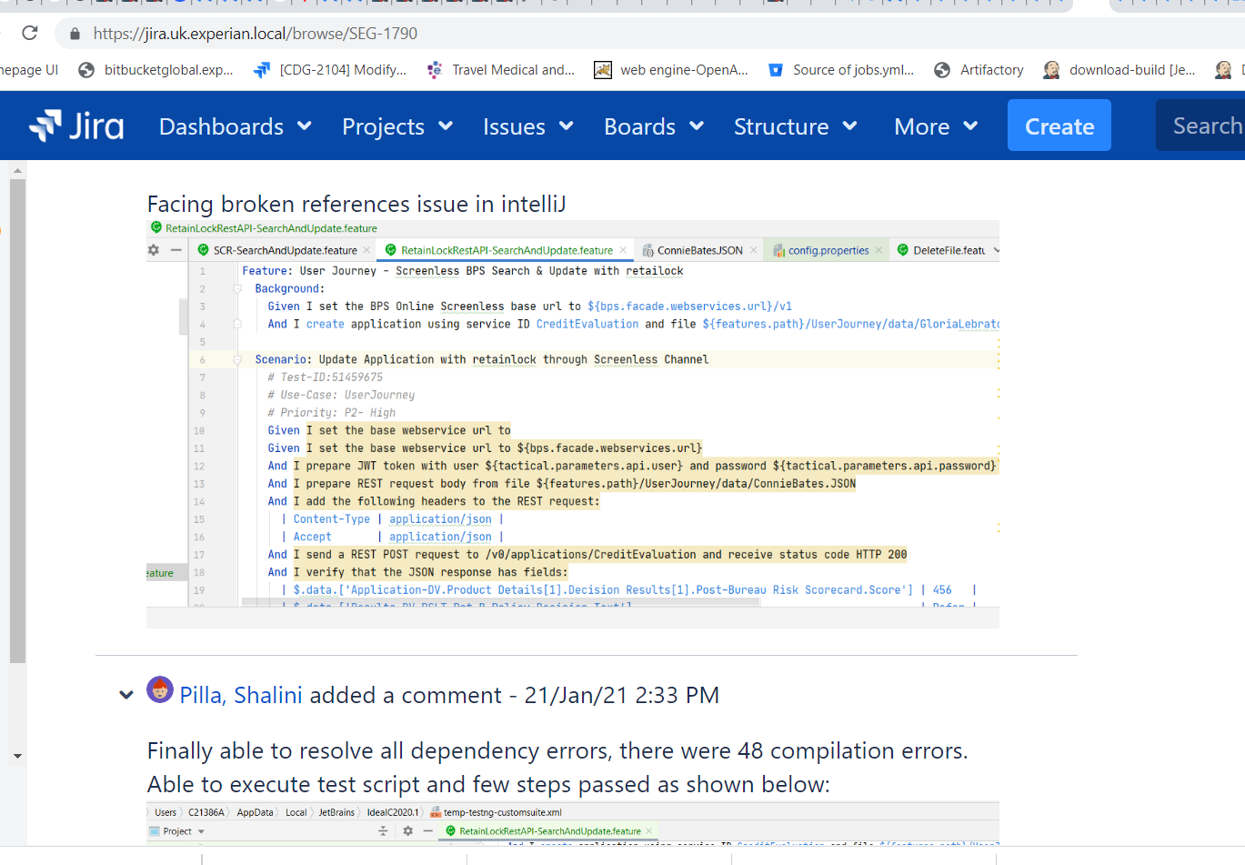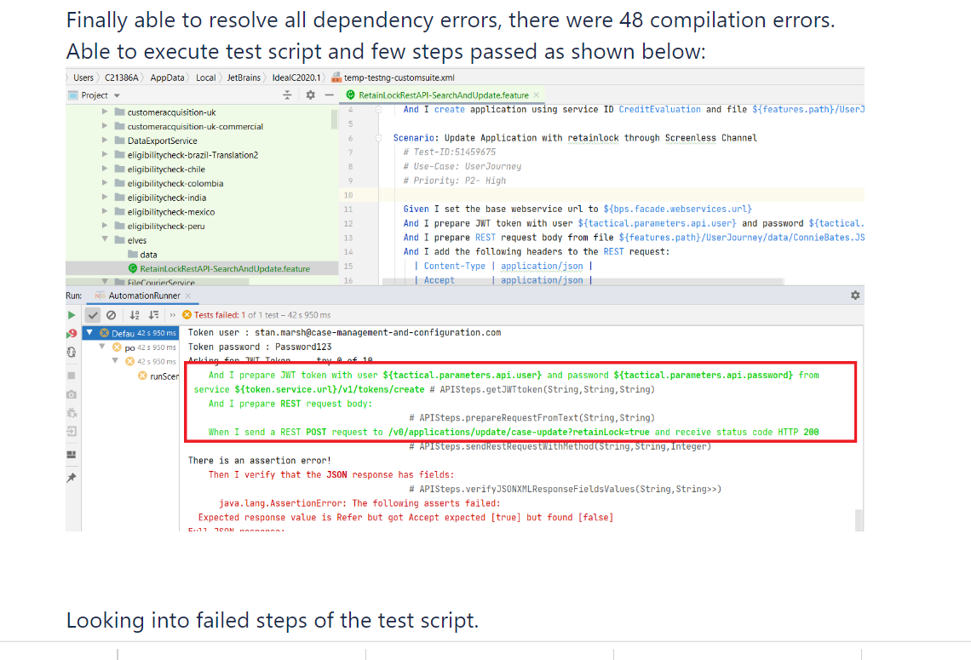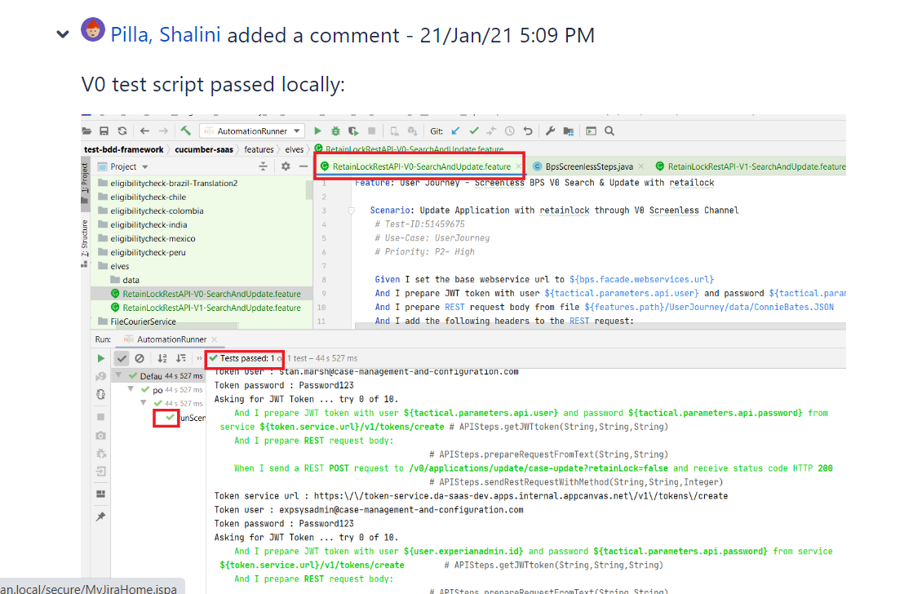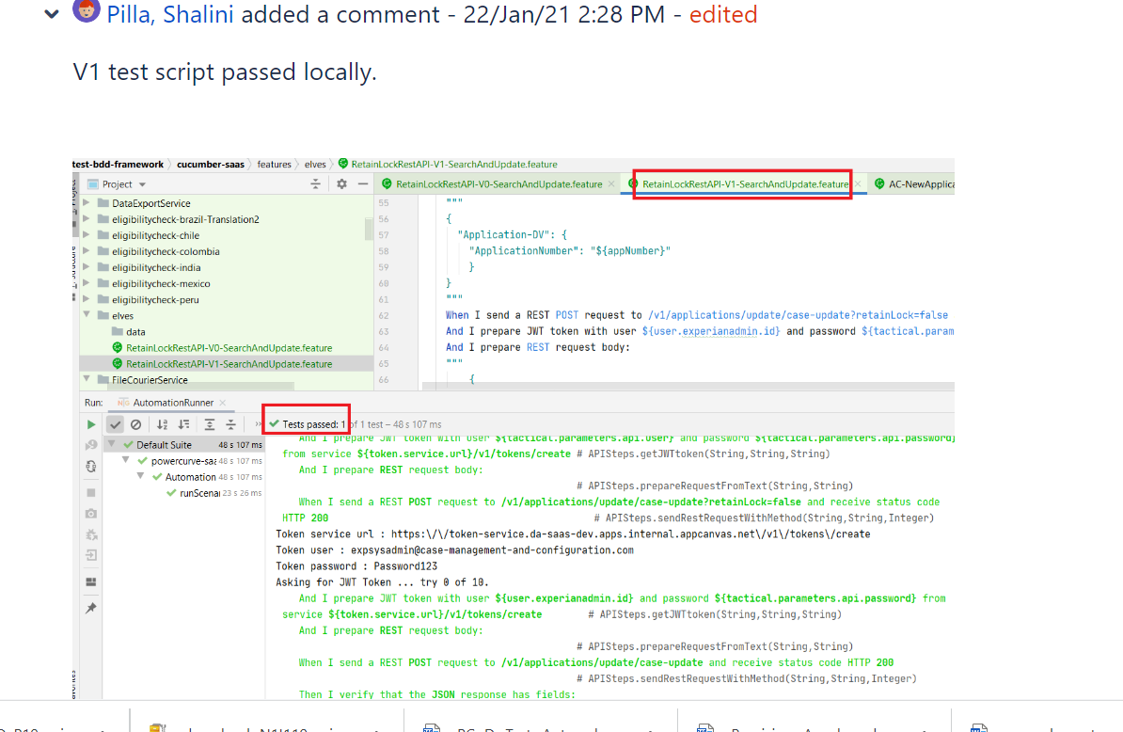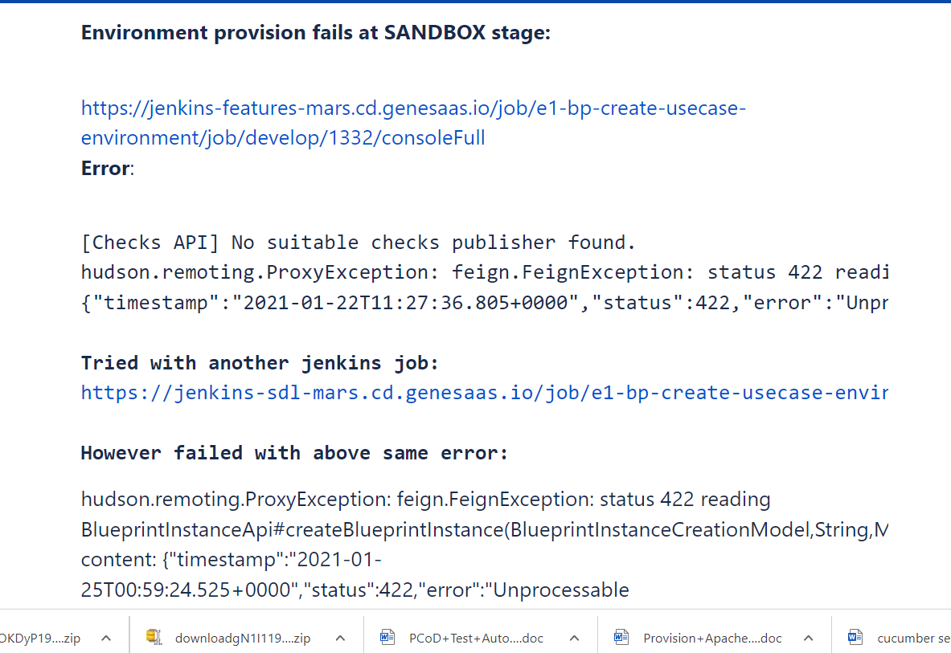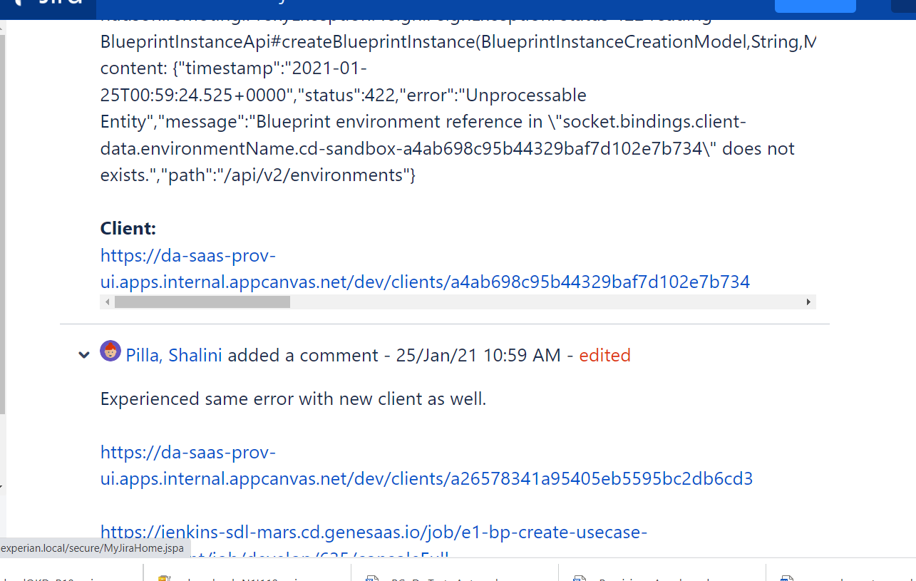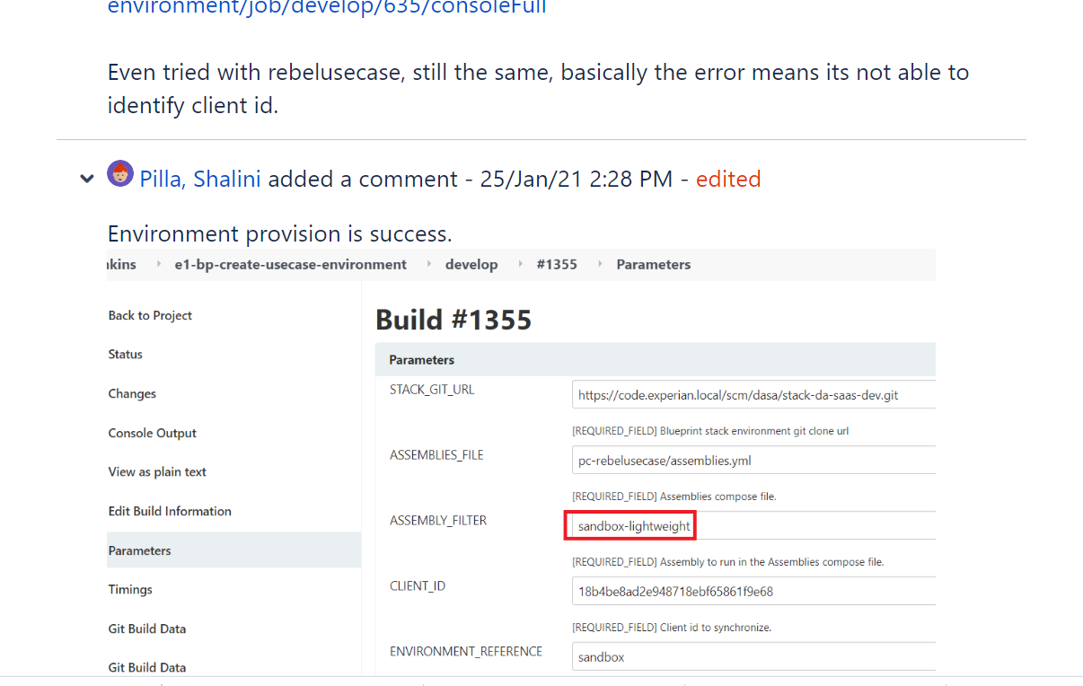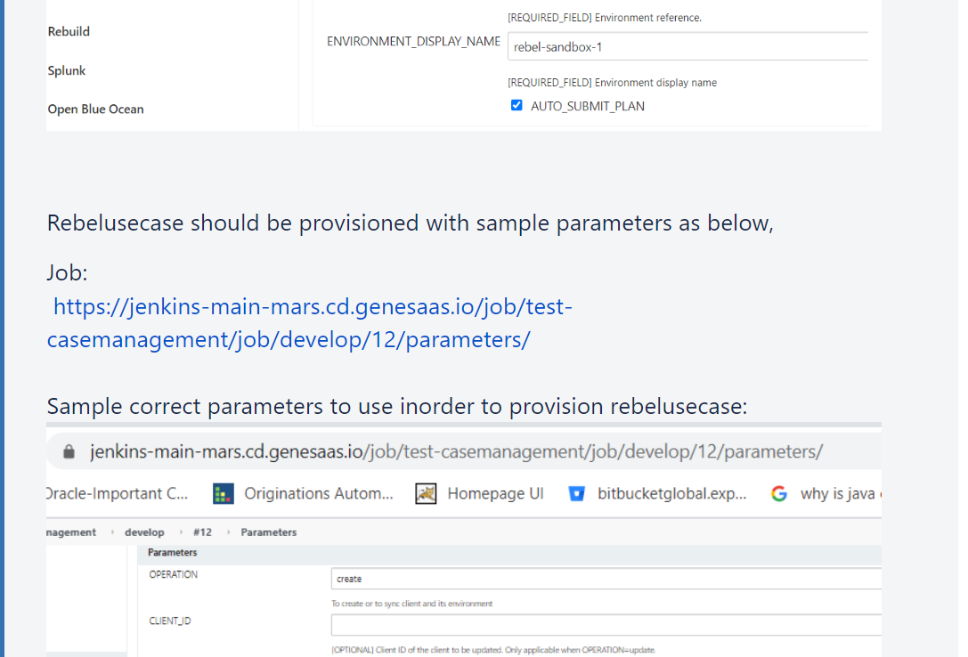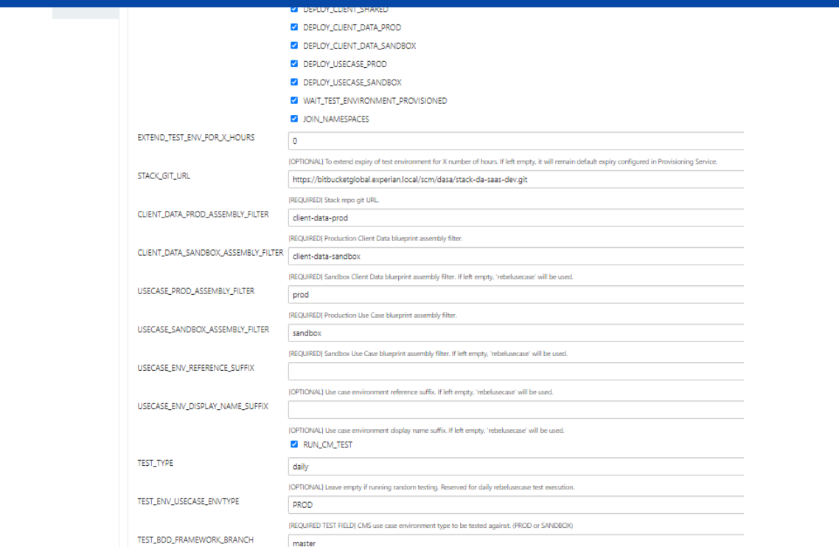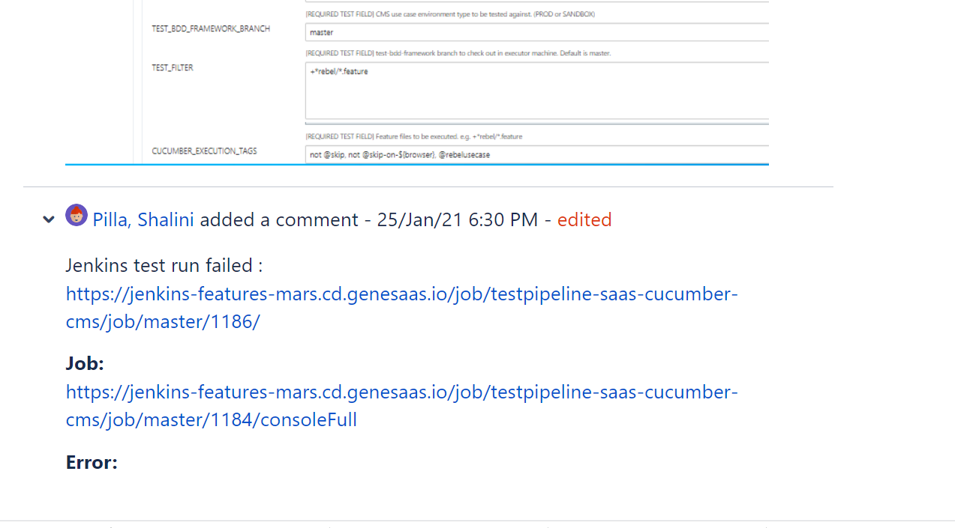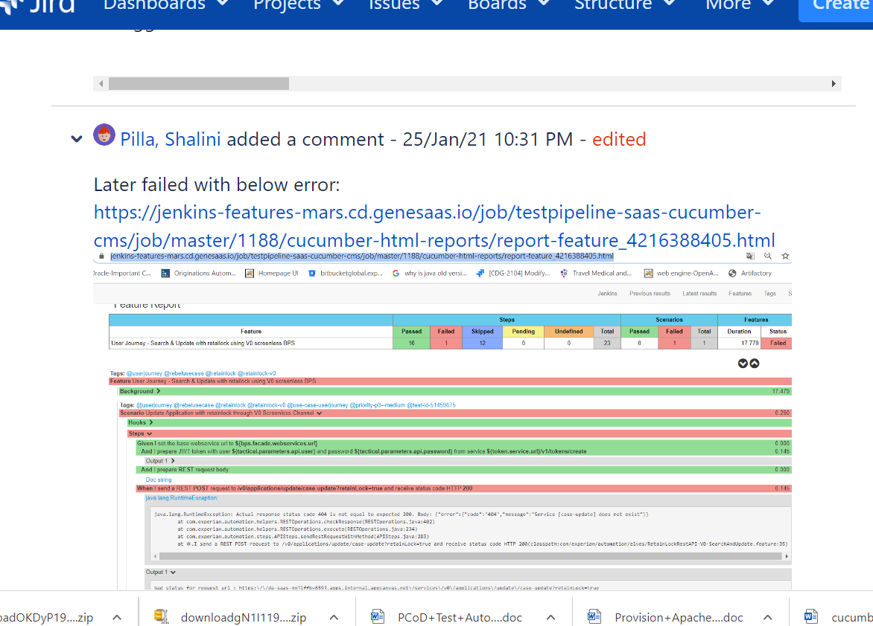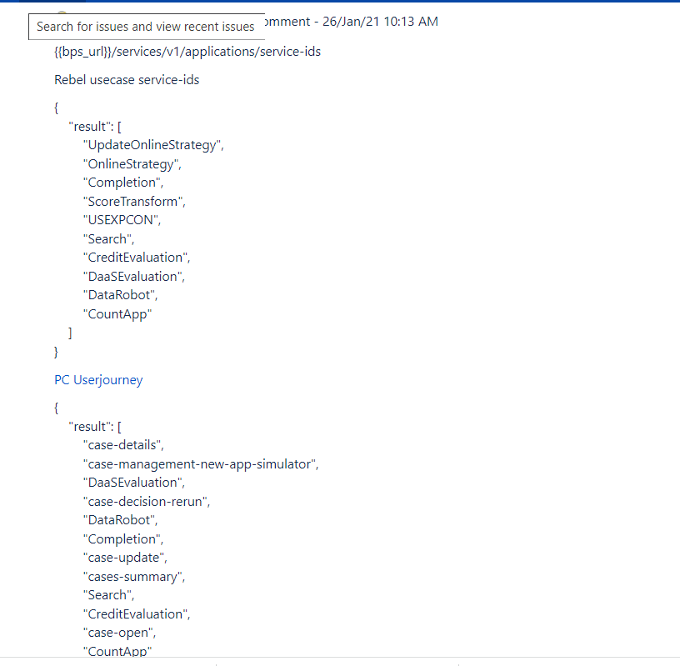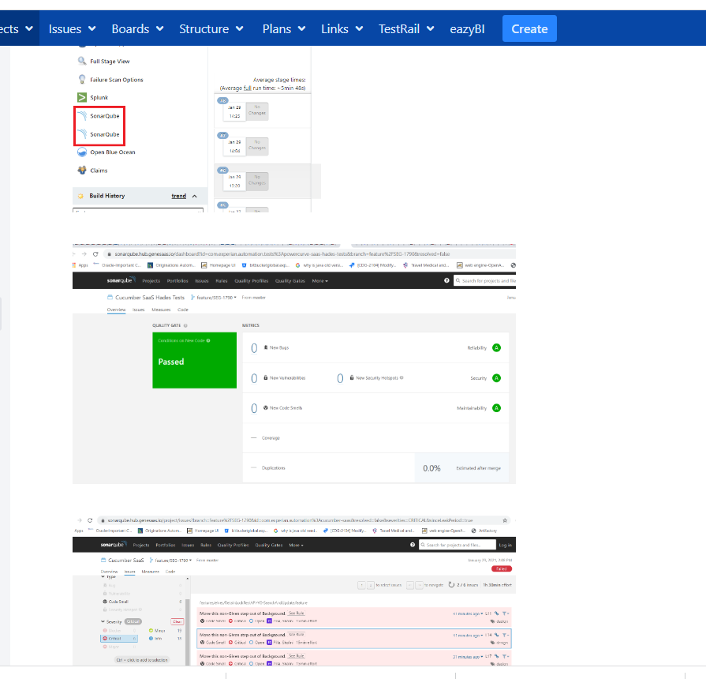

Advanced search reference - JQL keywords

This page describes information about keywords that are used for advanced searching. A keyword in JQL is a word or phrase that does (or is) any of the following:

* joins two or more clauses together to form a complex JQL query
* alters the logic of one or more clauses
* alters the logic of operators
* has an explicit definition in a JQL query
* performs a specific function that alters the results of a JQL query

AND

Used to combine multiple clauses, allowing you to refine your search.

Note that you can use parentheses to control the order in which clauses are executed.

**EXAMPLES**

* Find all open issues in the "New office" project:

project = "New office" and status = "open"

* Find all open, urgent issues that are assigned to jsmith:

status = open and priority = urgent and assignee = jsmith

* Find all issues in a particular project that are not assigned to jsmith:

project = JRA and assignee != jsmith

* Find all issues for a specific release which consists of different version numbers across several projects:

project in (JRA,CONF) and fixVersion = "3.14"

* Find all issues where neither the Reporter nor the Assignee is Jack, Jill or John:

reporter not in (Jack,Jill,John) and assignee not in (Jack,Jill,John)

[**^ top of page**](https://support.atlassian.com/jira-software-cloud/docs/advanced-search-reference-jql-keywords/#Advancedsearchingkeywordsreference-keywords)

OR

Used to combine multiple clauses, allowing you to expand your search.

Note that you can use parentheses to control the order in which clauses are executed.

(Note: also see [IN](https://confluence.atlassian.com/jirasoftwarecloud/advanced-searching-operators-reference-764478341.html#Advancedsearchingoperatorsreference-IN), which can be a more convenient way to search for multiple values of a field.)

**EXAMPLES**

* Find all issues that were created by either jsmith or jbrown:

reporter = jsmith or reporter = jbrown

* Find all issues that are overdue or where no due date is set:

duedate < now() or duedate is empty

[**^ top of page**](https://support.atlassian.com/jira-software-cloud/docs/advanced-search-reference-jql-keywords/#Advancedsearchingkeywordsreference-keywords)

NOT

Used to negate individual clauses or a complex JQL query (a query made up of more than one clause) using parentheses, allowing you to refine your search.

(Note: also see [NOT EQUALS](https://confluence.atlassian.com/jirasoftwarecloud/advanced-searching-operators-reference-764478341.html#Advancedsearchingoperatorsreference-NOT_EQUALS) ("!="), [DOES NOT CONTAIN](https://confluence.atlassian.com/jirasoftwarecloud/advanced-searching-operators-reference-764478341.html#Advancedsearchingoperatorsreference-DOES_NOT_CONTAIN) ("!~"), [NOT IN](https://support.atlassian.com/jira-software-cloud/docs/advanced-search-reference-jql-keywords/#Advancedsearchingkeywordsreference-NOT_IN) and [IS NOT](https://confluence.atlassian.com/jirasoftwarecloud/advanced-searching-operators-reference-764478341.html#Advancedsearchingoperatorsreference-IS_NOT).)

**EXAMPLES**

* Find all issues that are assigned to any user except jsmith:

not assignee = jsmith

* Find all issues that were not created by either jsmith or jbrown:

not (reporter = jsmith or reporter = jbrown)

[**^ top of page**](https://support.atlassian.com/jira-software-cloud/docs/advanced-search-reference-jql-keywords/#Advancedsearchingkeywordsreference-keywords)

EMPTY

Used to search for issues where a given field does not have a value. See also [NULL](https://support.atlassian.com/jira-software-cloud/docs/advanced-search-reference-jql-keywords/#Advancedsearchingkeywordsreference-NULL).

Note that EMPTY can only be used with fields that support the [IS](https://confluence.atlassian.com/jirasoftwarecloud/advanced-searching-operators-reference-764478341.html#Advancedsearchingoperatorsreference-IS) and [IS NOT](https://support.atlassian.com/jira-software-cloud/docs/advanced-search-reference-jql-keywords/#Advancedsearchingkeywordsreference-IS_NOT) operators. To see a field's supported operators, check the individual [field](https://confluence.atlassian.com/jirasoftwarecloud/advanced-searching-fields-reference-764478339.html) reference.

**EXAMPLES**

* Find all issues without a DueDate:

duedate = empty

or

duedate is empty

[**^ top of page**](https://support.atlassian.com/jira-software-cloud/docs/advanced-search-reference-jql-keywords/#Advancedsearchingkeywordsreference-keywords)

NULL

Used to search for issues where a given field does not have a value. See also [EMPTY](https://support.atlassian.com/jira-software-cloud/docs/advanced-search-reference-jql-keywords/#Advancedsearchingkeywordsreference-EMPTY).

Note that NULL can only be used with fields that support the [IS](https://support.atlassian.com/jira-software-cloud/docs/advanced-search-reference-jql-keywords/#Advancedsearchingkeywordsreference-IS) and [IS NOT](https://support.atlassian.com/jira-software-cloud/docs/advanced-search-reference-jql-keywords/#Advancedsearchingkeywordsreference-IS_NOT) operators. To see a field's supported operators, check the individual [field](https://confluence.atlassian.com/jirasoftwarecloud/advanced-searching-fields-reference-764478339.html) reference.

**EXAMPLES**

* Find all issues without a DueDate:

duedate = null

or

duedate is null

[**^ top of page**](https://support.atlassian.com/jira-software-cloud/docs/advanced-search-reference-jql-keywords/#Advancedsearchingkeywordsreference-keywords)

ORDER BY

Used to specify the fields by whose values the search results will be sorted.

By default, the field's own sorting order will be used. You can override this by specifying ascending order ("asc") or descending order ("desc").

**EXAMPLES**

* Find all issues without a DueDate, sorted by CreationDate:

duedate = empty order by created

* Find all issues without a DueDate, sorted by CreationDate, then by Priority (highest to lowest):

duedate = empty order by created, priority desc

* Find all issues without a DueDate, sorted by CreationDate, then by Priority (lowest to highest):

duedate = empty order by created, priority asc